

**SULOCHANA SALOON WEBSITE**

**PROPOSAL**

**2024**

Prepared by:

Prepared for:

**H.T. Upetha Laksiluni**

**Sulochana Saloon**

# HD in Computing & Software Engineering

*CSE5015 Computing Project Proposal Approval Sheet*

Student Use only;

|  |  |  |  |  |  |
| --- | --- | --- | --- | --- | --- |
| Group Name | H.T. Upetha Laksiluni | | | Attempt No |  |
| Title of the project | Sulochana Saloon App | | | | |
| System platform |  |  | Web Application Desktop Application Mobile Application  ………………………… | | |
|  |
| …… |
| Technology | Android App Development | | | | |
| Programming methodology |  |  | Structured System Analysis and Design Methodology  Object Oriented Analysis and Design Methodology | | |
|  |
|  |
| SDLC | Agile Methodology | | | | |

|  |  |  |  |
| --- | --- | --- | --- |
| Student No | CL/HDCSE/CMU/114/70 | Full Name | H.T. Upetha Laksiluni |
| Roles & Responsibilities;   1. Project Manager    1. Project planning and timeline management    2. Resource allocation    3. Client communication    4. Sprint planning and backlog management    5. Risk management    6. Stakeholder reporting 2. Frontend Developer    1. Implement responsive UI designs    2. Create interactive client-side features    3. Build admin and client dashboards    4. Ensure cross-browser compatibility    5. Implement form validations    6. Create dynamic data visualizations    7. Optimize website performance 3. Backend Developer    1. Design and implement database architecture    2. Create RESTful APIs for data handling    3. Implement authentication and authorization    4. Handle file uploads and processing    5. Create appointment scheduling system    6. Implement notification system    7. Database optimization and security 4. UI/UX Designer    1. Create wireframes and mockups    2. Design user interface components    3. Ensure consistent design language    4. Create responsive layouts    5. Design user flows and interactions    6. Ensure accessibility standards 5. QA Engineer    1. Create test cases and test plans    2. Perform functional testing    3. Cross-browser compatibility testing    4. Security testing    5. Performance testing    6. User acceptance testing coordination 6. Database Administrator    1. Database design and optimization    2. Data backup and recovery    3. Security implementation    4. Performance monitoring    5. Query optimization    6. Database maintenance 7. System Administrator    1. Server setup and configuration    2. SSL certificate management    3. Server maintenance and updates    4. Backup management    5. Security implementation    6. Performance monitoring | | | |

System Functionality:

|  |  |  |  |
| --- | --- | --- | --- |
| User Role | Feature | Function | Description |
| Client | Authentication & Profile | User Login | Allows users to log into their accounts. |
| User Registration | Enables new users to sign up. |
| Password Reset | Users can reset their passwords if forgotten. |
| Email Verification | Ensures users verify their email addresses. |
| View Profile Details | Displays user's profile information. |
| Edit Profile Information | Allows users to update their profile. |
| Change Password | Enables users to modify their password. |
| Client | Appointments | Book New Appointment | Users can schedule a new appointment. |
| Select Services | Choose from available services. |
| Choose Date & Time | Select a convenient date and time. |
| Select Stylist | Pick a preferred stylist. |
| Add Special Instructions | Provide specific requests for the appointment. |
| View All Appointments | Users can see a list of all their bookings. |
| View Appointment Details | Check details of a specific booking. |
| Cancel Appointment | Users can cancel an appointment. |
| Mark Appointment as Complete | Users can mark their appointment as completed. |
| Track Appointment Status | Check appointment progress. |
| Appointment Confirmation | Confirms an appointment after booking. |
| Get Booking Details | Displays booked appointment details. |
| Client | Notifications | View All Notifications | Users can see all notifications. |
| Read/Unread Status | Mark notifications as read/unread. |
| Real-time Updates | Receive instant notification updates. |
| Click to Navigate | Open the relevant page upon clicking the notification. |
| Filter Notifications | Sort and filter notifications as needed. |
| Client | Feedback | Submit Feedback | Users can submit their feedback. |
| Rate Services | Rate services after an appointment. |
| Validate Feedback | Ensure feedback meets requirements before submission. |
| Admin | Dashboard & Analytics | Overview Statistics | View key statistics about business operations. |
| Recent Activities | Display latest updates and user activities. |
| Appointment Analytics | Generate insights based on appointments. |
| Appointments Management | View All Appointments | View all scheduled and past appointments. |
| Filter by Date/Status | Search and filter appointments. |
| Approve/Reject Appointments | Admin can accept or decline bookings. |
| Add Notes | Admin can attach notes to appointments. |
| Update Status | Change the status of an appointment. |
| View Appointment Details | See complete booking details. |
| Admin | Service Management | View All Services | Display available services. |
| Add New Services | Create and offer new services. |
| Edit Service Details | Update service details and pricing. |
| Enable/Disable Services | Toggle the availability of services. |
| Admin | Staff Management | Add New Stylists | Add new stylists to the system. |
| Edit Stylist Details | Update information about stylists. |
| Manage Availability | Set the availability of each stylist. |
| View Stylist Performance | Monitor stylist performance. |
| Block/Unblock Stylists | Temporarily disable stylists if needed. |
| Admin | User Management | View All Users | Access a list of all registered users. |
| User Details | View detailed user information. |
| Booking History | View all appointments made by a user. |
| Block/Unblock Users | Restrict access to users if necessary. |
| View User Feedback | Admin can review submitted user feedback. |
| Admin | Notifications | View All Notifications | See all system notifications. |
| Read/Unread Status | Mark notifications as read/unread. |
| Real-time Updates | Get instant updates on activities. |
| Click to Navigate | Notifications link directly to relevant pages. |
| Filter Notifications | Organize and search notifications. |
| Shared | Database Operations | Database Connection | Manage connection to the database. |
| Query Execution | Execute SQL queries. |
| Transaction Management | Handle multiple related operations. |
| Error Handling | Log and manage database errors. |
| Shared | Authentication | validateLogin() | Validate user login credentials. |
| checkSession() | Check if the user is logged in. |
| handleLogout() | Log users out of their account. |
| resetPassword() | Allow users to reset their password. |
| Shared | Notification System | createNotification() | Generate new notifications. |
| getUnreadCount() | Get the count of unread notifications. |
| markAsRead() | Mark a notification as read. |
| getUserNotifications() | Fetch user-specific notifications. |
| Shared | File Handling | uploadImage() | Upload files and images. |
| resizeImage() | Resize images for optimal storage. |
| deleteFile() | Delete uploaded files when needed. |
| validateFileType() | Check file types before upload. |
| Shared | Appointments (JS) | validateBookingForm() | Validate appointment details before submission. |
| updateTotalPrice() | Dynamically update the total price based on selected services. |
| checkAvailability() | Ensure a stylist is available for the appointment. |
| Shared | Client Notifications (JS) | checkAvailability() | Check for new notifications. |
| updateNotificationCount() | Display the number of unread notifications. |
| clickNotification() | Open related page on notification click. |
| Shared | Admin Appointments (JS) | handleStatusUpdate() | Admin updates appointment status. |
| filterAppointments() | Allows admins to filter appointments by date, stylist, etc. |
| generateReports() | Generate reports based on appointment data. |

*Official use only*;

|  |  |  |  |  |
| --- | --- | --- | --- | --- |
| Status:Approval Status: Approved / RejectedApproved / Rejected  Date of the status:Date of the Status: ………………………….. ………………………………  Approved by:  ……………………… …………………………….. |  | ……………………………. |  | ………………………. |

 

Assignment Cover Sheet

|  |  |  |
| --- | --- | --- |
| Qualification | | Module Number and Title |
| HD in Computing and Software Engineering | | CSE5013 Computing Project |
| Student Name & No. | | Assessor |
| CL/HDCSE/CMU/114/70- H.T. Upetha Laksiluni | | Mr. Chathura |
| Hand out date | | Submission Date |
| 2024/09/20 | | 2025/03/15 |
| Assessment type  Coursework | Duration/Length of  Assessment Type  Practical project/report | Weighting of Assessment 100% |

|  |
| --- |
| Learner declaration |
| I certify that the work submitted for this assignment is my own and research sources are fully acknowledged. |

|  |  |  |  |
| --- | --- | --- | --- |
| Marks Awarded |  | | |
| First assessor |  |  | |
| IV marks |  |  | |
| Agreed grade |  |  | |
| Signature of the assessor |  | Date |  |

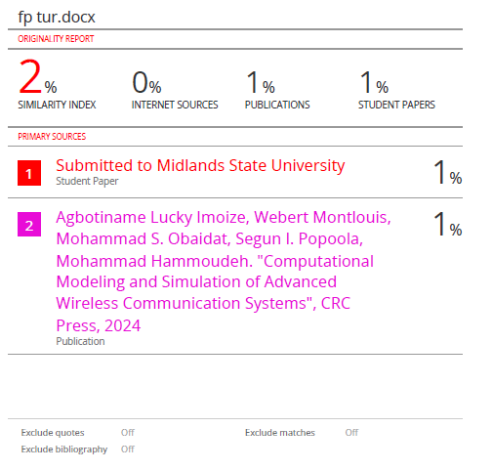

# TABLE OF CONTENT

HD in Computing & Software Engineering 2

TABLE OF CONTENT 13

TABLE OF FIGUERS 19

TABLE OF TABLES 23

Acknowledgment 25

SULOCHANA SALOON WEBSITE 26

01. Title Page 26

02. Introduction 27

Key Features 28

03. Problem Statement & Proposed Solution 28

04. Background Study 31

05. Literature Review 32

1. Existing Research on Digital Salon Management Systems 33

1.1 Appointment Scheduling Systems 33

1.2 Customer Data Management & CRM 33

1.3 Online Payments & Digital Transactions 33

1.4 Business Analytics & Performance Tracking 33

2. Comparison of Manual vs. Digital Salon Management Systems 34

3. Key Technologies in Modern Salon Management 34

3.1 Cloud Computing 34

3.2 Artificial Intelligence (AI) & Chatbots 35

3.3 Mobile Applications & Online Accessibility 35

3.4 Security Measures & Data Protection 35

4. The Role of Agile Development in Salon Systems 35

5. Proposed Solution & Contributions 36

06. Background Study 36

1. Existing Challenges in Salon Management: 36

2. Technological Advancements in Salon Management 37

3. Importance of an Automated Salon Management System 37

07. Justification of the Solution 37

08. Scope Coverage 40

1. Project Scope 40

a. Scope Coverage Breakdown 40

2. Functional Requirements 41

3. Non-Functional Requirements 43

09. Methodology & Technology 44

1. Methodology 44

o Why Choose Agile for Sulochana Salon Website? 44

a. Dynamic Requirements 45

b. Quick Time-to-Market 45

c. Flexibility 45

o Problems with Other Methodologies 45

a. Waterfall Methodology Issues 45

b. Hybrid Methodology Challenges 46

2. Agile Implementation Plan 46

3. Project Timeline 47

4. Benefits of Agile for Salon Website 47

a. Business Benefits 47

b. Technical Benefits 47

c. Operational Benefits 47

d. Success Metrics 48

10. Feasibility Study 48

a. Technical Feasibility 48

b. Economic Feasibility 48

c. Operational Feasibility 49

11. Risk Assessment 49

a. Technical Risks 49

b. Business Risks 49

12. Requirement Gathering 50

a. Questionnaires asked from Users 50

b. Answers for the Questionnaires asked from Users 59

c. Questionnaire asked from my client 70

1. Real-Time Appointment Booking 70

2. Service Selection 70

3. Stylist Selection 71

4. Booking Confirmation & Reminders 71

5. User Profile Management 71

6. Loyalty Program 71

7. Online Payments 71

8. Push Notifications 72

9. In-App Chat 72

10. Stylist Portfolio 72

11. Reviews & Feedback 72

12. Admin Dashboard 73

13. Technology Used for Sulochana Salon Website 73

a. Frontend 73

b. Backend 74

c. Development Tools 74

14. Justification for the Methodology (Agile) 74

15. Risks and Uncertainties 75

a. Technical Risks: 75

b. Business Risks: 75

c. Operational Risks: 75

d. Module Details 75

i. User Management Module: 75

ii. Appointment Management: 76

iii. Service Management: 76

iv. Notification System: 76

16. Testing Methodology and Justification 76

a. Testing Types: 76

17. Comprehensive Test Plan for Sulochana Salon System 77

1. Test Plan Summary 77

2. Client Side Test Cases 77

▪ Client Side Features Summary 77

➢ Client Side Detailed Test Cases 77

o C1. User Registration (TC-C101-C103) 77

o C2. User Login (TC-C104-C108) 82

o C3. Profile Management (TC-C109-C112) 84

o C4. Booking System (TC-C113-C117) 88

o C5. Appointment Tracking (TC-C118-C120) 91

o C6. Service Selection (TC-C121-C123) 97

o C7. Rating System (TC-C124-C126) 97

o C8-C9. Notifications (TC-C127-C130) 100

o C10. Email Verification (C- C131- C133) 103

o C11. Password Reset (C- C134- C137) 103

o C12. Reset Confirmation (C- C138- C139) 104

o C13. Current Password Verification (C-CP140-CP142) 104

C11. New Password Validation (C-CP143-CP146) 105

3. Admin Side Test Cases 108

▪ Admin Side Detailed Test Cases 108

o A1. Admin Login (TC-A101-A105) 108

o A2. Analytics & Reporting (TC-A106-A110) 111

o A3. Customer Management (TC-A111-A114) 113

o A4. Appointment Tracking (TC-A115-A118) 116

o A5. Stylist Management (TC-A119-A122) 120

o A6. Service Management (TC-A123-A126) 123

o A7. Pricing Management (TC-A127-A129) 127

o A8. Notifications (TC-A127-C130) 127

4. Test Conclusions 131

18. Co-functionalities Used Here 133

19. Hardware & Software Requirements 148

1. Hardware Requirements: 148

2. Software Requirements: 148

20. Observations and Review of Existing Systems for Salon Management 149

a. Strengths of Existing Systems: 149

21. Limitations of the Project 149

1. Limitations of Existing Systems 149

1.1 Complex User Interface 149

1.2 Limited Customization 149

1.3 Scalability Issues 150

2. Limitations of the Sulochana Salon Website 150

2.1 Internet Dependency 150

3 User Learning Curve 151

3.1 Scalability Challenges 151

4. Data Security & Privacy Concerns 152

22. Lessons Learned from the Project 153

1. Importance of Regular Feedback 153

Key Takeaways: 153

2. Agile Workflow & Iterative Development 153

Key Takeaways: 154

3. Security Focus & Data Protection 154

Key Takeaways: 154

4. Real-Time Updates & System Performance Optimization 155

Key Takeaways: 155

20. Resource Identification 155

a. Hardware Resources 155

b. Software Resources 155

c. Human Resources 156

21. Design of the system 157

a. Database 157

• ER Diagrams 157

• Normalized Relational Schema 158

Step 1: Understand the Entities and Attributes 158

Step 2: Normalization Steps 160

Step 3: Final Normalized Relational Schema 161

Completed Normalized Relational Schema 162

22. Future Recommendations 163

1. Product Sales & E-Commerce Integration 163

A. Why? 163

2. AI-Powered Chatbot for Customer Support 163

A. Why? 163

3. Mobile Application Integration 164

A. Why? 164

4. Real-Time Appointment Reminders & Notifications 165

A. Why? 165

5. Showing Available Time Slots for Clients 165

A. Why? 165

23. Gantt chart 166

# TABLE OF FIGUERS

Figure 1 27

Figure 2 - Requirement Gathering 50

Figure 3 - Requirement Gathering 51

Figure 4 - Requirement Gathering 52

Figure 5 - Requirement Gathering 53

Figure 6 - Requirement Gathering 54

Figure 7 - Requirement Gathering 55

Figure 8 - Requirement Gathering 56

Figure 9 - Requirement Gathering 57

Figure 10 - Requirement Gathering 58

Figure 11 - Requirement Gathering 58

Figure 12 - Requirement Gathering 59

Figure 13 - Requirement Gathering 59

Figure 14 - Requirement Gathering 60

Figure 15 - Requirement Gathering 60

Figure 16 - Requirement Gathering 61

Figure 17 - Requirement Gathering 61

Figure 18 - Requirement Gathering 62

Figure 19 - Requirement Gathering 62

Figure 20 - Requirement Gathering 63

Figure 21 - Requirement Gathering 63

Figure 22 - Requirement Gathering 64

Figure 23 - Requirement Gathering 64

Figure 24 - Requirement Gathering 65

Figure 25 - Requirement Gathering 65

Figure 26 - Requirement Gathering 66

Figure 27 - Requirement Gathering 66

Figure 28 - Requirement Gathering 67

Figure 29 - Requirement Gathering 67

Figure 30 - Requirement Gathering 68

Figure 31 - Requirement Gathering 68

Figure 32 - Requirement Gathering 69

Figure 33 - Requirement Gathering 69

Figure 34 - Requirement Gathering 70

Figure 35 78

Figure 36 79

Figure 37 80

Figure 38 81

Figure 39 82

Figure 40 83

Figure 41 84

Figure 42 85

Figure 43 85

Figure 44 86

Figure 45 86

Figure 46 87

Figure 47 87

Figure 48 89

Figure 49 89

Figure 50 90

Figure 51 91

Figure 52 92

Figure 53 93

Figure 54 94

Figure 55 94

Figure 56 95

Figure 57 95

Figure 58 96

Figure 59 96

Figure 60 97

Figure 61 98

Figure 62 99

Figure 63 99

Figure 64 100

Figure 65 101

Figure 66 102

Figure 67 102

Figure 68 106

Figure 69 106

Figure 70 107

Figure 71 107

Figure 72 108

Figure 73 109

Figure 74 110

Figure 75 110

Figure 76 111

Figure 77 112

Figure 78 112

Figure 79 113

Figure 80 114

Figure 81 114

Figure 82 115

Figure 83 115

Figure 84 117

Figure 85 117

Figure 86 118

Figure 87 119

Figure 88 119

Figure 89 120

Figure 90 121

Figure 91 122

Figure 92 122

Figure 93 123

Figure 94 124

Figure 95 124

Figure 96 125

Figure 97 125

Figure 98 126

Figure 99 126

Figure 100 127

Figure 101 129

Figure 102 129

Figure 103 130

Figure 104 131

Figure 105 131

Figure 106 134

Figure 107 134

Figure 108 135

Figure 109 136

Figure 110 137

Figure 111 138

Figure 112 139

Figure 113 139

Figure 114 140

Figure 115 140

Figure 116 141

Figure 117 141

Figure 118 142

Figure 119 143

Figure 120 144

Figure 121 144

Figure 122 145

Figure 123 145

Figure 124 146

Figure 125 147

Figure 126 147

Figure 127 148

Figure 128 - ER Diagrams 157

Figure 129 161

Figure 130 - Completed Normalized Relational Schema 162

Figure 131 - Gantt chart 166

Figure 132 - Gantt chart 167

# TABLE OF TABLES

Table 1 34

Table 2 41

Table 3 42

Table 4 43

Table 5 44

Table 6 77

Table 7 77

Table 8 78

Table 9 83

Table 10 84

Table 11 88

Table 12 92

Table 13 97

Table 14 98

Table 15 101

Table 16 103

Table 17 104

Table 18 104

Table 19 105

Table 20 105

Table 21 109

Table 22 111

Table 23 113

Table 24 116

Table 25 120

Table 26 123

Table 27 127

Table 28 128

Table 29 155

Table 30 156

Table 31 156

# Acknowledgment

We would like to express our sincere gratitude to our campus lecturer, Mr. Chathura, for invaluable guidance and support throughout our academic journey. His passion for teaching and dedication to his students have been a constant source of inspiration for us. We are grateful for his patience and willingness to go beyond to ensure that we understood the course material. Their feedback and constructive criticism have helped us to improve our academic performance and critical thinking skills. We would also like to thank the ICBT Campus for providing us with a supportive and stimulating learning environment. Finally, we would like to acknowledge our family and friends for their unwavering encouragement and motivation. Thank you all for being a part of my academic success.

# SULOCHANA SALOON WEBSITE

# Title Page

* Proposed System: Sulochana Saloon Appointment and Management website
* Prepared by: Upetha Laksiluni
* Saloon Name: Sulochana Saloon, Makola
* Saloon Owner: Sulochana

# Introduction



Figure 1

The Salon Management System is a modern, user-friendly web application designed to streamline salon operations and enhance the overall customer experience. This system provides an intuitive interface for clients to book appointments, manage profiles, receive notifications, and submit feedback. Simultaneously, it equips salon administrators with powerful tools to manage appointments, services, staff, customer interactions, and business analytics.

With a seamless integration of frontend and backend technologies, the system ensures real-time updates, secure authentication, and an efficient workflow. Clients can easily browse services, select their preferred stylist, and receive appointment reminders, while the admin panel enables salon owners to optimize operations, track revenue, and engage with customers.

## Key Features

1. Client Portal: User registration, profile management, appointment scheduling, and feedback submission.
2. Admin Dashboard: Real-time analytics, appointment approvals, service and staff management, and revenue tracking.
3. Notification System: Instant alerts for bookings, feedback, and appointment status updates.
4. Secure Authentication: Login, password reset, and session management.
5. User-Friendly Interface: Aesthetic and responsive design for an engaging experience.

# **Problem Statement & Proposed Solution**

* + - 1. **Problem: Inefficient Appointment Booking Process**
* **Description:**   
  Many salons still rely on manual appointment scheduling, leading to overbooking, missed appointments, and miscommunication between clients and staff. Clients often face difficulty in selecting their preferred services and stylists due to lack of availability updates.
* **Proposed Solution:**  
  The **Salon Management System** offers an **automated appointment booking feature**, where clients can:
  + Choose services from an interactive menu.
  + View available time slots and book appointments in real time.
  + Select their preferred stylist and provide special instructions.
  + Receive instant booking confirmation and reminders.
  + This ensures a seamless, efficient, and error-free booking experience, reducing staff workload and improving client satisfaction.
    - 1. **Problem: Lack of Centralized Customer Data Management**
* **Description:**   
  Traditional record-keeping methods make it difficult to maintain a database of customer preferences, booking history, and feedback. This results in poor personalization and ineffective customer engagement.
* **Proposed Solution:**  
  The system provides a **centralized client profile management module**, allowing customers to:
  + View and update their personal details.
  + Track their appointment history.
  + Change passwords and manage authentication securely.
  + Receive targeted offers and recommendations based on past services.
  + This enhances the salon's ability to deliver a **personalized customer experience**, improving retention and engagement.
    - 1. **Problem: Manual Notifications & Communication Delays**
* **Description:**   
  Salon staff often struggle with manually informing customers about appointment confirmations, cancellations, or changes. This can cause delays, miscommunication, and customer dissatisfaction.
* **Proposed Solution:**  
  A **real-time notification system** is integrated to:
  + Send instant alerts for appointment confirmations, rejections, or cancellations.
  + Notify clients about upcoming appointments via email and dashboard alerts.
  + Allow admin to send promotional messages and offers to clients.
  + This **automated system improves communication**, ensuring clients stay informed without the need for manual intervention.
    - 1. **Problem: Difficulty in Managing Services & Pricing**
* **Description:**   
  Manually updating service lists and pricing can be time-consuming and prone to errors, leading to inconsistencies in service availability and billing.
* **Proposed Solution:**  
  The system includes an **Admin Service Management module**, allowing salon managers to:
  + Easily add, edit, or remove services.
  + Categorize services for better organization.
  + Update pricing dynamically and reflect changes in real time.
  + Set up promotional discounts or seasonal offers.
  + This **streamlines service management**, reducing errors and ensuring accurate pricing and availability.
    - 1. **Problem: Inefficient Staff & Stylist Management**
* **Description:**   
  Salon managers often face challenges in tracking stylist availability, performance, and workload distribution, leading to scheduling conflicts and customer dissatisfaction.
* **Proposed Solution:**  
  The **Staff Management module** helps administrators to:
  + Add and manage stylist profiles.
  + Set and update availability schedules.
  + Assign stylists to appointments based on workload.
  + Track stylist performance and customer feedback.
  + This enhances **workforce efficiency** and ensures customers receive services from their preferred stylists without scheduling conflicts.
    - 1. **Problem: Lack of Data-Driven Insights & Business Analytics**
* **Description:**   
  Salons often lack the ability to track revenue, analyze appointment trends, and measure customer retention, making strategic planning difficult.
* **Proposed Solution:**  
  The **Admin Dashboard** provides:
  + **Analytics on revenue, bookings, and customer trends.**
  + **Real-time reports** on salon performance.
  + **Customer statistics**, including frequent visitors and popular services.
  + **Insights into peak hours and demand forecasting.**
  + This empowers salon owners with **data-driven decision-making**, optimizing business operations and maximizing profitability.
    - 1. **Problem: Inadequate Feedback & Review System**
* **Description:**   
  Many salons struggle to collect and analyze customer feedback, leading to missed opportunities for service improvement.
* **Proposed Solution:**  
  The **Feedback System** allows:
  + Clients to **rate services** and leave comments.
  + Admin to **view and filter feedback** based on ratings and keywords.
  + Performance-based decision-making for service and staff improvements.
  + By integrating this **structured feedback system**, salons can continuously improve their services and customer satisfaction.
    - 1. **Problem: Security & Data Privacy Concerns**
* **Description:**   
  Without a robust authentication system, customer data and payment details may be vulnerable to security breaches.
* **Proposed Solution:**  
  The system incorporates **secure authentication and data protection mechanisms** such as:
  + **Role-based access control (RBAC)** for clients, staff, and admins.
  + **Secure password hashing** to protect credentials.
  + **SSL encryption** for safe data transmission.
  + **Regular database backups** to prevent data loss.
  + This ensures **a high level of security** for both clients and administrators, protecting sensitive data.

# Background Study

The salon industry has increasingly embraced digital transformation to enhance customer experience and streamline operations. Traditional salon management relies heavily on manual booking systems, phone-based reservations, and in-person consultations, which can lead to inefficiencies and scheduling conflicts. The rise of online booking systems has revolutionized salon businesses by providing customers with the convenience of scheduling appointments at any time, selecting preferred services, and choosing their favorite stylists.

Furthermore, salons require an effective customer relationship management (CRM) system to maintain records of frequent clients, their service preferences, and feedback. The integration of digital solutions has proven to increase customer retention, reduce administrative workload, and boost operational efficiency. Many modern salons have also started leveraging automated notification systems for appointment reminders and promotional campaigns to enhance customer engagement.

Given the rapid growth of the beauty and wellness industry, developing a robust and interactive salon management system is essential to stay competitive. The **proposed website** will serve as a **comprehensive solution** that caters to both customers and salon administrators, ensuring seamless appointment management, service tracking, and client interaction.

# Literature Review

* The evolution of **salon management systems** has been driven by the increasing need for **efficiency, automation, and customer engagement** in the beauty and wellness industry. Traditional salon management relied on **manual booking, paper-based records, and in-person appointment scheduling**, which often resulted in **errors, double bookings, and inefficient customer service**. Salons faced challenges in keeping track of customer preferences, service histories, and appointment schedules. These inefficiencies led to **customer dissatisfaction, missed appointments, and increased administrative workload** for salon owners and staff.
* With **advancements in web-based technologies, cloud computing, and mobile applications**, modern salon management systems now offer **automated scheduling, customer relationship management (CRM), real-time notifications, and business analytics**. These systems **improve salon operations, reduce human errors, and provide a more convenient experience for customers**. Additionally, integrating **online payment gateways, AI-driven customer engagement, and mobile-friendly interfaces** has revolutionized the way salons interact with their clients. The following sections explore existing research, technology trends, and comparisons between **manual and digital salon management systems**.

## **Existing Research on Digital Salon Management Systems**

Several studies and reports have explored the benefits of integrating **technology into salon management**. Research indicates that **modern digital systems significantly enhance efficiency, customer satisfaction, and revenue generation**. Below are some key areas where digital transformation has improved salon operations:

### **Appointment Scheduling Systems**

Traditional appointment booking methods relied on **phone calls, walk-ins, and manual registers**, leading to **overbooking, scheduling conflicts, and long wait times**. Research suggests that **automated booking systems** reduce **waiting times, optimize stylist availability, and prevent last-minute cancellations**. Modern **online scheduling platforms** allow customers to **view available time slots in real-time, select their preferred stylist, and receive instant booking confirmations**.

### **Customer Data Management & CRM**

Customer Relationship Management (CRM) systems play a crucial role in **improving customer retention and personalization**. Studies show that salons that use **CRM solutions** can track **customer appointment histories, preferences, and feedback**, enabling them to offer **personalized recommendations**. Digital systems **store and analyze** customer data, helping salons send **personalized promotions, loyalty rewards, and targeted service recommendations**.

### **Online Payments & Digital Transactions**

The integration of **secure payment gateways** like **PayPal, Stripe, Visa, and MasterCard** has transformed the salon industry by offering **cashless, hassle-free transactions**. Research shows that customers prefer **online payment methods,** as they are **faster, safer, and more convenient** than handling cash or manual invoicing. Many **modern salon management systems** now include **prepaid booking options, automatic invoicing, and promotional discount codes**, encouraging **higher customer retention rates**.

### **Business Analytics & Performance Tracking**

One of the biggest advantages of digital salon management is **data-driven decision-making**. Research highlights that **salon owners benefit from analytics tools that track revenue, customer trends, appointment cancellations, and stylist performance**. Built-in analytics dashboards allow **owners to make strategic decisions, optimize pricing, and identify peak booking times**. By leveraging **big data and business intelligence tools**, salons can **increase profitability and improve operational efficiency**.

## **Comparison of Manual vs. Digital Salon Management Systems**

Many salons **still operate using traditional methods**, but transitioning to **digital systems** offers numerous advantages. The table below highlights the **differences between manual and digital management approaches**:

|  |  |  |
| --- | --- | --- |
| **Feature** | **Manual Salon Management** | **Digital Salon Management** |
| **Appointment Booking** | Phone calls, walk-ins, and handwritten logs. | Online booking with real-time availability. |
| **Customer Management** | Paper records with limited customer history. | Centralized database storing customer details, preferences, and past appointments. |
| **Notifications** | Staff manually contacts clients. | Automated SMS, email, and in-app notifications for bookings and promotions. |
| **Payment Processing** | Cash transactions and manual invoices. | Online payments with instant invoices and payment tracking. |
| **Business Insights** | Difficult to track revenue and customer trends. | Built-in analytics for revenue, customer behavior, and staff performance. |

Table 1

From the comparison, it is evident that **digital salon management** not only **reduces operational workload** but also **enhances customer experience, minimizes human errors, and optimizes revenue generation**.

## **Key Technologies in Modern Salon Management**

Technological advancements have **redefined salon operations** by providing efficient, **cloud-based, AI-driven, and mobile-friendly** solutions. The following technologies are commonly used in **modern salon management systems**:

### **Cloud Computing**

Cloud-based salon management systems **enable remote data access**, allowing salon owners and staff to **manage bookings, payments, and customer interactions from anywhere**. Cloud storage **reduces dependency on physical records, minimizes data loss, and improves operational flexibility**.

### **Artificial Intelligence (AI) & Chatbots**

AI is revolutionizing salon management by offering **personalized recommendations** and **automated chatbot services**. AI-powered chatbots can:

* **Handle appointment bookings** via live chat.
* **Answer customer inquiries** instantly.
* **Provide personalized service suggestions** based on customer history.

### **Mobile Applications & Online Accessibility**

With **65%+ of salon bookings** now made through mobile devices, having a **mobile-friendly salon management system** is crucial. Many modern platforms now provide **dedicated mobile applications** that allow users to **book services, receive real-time notifications, and make cashless payments conveniently**.

### **Security Measures & Data Protection**

Security is a **critical concern** in digital systems. Advanced **role-based access control (RBAC)**, **SSL encryption**, and **secure authentication methods** protect **customer data, payment details, and business information**. Regular **security audits and compliance with data protection regulations (e.g., GDPR)** ensure customer trust and data integrity.

## **4. The Role of Agile Development in Salon Systems**

Agile methodology is widely used in **modern salon management software development** due to its flexibility and **incremental feature delivery approach**. Key benefits of Agile for salon management systems include:

* **Faster Response to Changing Requirements** – New features like **promotional campaigns, loyalty programs, or service updates** can be implemented **quickly and efficiently**.
* **Continuous Testing & Improvement** – Agile ensures that **each feature is tested thoroughly before deployment**, reducing bugs and improving performance.
* **Seamless Feature Integration** – New functionalities such as **gift cards, referral programs, and stylist reviews** can be added progressively without disrupting existing operations.

## **Proposed Solution & Contributions**

The **Sulochana Salon Management System** is designed to address common industry challenges by incorporating the following key features:

* **Automated Booking & Real-Time Scheduling** – Customers can **view available slots, book services instantly, and receive confirmation notifications**.
* **User-Friendly Client & Admin Dashboards** – The system provides **a clean, intuitive interface for both customers and salon staff** to manage appointments efficiently.
* **Secure Authentication & Customer Data Protection** – Implements **role-based access control (RBAC), password encryption, and SSL security protocols** to ensure **data privacy and security**.
* **Business Analytics & Revenue Tracking** – Owners can **monitor revenue, track customer trends, and analyze staff performance** using built-in dashboards and reports.
* **AI-Powered Chatbot & Personalized Recommendations** – Enhances **customer engagement** by **automating inquiries and suggesting services based on customer history**.

# Background Study

The salon industry has evolved significantly with technological advancements, yet many salons still rely on outdated methods for managing appointments, customer records, and business operations. Traditional paper-based or manual booking systems lead to inefficiencies such as scheduling conflicts, overbookings, missed appointments, and lack of proper customer data management. To address these challenges, digital salon management systems have emerged as a crucial solution.

## Existing Challenges in Salon Management:

1. Manual Appointment Booking:
   1. Many salons still rely on phone calls or walk-ins, leading to appointment clashes and scheduling difficulties.
   2. Customers have limited visibility into stylist availability.
2. Lack of Centralized Customer Data:
   1. Traditional methods make it hard to track customer preferences, appointment history, and feedback.
   2. Salons struggle to offer personalized services without proper data management.
3. Inefficient Communication & Notifications:
   1. Without an automated notification system, customers may forget appointments.
   2. Salon staff must manually call or message clients, leading to inefficiencies.
4. Limited Business Insights & Analytics:
   1. Many salons lack real-time analytics to track appointment trends, revenue, and stylist performance.
   2. Without data-driven decision-making, service improvements and marketing strategies are less effective.

## Technological Advancements in Salon Management

Modern digital solutions leverage web-based platforms to provide a seamless and automated experience for both clients and salon administrators. With features like online booking, automated notifications, real-time analytics, and secure data management, these systems improve efficiency, reduce manual work, and enhance customer satisfaction.

## Importance of an Automated Salon Management System

A digital Salon Management System aims to eliminate inefficiencies by offering:

* Online Booking System for easy appointment scheduling.
* Real-time Notifications to keep customers and staff informed.
* Centralized Customer Profiles to store preferences, history, and feedback.
* Business Analytics Dashboard for revenue tracking and performance evaluation.

# Justification of the Solution

The Salon Management System is designed to address the inefficiencies and challenges faced by traditional salon operations. Below is a detailed justification for why this solution is necessary and beneficial for both clients and salon administrators.

Automation of Appointment Booking

* Justification:

1. Traditional phone-based or walk-in bookings result in scheduling conflicts, long wait times, and double bookings.
2. Clients need real-time access to available slots and stylists without manual intervention.

* Why This Solution Works:
  1. Online booking system eliminates scheduling conflicts.
  2. 24/7 accessibility, allowing clients to book appointments anytime.
  3. Automatic confirmations and reminders reduce no-shows.

Centralized Customer Data Management

* Justification:

1. Manual record-keeping lacks organization, making it hard to track customer preferences, appointment history, and special requests.
2. A centralized database ensures quick access to client history, improving service personalization.

* Why This Solution Works:
  1. Stores customer profiles, appointment history, and preferences securely.
  2. Enables targeted promotions based on past visits.
  3. Improves customer retention through personalized recommendations.

Real-Time Notifications and Reminders

* Justification:

1. Customers often forget appointments due to lack of reminders, leading to wasted time slots and lost revenue.
2. Salons need instant communication channels to update clients about bookings and promotions.

* Why This Solution Works:
  1. Automated SMS and email alerts ensure timely reminders.
  2. Reduces last-minute cancellations and no-shows.
  3. Enhances customer engagement with promotional notifications.

Efficient Service & Pricing Management

* Justification:

1. Manually updating services and pricing is prone to errors and inconsistencies.
2. Clients need clear, updated service lists with pricing transparency.

* Why This Solution Works:

1. Admins can easily add, edit, or remove services in real-time.
2. Dynamic pricing updates reflect instantly across the system.
3. Categorized service lists improve customer navigation.

Enhanced Staff & Stylist Management

* Justification:

1. Salons face challenges in managing stylist availability and workload.
2. Customers prefer selecting their preferred stylist, which requires an organized scheduling system.

* Why This Solution Works:

1. Staff availability tracking prevents overbooking.
2. Performance analytics help in evaluating stylist efficiency.
3. Clients can choose preferred stylists, enhancing satisfaction.

Business Analytics & Reporting for Decision-Making

* Justification:

1. Salons need real-time business insights to track revenue, popular services, and customer trends.
2. Data-driven decision-making is essential for growth and profitability.

* Why This Solution Works:
  1. Graphical reports and dashboards provide actionable insights.
  2. Identifies peak booking hours and high-demand services.
  3. Helps in strategic business planning and marketing.

Secure Authentication & Role-Based Access Control

* Justification:

1. Customer and business data security is crucial to prevent unauthorized access and data breaches.
2. Traditional systems lack robust authentication and access control measures.

* Why This Solution Works:

1. Role-based access control (RBAC) ensures secure data handling.
2. Encrypted password storage protects user credentials.
3. Regular backups and security protocols safeguard business data.

# **Scope Coverage**

## **Project Scope**

The **Salon Management System** is designed to automate and streamline salon operations, including **appointment booking, service management, staff scheduling, customer management, and business analytics**. The system provides a **user-friendly interface** for clients, while administrators can manage services, bookings, and business insights.

### **Scope Coverage Breakdown**

|  |  |
| --- | --- |
| **Scope Area** | **Description** |
| **User Management** | Customers can register, log in, manage profiles, and book services. Admins can manage users, assign roles, and track client interactions. |
| **Appointment Booking** | Clients can schedule, reschedule, or cancel appointments with real-time availability tracking. |
| **Service Management** | Admins can add, update, categorize, and manage salon services with dynamic pricing. |
| **Stylist & Staff Management** | Admins can manage stylist schedules, track performance, and assign bookings. |
| **Notification System** | Automated notifications for appointment confirmations, cancellations, reminders, and promotions. |
| **Feedback & Reviews** | Clients can submit feedback and rate services, while admins can track and analyze reviews. |
| **Business Analytics** | Dashboard analytics for revenue tracking, customer trends, and stylist performance. |
| **Security & Authentication** | Role-based access control (RBAC), encrypted login, and secure payment integration. |

Table 2

## **Functional Requirements**

The system is divided into **features and their corresponding functional requirements** that ensure smooth operation.

**Feature & Functional Requirements Table**

|  |  |  |
| --- | --- | --- |
| **Feature** | **Functional Requirement** | **Description** |
| **User Authentication** | User Registration | Clients can register with email and password authentication. |
|  | User Login | Secure login with encrypted credentials. |
|  | Password Recovery | Users can reset their password via email verification. |
|  | Role-Based Access | Different access levels for clients, stylists, and admins. |
| **Appointment Booking** | Online Booking | Clients can schedule appointments by selecting services, stylists, and available time slots. |
|  | Modify Appointment | Clients can reschedule or cancel appointments as per salon policy. |
|  | Availability Check | Real-time checking of stylist and service availability. |
|  | Confirmation & Reminders | Automatic notifications for confirmations and upcoming appointments. |
| **Service Management** | Add/Edit Services | Admins can add, edit, or remove salon services. |
|  | Categorization | Services are grouped into categories (e.g., Haircuts, Facials, Manicure). |
|  | Dynamic Pricing | Admins can update service prices dynamically. |
| **Stylist & Staff Management** | Add/Edit Staff | Admins can manage stylist profiles and availability. |
|  | Assign Appointments | Automatically or manually assign appointments to stylists. |
|  | Performance Monitoring | Admins can track stylist ratings and customer feedback. |
| **Notification System** | Appointment Alerts | Clients receive confirmation, reminders, and cancellation alerts. |
|  | Promotional Notifications | Admins can send offers, discounts, and updates to clients. |
| **Feedback & Review System** | Submit Reviews | Clients can provide service ratings and feedback. |
|  | View Feedback | Admins can filter and analyze client reviews. |
| **Business Analytics** | Revenue Reports | Admins can track salon revenue and monthly earnings. |
|  | Customer Insights | Track customer retention, visit frequency, and popular services. |
|  | Staff Performance | Monitor stylist efficiency and customer satisfaction. |
| **Security & Payment Integration** | Secure Login | Encrypted authentication to prevent unauthorized access. |
|  | Role-Based Access | Limits access based on user roles (client, admin, stylist). |
|  | Payment Processing | Integration with online payment gateways for prepaid bookings. |

Table 3

## **Non-Functional Requirements**

These requirements define the **system performance, security, and usability** aspects.

|  |  |
| --- | --- |
| **Requirement** | **Description** |
| **Performance** | The system should handle **multiple concurrent bookings** without lag. |
| **Usability** | The UI/UX design should be **intuitive and easy to navigate** for all user types. |
| **Scalability** | The system should be able to handle an **increasing number of users and bookings** without performance issues. |
| **Security** | Implements **SSL encryption, hashed passwords, and role-based access control (RBAC)** for secure data handling. |
| **Availability** | The system should have **99.9% uptime**, ensuring constant accessibility for clients and admins. |
| **Maintainability** | Code should be **modular and well-documented** to allow easy updates and feature additions. |
| **Compatibility** | The web application should be **responsive and work on desktops, tablets, and mobile devices**. |
| **Backup & Recovery** | The system should include **automated database backups** to prevent data loss. |
| **Integration** | Should support **third-party APIs** for SMS notifications, payment gateways, and email alerts. |

Table 4

**4. Justification for the Selected Scope**

The selected scope is justified based on the **current industry challenges and technological advancements**.

|  |  |
| --- | --- |
| **Scope Area** | **Justification** |
| **Online Booking** | Automates appointment scheduling, reducing manual errors and improving efficiency. |
| **Real-Time Notifications** | Keeps clients informed, reducing no-shows and enhancing customer engagement. |
| **Customer Profiles** | Enables personalized services based on client history and preferences. |
| **Service & Pricing Management** | Ensures service offerings are updated dynamically and accurately. |
| **Business Analytics** | Data-driven insights help in strategic decision-making and improving salon performance. |
| **Role-Based Security** | Prevents unauthorized access, ensuring customer data privacy and secure transactions. |
| **Multi-Platform Support** | Ensures the system works seamlessly on different devices (PC, tablet, mobile). |

Table 5

# Methodology & Technology

## Methodology

### Why Choose Agile for Sulochana Salon Website?

#### Dynamic Requirements

One of the main reasons to choose Agile methodology for the Sulochana Salon website is the inherent flexibility it offers in handling dynamic and evolving requirements. In the beauty and salon industry, customer preferences and business operations can change quickly. For example, a salon might need to update the list of services offered, change booking schedules, or introduce new promotional offers. Agile allows the development team to respond swiftly to these changes by adjusting features and functionalities based on real-time feedback from clients and salon staff. Unlike other methodologies, Agile enables the team to prioritize features according to immediate business needs, allowing the most critical aspects like the appointment booking system—to be implemented and delivered early in the project.

#### Quick Time-to-Market

Agile’s iterative development process leads to quicker releases and faster delivery of key features. With the salon website, basic features such as user registration and appointment booking can be released early, followed by more advanced features like staff management and analytics. This approach ensures that the most essential services are available to customers quickly, which is crucial for maintaining business continuity and meeting client demands. Agile’s sprint-based methodology, where development happens in two-week cycles, allows for a continuous release of updates, keeping the site evolving according to the latest business needs and customer feedback.

#### Flexibility

Agile’s flexible planning makes it an ideal choice for a project like the Sulochana Salon website. As the development progresses, the team can adapt to changing requirements based on feedback from users, business stakeholders, or external factors like industry trends. This adaptability ensures that the website remains relevant and functional throughout its lifecycle. Additionally, Agile's emphasis on scalability makes it easy to incorporate new services or enhance existing ones in the future. Agile also provides a quick resolution for bugs or issues as they arise, ensuring minimal downtime and a smoother user experience.

### Problems with Other Methodologies

#### Waterfall Methodology Issues

In contrast to Agile, the Waterfall methodology presents several challenges for dynamic projects like a salon website. Waterfall follows a linear, sequential development process, which means that once the requirements are set at the beginning of the project, it becomes difficult and costly to modify them later. If a client requests changes to the booking system after significant development has been completed, it could lead to project delays and additional costs. Furthermore, Waterfall typically doesn’t allow for continuous feedback from the end users until the very end of the project, which risks delivering a final product that may not fully meet user expectations or business goals. This delayed feedback loop could result in functionality that customers don't find helpful or relevant, leading to dissatisfaction.

#### Hybrid Methodology Challenges

While Hybrid methodologies attempt to combine the strengths of both Waterfall and Agile, they also introduce complexities that may not be ideal for this type of project. The complexity of managing two different approaches can increase project overhead, as the team needs to balance the rigid structure of Waterfall with the flexibility of Agile. Additionally, the documentation requirements in Hybrid models can become overwhelming, causing unnecessary delays. Resource management in a Hybrid approach can also become difficult, as it is not always clear when to apply Waterfall’s structured stages versus Agile’s adaptive cycles. This confusion can slow down the development process and hinder team collaboration.

## Agile Implementation Plan

* 1. Sprint 1: Core Features

In the first two-week sprint, the development team will focus on building essential features like user authentication (registration, login), basic appointment booking, and a service catalog. These foundational features ensure that customers can easily navigate the site and schedule appointments. By prioritizing core functionalities first, Agile allows the team to get the basic site up and running, with room for refinement in future sprints.

* 1. Sprint 2: Admin Features

The second sprint will focus on building out administrative features, including an admin dashboard for managing appointments, staff, and services. These features are essential for salon staff to efficiently track customer appointments and manage their schedules. The admin section is critical for salon operations, and delivering these features early will allow staff to familiarize themselves with the system and provide feedback on improvements.

* 1. Sprint 3: Advanced Features

In later sprints, more advanced features such as notification systems, ratings and feedback mechanisms, and report generation will be added. These features enhance customer engagement and improve the operational efficiency of the salon. Through iterative releases, Agile ensures that features are added and refined progressively, keeping the development process responsive to real-world use and feedback.

## Project Timeline

The Sulochana Salon website will be developed in three main phases, with each phase aligned with Agile sprints. The first month will be dedicated to gathering requirements, establishing the basic architecture, and developing core features. The second month will focus on implementing advanced features and testing, while the third month will include final testing, user training, and deployment. This timeline allows for continuous improvement and feature release, ensuring that the website meets the salon’s needs at every stage of development.

## Benefits of Agile for Salon Website

### Business Benefits

Agile offers significant business benefits, including a faster launch of essential features, allowing the salon to start receiving bookings quickly. Regular updates and improvements based on customer and staff feedback ensure that the site remains aligned with evolving business goals. These updates also contribute to higher user satisfaction, as features are continuously refined and optimized.

### Technical Benefits

From a technical perspective, Agile’s continuous testing and iterative approach lead to better-quality code and fewer bugs in the final product. The ability to adapt to new requirements during development reduces the chances of delivering a product that doesn’t meet the salon’s needs. Additionally, Agile's continuous integration practices ensure that the website can be updated frequently without disrupting operations.

### Operational Benefits

Operationally, Agile ensures that salon staff can efficiently use the new system as it is rolled out incrementally. Agile’s focus on user feedback also helps improve customer interactions, providing a smoother booking experience. Regular updates and improvements mean that the salon’s operations can evolve without major disruptions, leading to enhanced staff productivity and customer satisfaction.

### Success Metrics

To gauge the success of the project, various metrics will be tracked, such as user adoption rates (number of online bookings), business performance (reduced no-shows, increased bookings), and technical performance (system uptime, response times). These metrics will help the team ensure that the website is meeting its objectives and contributing to the salon’s growth.

In conclusion, Agile methodology is ideal for the Sulochana Salon website due to its flexibility, rapid delivery, and ability to continuously improve based on user feedback. By choosing Agile, the development team can ensure that the project remains aligned with business goals while delivering a high-quality, user-friendly website.

# Feasibility Study

## Technical Feasibility

The technical feasibility of building the Sulochana Salon website using Agile is very high. The website can be hosted on common web server platforms such as Apache or Nginx, and the database can be managed using MySQL, a reliable and widely used relational database system. Development tools like Visual Studio Code for coding and Git for version control will facilitate smooth collaboration among team members. With these readily available tools and platforms, there is no significant technical barrier to using Agile for this project. Moreover, Agile’s ability to deliver incremental progress aligns well with the technical capabilities of these systems, ensuring that features can be tested and deployed quickly without major infrastructure changes.

## Economic Feasibility

The economic feasibility of the Sulochana Salon website project under Agile is also favorable. The team will consist of professionals whose combined salaries, development tools, and software licenses will constitute the primary costs. However, Agile’s iterative nature reduces the risk of overspending because the project is divided into smaller, manageable phases. By regularly assessing the value of features through feedback and prioritizing based on business needs, Agile ensures that the investment is aligned with immediate business objectives, leading to higher ROI. The long-term benefits, such as reduced manual effort for appointment management and improved customer satisfaction, contribute to cost savings and increased revenue opportunities.

## Operational Feasibility

Operationally, the Agile approach to developing the salon website allows for seamless integration into the salon’s daily operations. Staff training, system maintenance, and ongoing user support are all streamlined under Agile, as features are incrementally introduced and tested. As the system is refined, salon staff can gradually adopt new features without overwhelming them with a complete system overhaul. This method reduces the chances of resistance to new technology, as staff and customers will be familiar with each new feature as it becomes available. Agile’s iterative updates also ensure that the website remains aligned with operational goals, helping the salon stay competitive and efficient.

# Risk Assessment

## Technical Risks

Several technical risks could arise during the project, including integration challenges between various components, third-party services, and potential performance issues with the database. However, Agile’s emphasis on continuous testing and iteration will help mitigate these risks by addressing problems early in the development process.

## Business Risks

On the business side, risks include user adoption challenges, particularly with salon staff who may be resistant to new technology. However, Agile's incremental delivery ensures that staff members are gradually introduced to new features, reducing the risk of resistance. Additionally, the flexibility of Agile allows the development team to address issues that arise from real-world usage quickly, ensuring smooth business operations.

# Requirement Gathering

## Questionnaires asked from Users

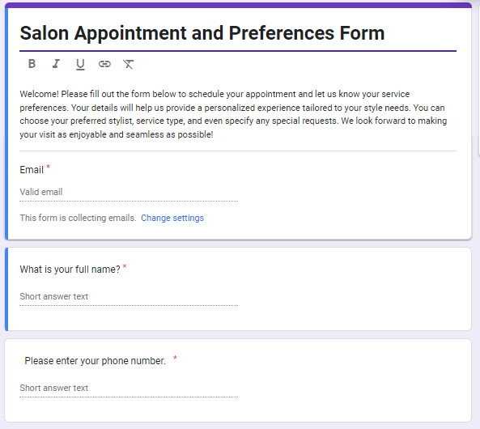

Figure 2 - Requirement Gathering

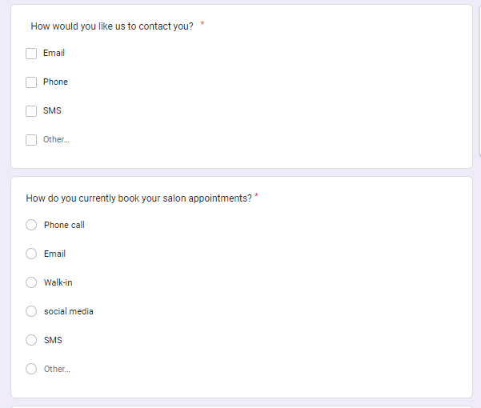

Figure 3 - Requirement Gathering

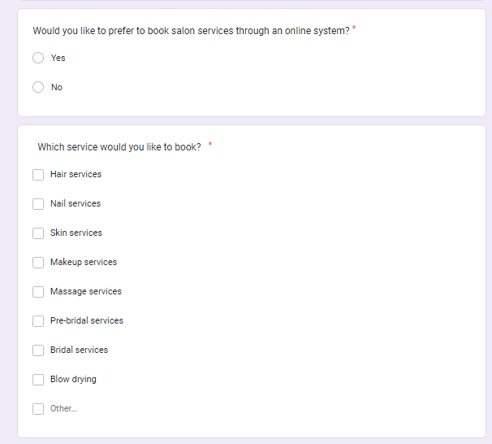

Figure 4 - Requirement Gathering

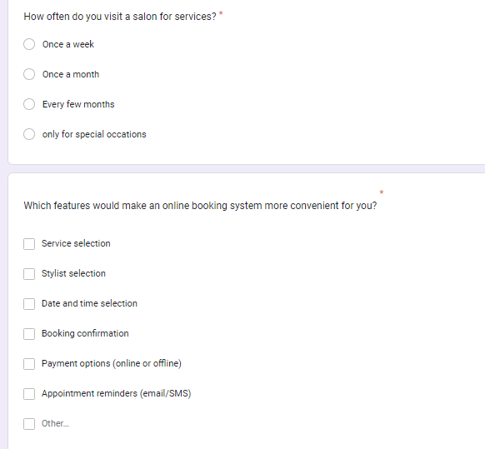

Figure 5 - Requirement Gathering

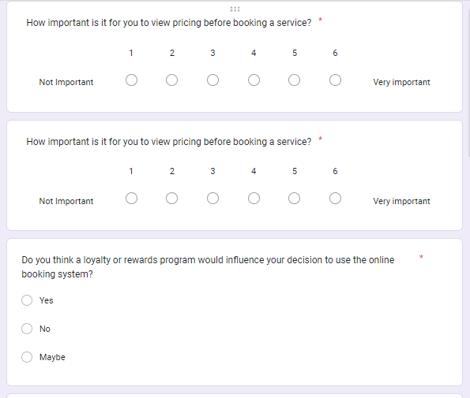

Figure 6 - Requirement Gathering

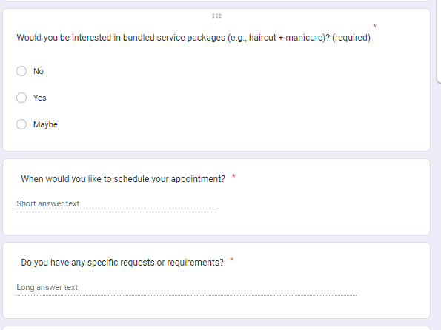

Figure 7 - Requirement Gathering

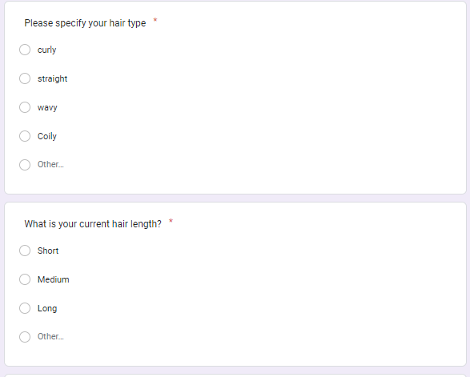

Figure 8 - Requirement Gathering

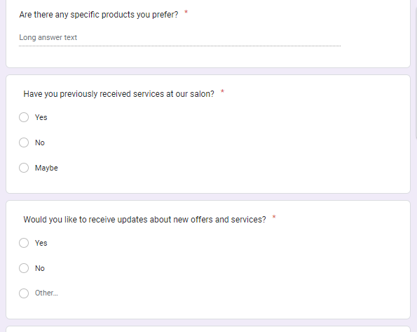

Figure 9 - Requirement Gathering

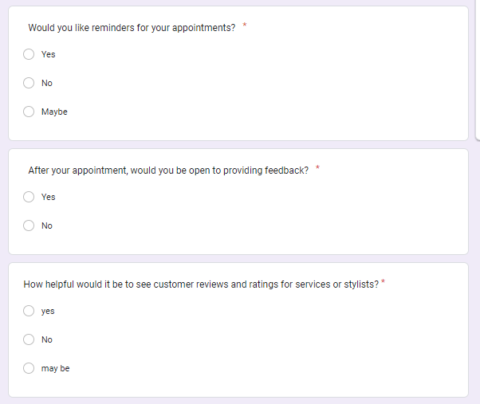

Figure 10 - Requirement Gathering

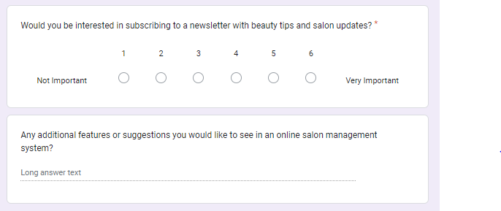

Figure 11 - Requirement Gathering

## Answers for the Questionnaires asked from Users

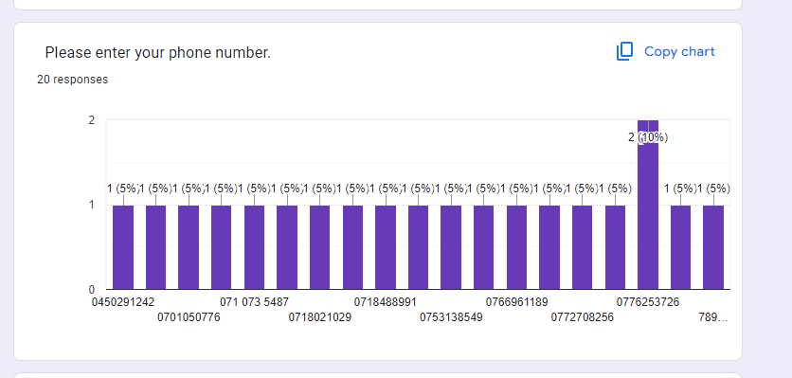

Figure 12 - Requirement Gathering

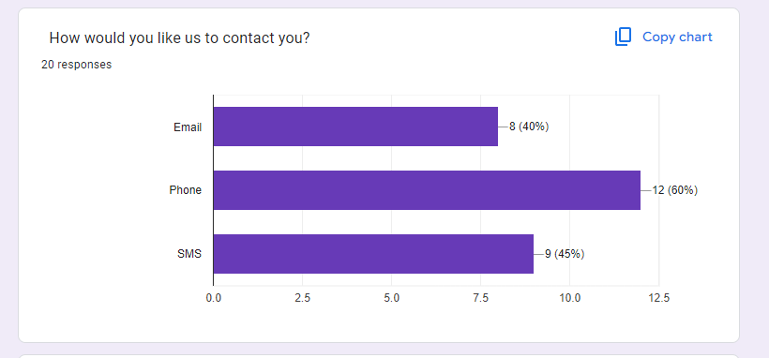

Figure 13 - Requirement Gathering

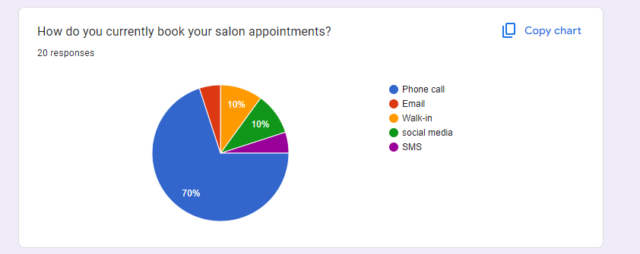

Figure 14 - Requirement Gathering

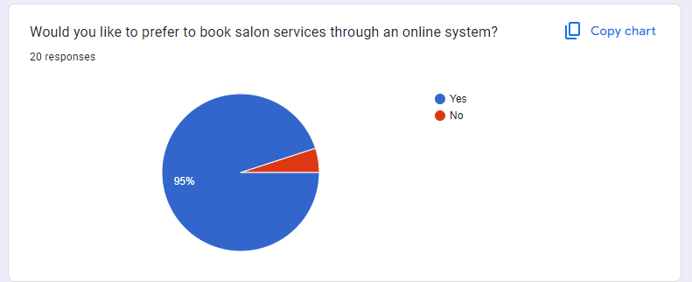

Figure 15 - Requirement Gathering

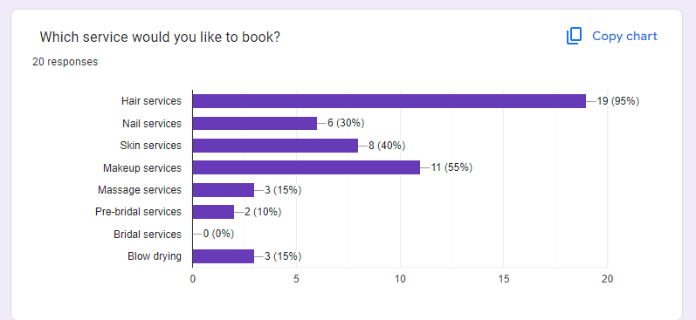

Figure 16 - Requirement Gathering

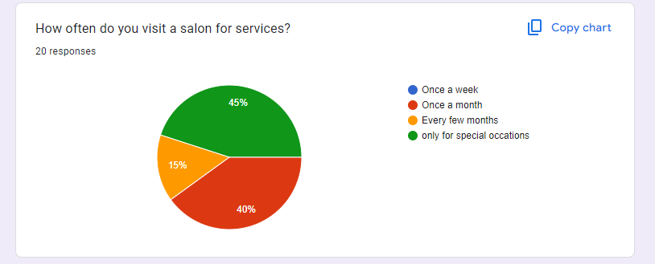

Figure 17 - Requirement Gathering

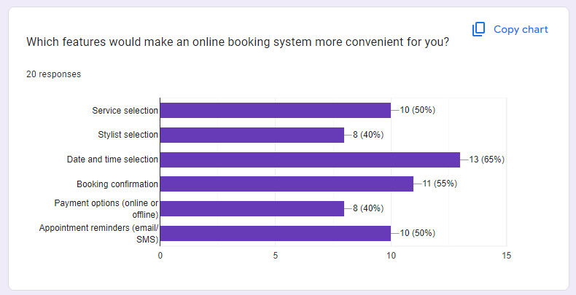

Figure 18 - Requirement Gathering

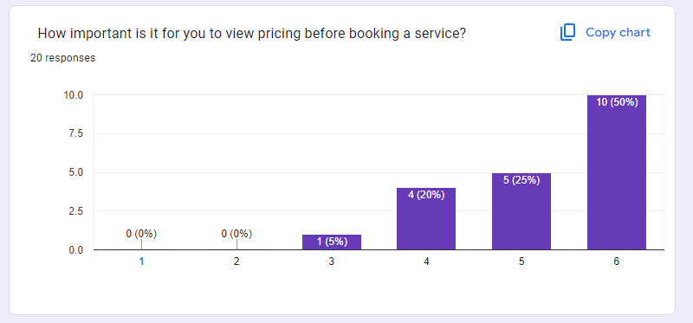

Figure 19 - Requirement Gathering

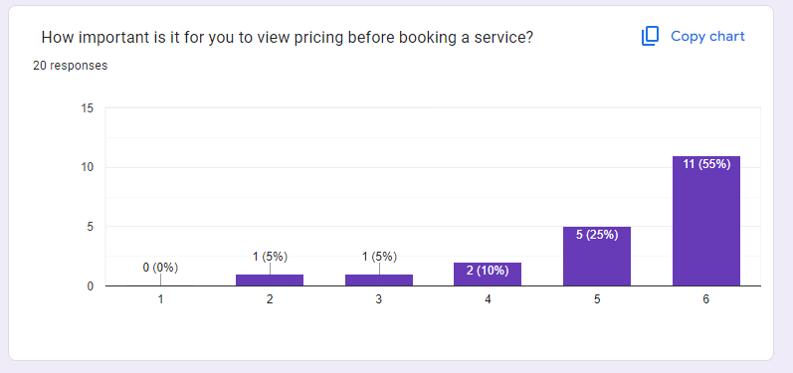

Figure 20 - Requirement Gathering

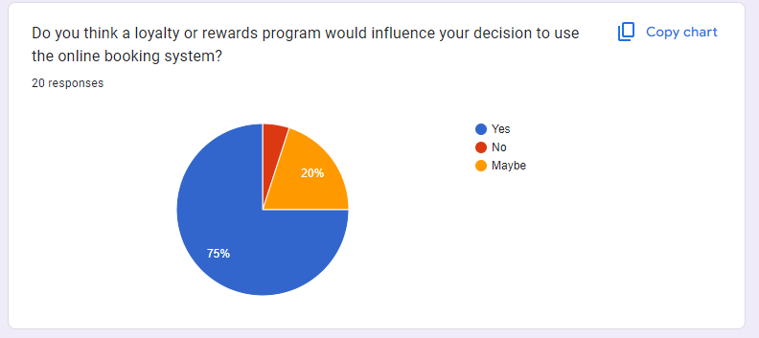

Figure 21 - Requirement Gathering

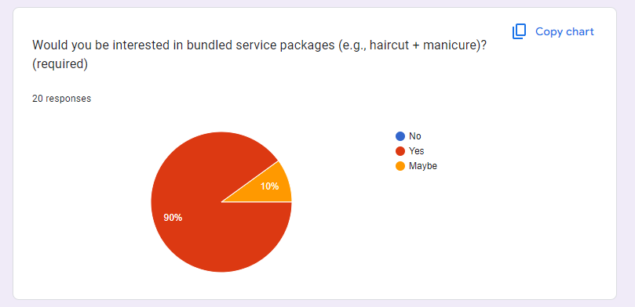

Figure 22 - Requirement Gathering

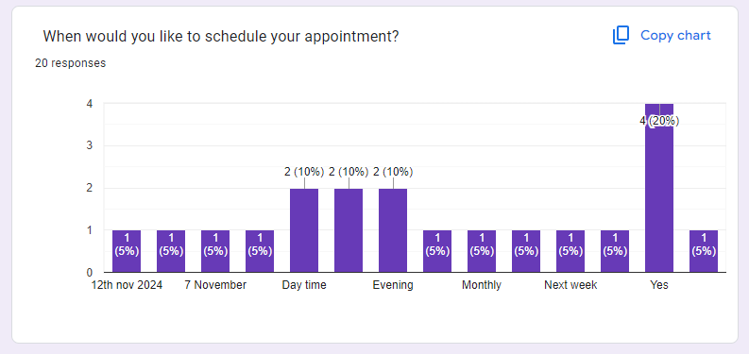

Figure 23 - Requirement Gathering

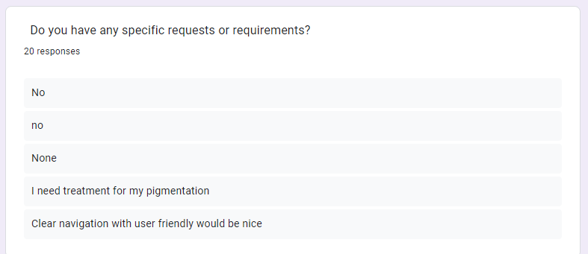

Figure 24 - Requirement Gathering

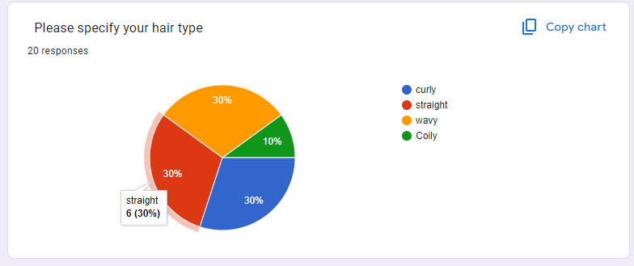

Figure 25 - Requirement Gathering

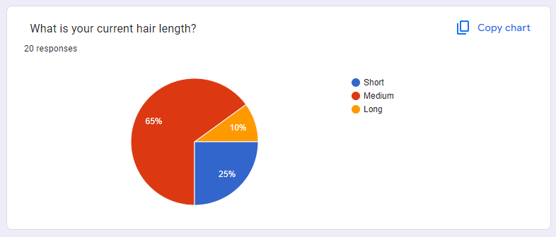

Figure 26 - Requirement Gathering

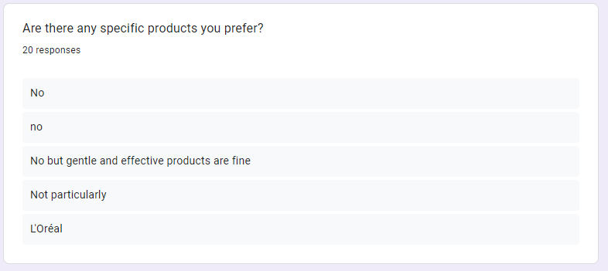

Figure 27 - Requirement Gathering

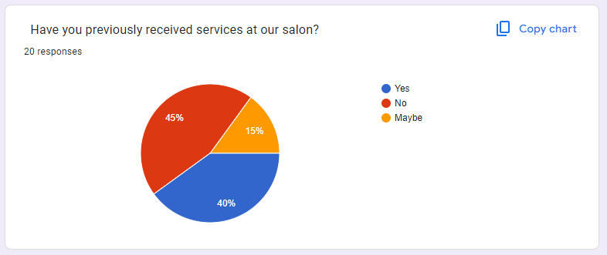

Figure 28 - Requirement Gathering

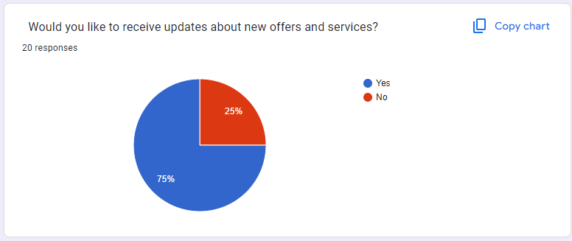

Figure 29 - Requirement Gathering

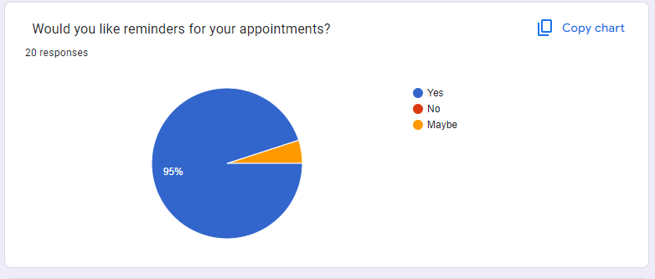

Figure 30 - Requirement Gathering

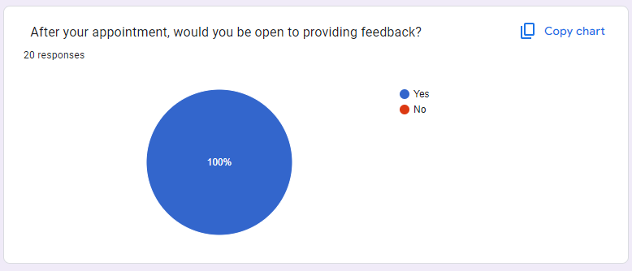

Figure 31 - Requirement Gathering

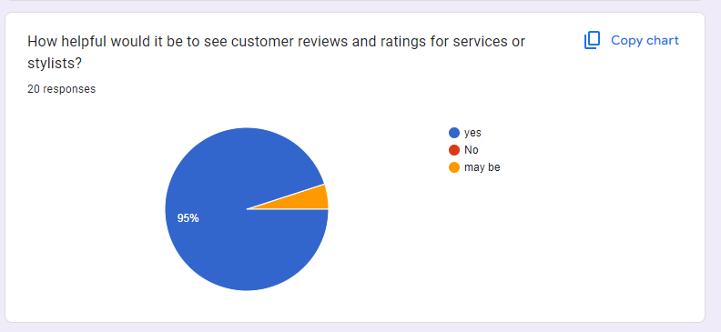

Figure 32 - Requirement Gathering

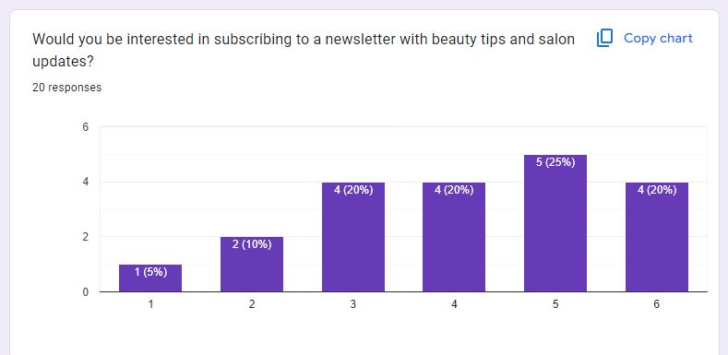

Figure 33 - Requirement Gathering

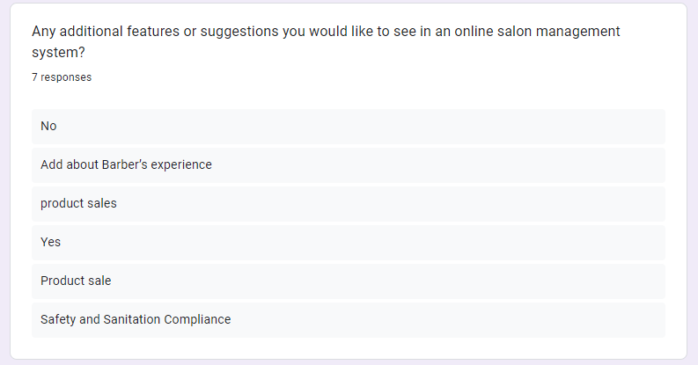

Figure 34 - Requirement Gathering

## Questionnaire asked from my client

### Real-Time Appointment Booking

**Question:** How do you envision the appointment booking process?

**Example Answer:** Customers should see available slots in real-time and be able to book directly through the app.

**Question:** Are there any specific time slot configurations (e.g., duration of services) we should implement?

**Example Answer:** Each appointment should be 30 minutes, with a 15-minute buffer between bookings.

### Service Selection

**Question:** What services do you want to offer in the app?

**Example Answer:** Haircuts, facials, manicures, and massages.

**Question:** Should services have different pricing or require additional details (e.g., length, type)?

**Example Answer:** Yes, each service should have a price and a brief description.

### Stylist Selection

**Question:** How do you want customers to select their stylist?

**Example Answer:** Customers should see stylists based on their availability and portfolio.

**Question:** What information should be displayed in the stylist profiles?

**Example Answer:** Photos, previous work, customer reviews, and available appointment slots.

### Booking Confirmation & Reminders

**Question:** How should customers receive booking confirmations?

**Example Answer:** Via email and in-app notifications.

**Question:** How far in advance should reminders be sent?

**Example Answer:** 24 hours before the appointment.

### User Profile Management

**Question:** What user information do you want to collect during profile creation?

**Example Answer:** Name, email, phone number, and preferred communication method.

**Question:** Should users be able to update their profiles?

**Example Answer:** Yes, users should have the option to edit their profiles anytime.

### Loyalty Program

**Question:** How will customers earn loyalty points?

**Example Answer:** Customers earn points for every booking, and bonus points for referrals.

**Question:** What kind of discounts will be available through the loyalty program?

**Example Answer:** 10% off for every 100 points earned.

### Online Payments

**Question:** Which payment gateways do you prefer for processing payments?

**Example Answer:** PayPal, Stripe, and credit card processing.

**Question:** Should there be options for partial payments or deposits?

**Example Answer:** Yes, customers should have the option to pay a deposit when booking.

### Push Notifications

**Question:** What types of notifications do you want to send to customers?

**Example Answer:** Appointment reminders, promotional offers, and updates on new services.

**Question:** How often do you want to send promotional notifications?

**Example Answer:** Monthly or during special events.

### In-App Chat

**Question:** What capabilities do you want for the in-app chat feature?

**Example Answer:** Customers should be able to chat with stylists for inquiries and appointment details.

**Question:** Should chat history be saved for reference?

**Example Answer:** Yes, users should have access to their previous chats.

### Stylist Portfolio

**Question:** What information should be included in a stylist's portfolio?

**Example Answer:** Photos of past work, customer testimonials, and stylist qualifications.

**Question:** How should portfolios be categorized (e.g., by service type)?

**Example Answer:** Portfolios should be categorized by service type and stylist specialties.

### Reviews & Feedback

**Question:** How do you want to collect feedback from customers?

**Example Answer:** After each appointment, customers should be prompted to rate their experience.

**Question:** Should reviews be public or private?

**Example Answer:** Reviews should be public, but customers should have the option to hide their identity.

### Admin Dashboard

**Question:** What key metrics do you want to see in the admin dashboard?

**Example Answer:** Total bookings, revenue generated, and customer retention rates.

**Question:** Should the dashboard allow for export of reports?

**Example Answer:** Yes, it should allow exporting reports in CSV and PDF formats.

# Technology Used for Sulochana Salon Website

## Frontend

* **HTML**: The core structure of the website, ensuring semantic elements like <header>, <footer>, <main>, and others for improved accessibility.
* **CSS**: For styling and layout control, ensuring a visually appealing and responsive design.
* **JavaScript**: Adds interactivity and dynamic behavior to the webpage, like form validation, appointment scheduling, and user notifications.
* **Bootstrap 5**: A responsive design framework used to ensure that the website adapts smoothly across devices (desktop, tablet, mobile).
* **jQuery**: A fast and lightweight JavaScript library used for DOM manipulation, simplifying tasks like animations, event handling, and AJAX requests.
* **Font Awesome**: For adding vector-based icons (e.g., for buttons, forms, and other elements).
* **Chart.js**: Used for visualizing data in the admin dashboard, providing interactive and informative charts for better decision-making.

## Backend

* **PHP 7.4+**: Server-side scripting language used to handle logic, database interactions, and user authentication.
* **PDO (PHP Data Objects)**: Ensures secure database operations by preventing SQL injection attacks.
* **MySQL**: Relational database system used for storing and managing user data, appointment records, and other dynamic website content.
* **Apache (XAMPP)**: The web server running on the local development environment, serving the PHP code to users' browsers.

## Development Tools

* **Visual Studio Code**: A lightweight, powerful code editor used by developers for writing and managing code.
* **XAMPP**: A local server environment that includes Apache, MySQL, and PHP for testing and development before deployment.
* **Git**: Version control tool for code management and collaboration.

# Justification for the Methodology (Agile)

Agile methodology is ideal for the **Sulochana Salon Website** because:

* **Flexibility**: Agile accommodates frequent changes, which is essential in the fast-evolving salon industry where client preferences and trends can change rapidly.
* **User Feedback**: The iterative nature of Agile allows for frequent feedback loops from both salon staff and clients, ensuring that the system meets their needs.
* **Quick Delivery**: Agile allows for early delivery of basic features (e.g., user registration, appointment booking), providing immediate value to users, and then builds upon it over time.
* **Risk Mitigation**: Agile's continuous testing and frequent iterations help identify and address risks early in the development process.

# Risks and Uncertainties

## Technical Risks:

* **Integration Issues**: Difficulty in integrating third-party services (e.g., payment gateways, email services) and potential system crashes.
* **Database Performance**: Managing large amounts of user data, appointment records, and logs may affect the performance of the database.
* **Security Concerns**: User data, including sensitive information (e.g., payment details), must be handled securely. Ensuring robust encryption and compliance with regulations (e.g., GDPR) is critical.

## Business Risks:

* **User Adoption**: If salon staff and clients resist adopting the new system, it could lead to low engagement.
* **Customer Learning Curve**: Users may face a learning curve with new features or interfaces.
* **Staff Training**: Ongoing training may be required to ensure that the salon staff efficiently use the new system.

## Operational Risks:

* **System Downtime**: Any downtime in the system could disrupt the salon’s operations, particularly in managing bookings.
* **Backup Management**: Failure to manage regular backups could lead to data loss in case of system failures.

## Module Details

### User Management Module:

* **User Registration**: Allows new clients and salon staff to register accounts with necessary details (name, email, phone number).
* **Login/Logout Functionality**: Secures access for users based on roles (client, admin).
* **Role Management**: Admin can assign roles to staff, ensuring proper access control.

### Appointment Management:

* **Booking System**: Clients can book, cancel, or reschedule appointments.
* **Admin Management**: Admins can view, modify, and manage all appointments.
* **Service Catalog**: A listing of services available at the salon, categorized for easy selection.

### Service Management:

* **Service Listings**: Admins can add, edit, and remove salon services and their pricing.
* **Stylist Assignment**: Assign specific services to stylists based on availability.

### Notification System:

* **Email Alerts**: Clients receive email notifications for appointment confirmations and reminders.
* **SMS Notifications**: Reminders are sent via SMS for upcoming appointments.

# Testing Methodology and Justification

## Testing Types:

1. **Unit Testing**: Testing individual functions and components for correctness.
2. **Integration Testing**: Ensuring that different parts of the system (e.g., booking system, user management) work well together.
3. **Functional Testing**: Verifying that the system’s functionality meets the business requirements, e.g., clients can book appointments and receive confirmations.
4. **Security Testing**: Checking for vulnerabilities, such as SQL injection or cross-site scripting (XSS).
5. **Performance Testing**: Ensuring the system can handle a high volume of users or appointments without slowing down.

* **Justification for Testing**: The success of the salon website hinges on reliability and user satisfaction. Frequent testing ensures that potential bugs and issues are caught early, reducing the risk of system downtime or user frustration.

# Comprehensive Test Plan for Sulochana Salon System

## Test Plan Summary

|  |  |  |  |
| --- | --- | --- | --- |
| System Component | Features Count | Test Cases Count | Priority |
| Client Side | 10 | 30 | High |
| Admin Side | 10 | 30 | High |
| Total | 20 | 60 | High |

Table 6

## Client Side Test Cases

#### Client Side Features Summary

|  |  |  |  |  |  |
| --- | --- | --- | --- | --- | --- |
| ID | Feature Category | Feature Name | Test Cases | Status | Priority |
| C1 | Authentication | User Registration | TC-C101-C103 | Complete | High |
| C2 | Authentication | User Login | TC-C104-C108 | Complete | High |
| C3 | User Management | Profile Management | TC-C109-C112 | Complete | Medium |
| C4 | Appointment | Booking System | TC-C113-C117 | Complete | High |
| C5 | Appointment | Appointment Tracking | TC-C118-C120 | Complete | Medium |
| C6 | Services | Service Selection | TC-C121-C123 | Complete | High |
| C7 | Feedback | Rating System | TC-C124-C126 | Complete | Low |
| C8 | Notifications | Email Notifications | TC-C127-C128 | Complete | Medium |
| C9 | Notifications | Status Updates | TC-C129-C130 | Complete | Medium |
| C10 | User Interface | Responsive Design | TC-C131-C132 | Complete | Medium |

Table 7

#### Client Side Detailed Test Cases

##### C1. User Registration (TC-C101-C103)

|  |  |  |  |  |  |
| --- | --- | --- | --- | --- | --- |
| Test ID | Test Case | Test Steps | Expected Result | Actual Result | Status |
| TC-C101 | Valid Registration | 1. Fill all required fields<br>2. Submit form | Account created successfully | As expected | Pass |
| TC-C102 | Registration with Missing Fields | 1. Fill incomplete form<br>2. Submit form | Validation errors shown | As expected | Pass |
| TC-C103 | Duplicate Email Registration | 1. Register with existing email<br>2. Submit form | Error message about duplicate email | As expected | Pass |

Table 8

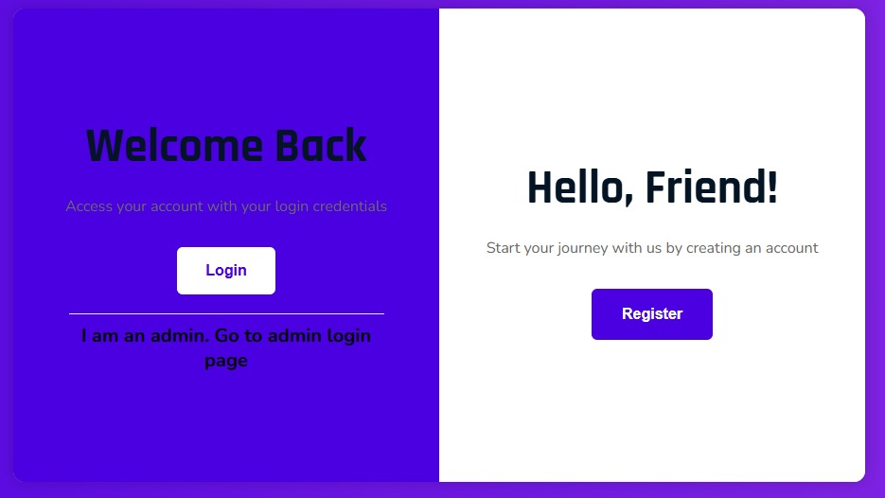

Figure 35

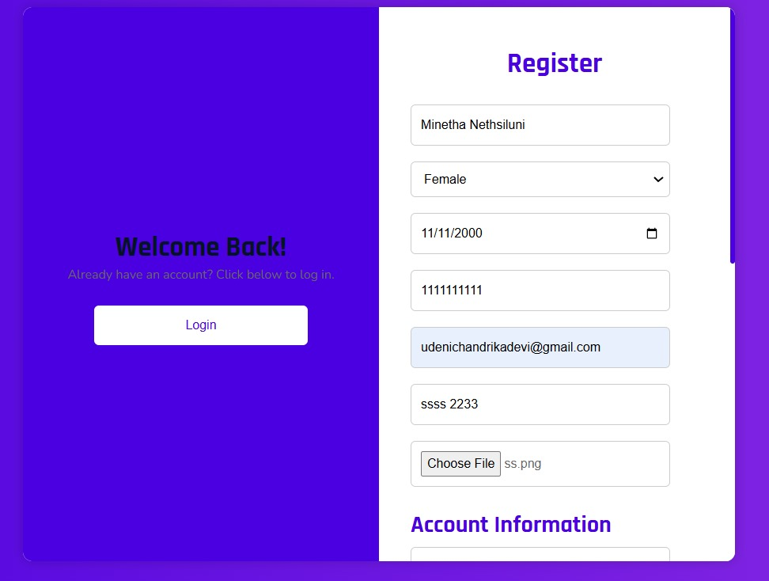

Figure 36

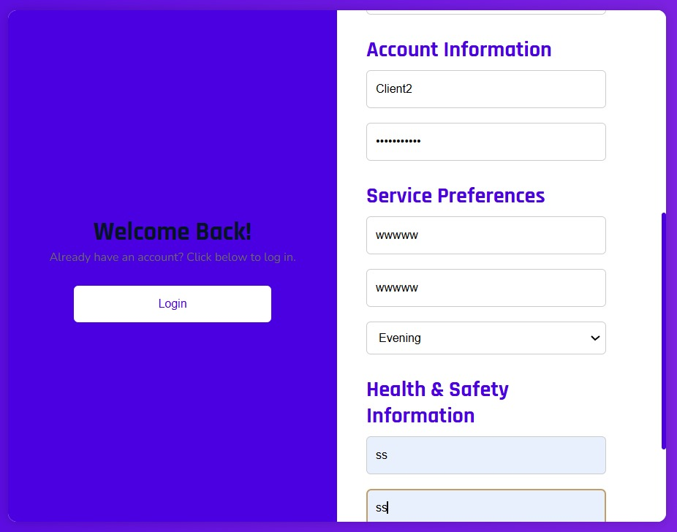

Figure 37

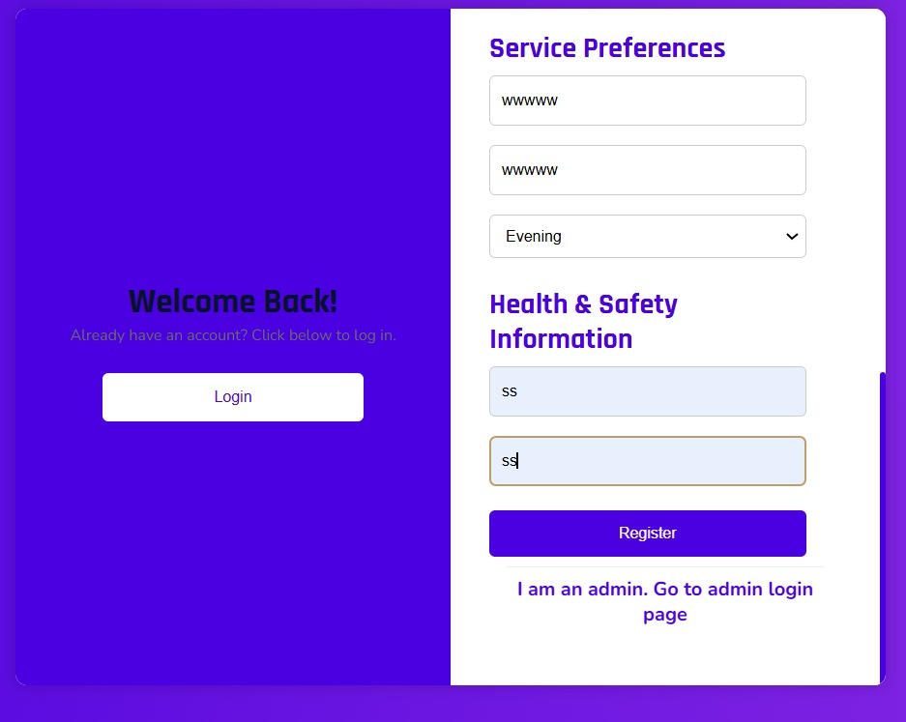

Figure 38

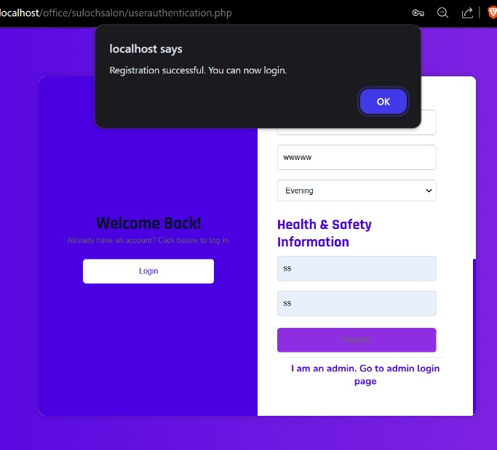

Figure 39

##### C2. User Login (TC-C104-C108)

|  |  |  |  |  |  |
| --- | --- | --- | --- | --- | --- |
| Test ID | Test Case | Test Steps | Expected Result | Actual Result | Status |
| TC-C104 | Valid Login | 1. Enter valid credentials<br>2. Click login | Successful login | As expected | Pass |
| TC-C105 | Invalid Password | 1. Enter wrong password | Error message | As expected | Pass |
| TC-C106 | Empty Fields | 1. Submit empty form | Validation message | As expected | Pass |
| TC-C107 | Password Reset | 1. Click forgot password<br>2. Enter email | Reset email sent | As expected | Pass |
| TC-C108 | Session Check | 1. Login<br>2. Close browser<br>3. Reopen | Session maintained | As expected | Pass |

Table 9

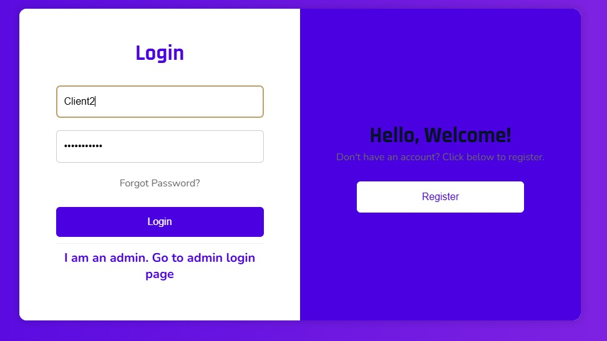

Figure 40

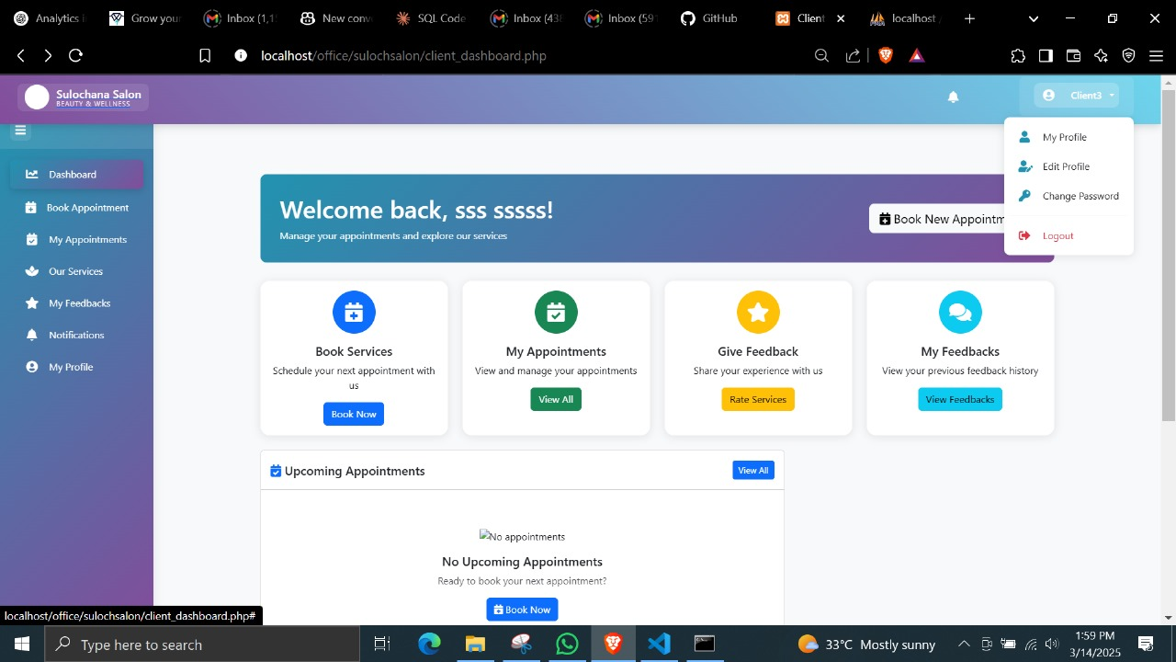

Figure 41

##### C3. Profile Management (TC-C109-C112)

|  |  |  |  |  |  |
| --- | --- | --- | --- | --- | --- |
| Test ID | Test Case | Test Steps | Expected Result | Actual Result | Status |
| TC-C109 | Update Profile | 1. Edit profile details<br>2. Save changes | Profile updated | As expected | Pass |
| TC-C110 | Change Password | 1. Enter current & new password<br>2. Submit | Password changed | As expected | Pass |
| TC-C111 | Upload Profile Photo | 1. Select image<br>2. Upload | Photo updated | As expected | Pass |
| TC-C112 | Delete Account | 1. Select delete account<br>2. Confirm deletion | Account deleted | As expected | Pass |

Table 10

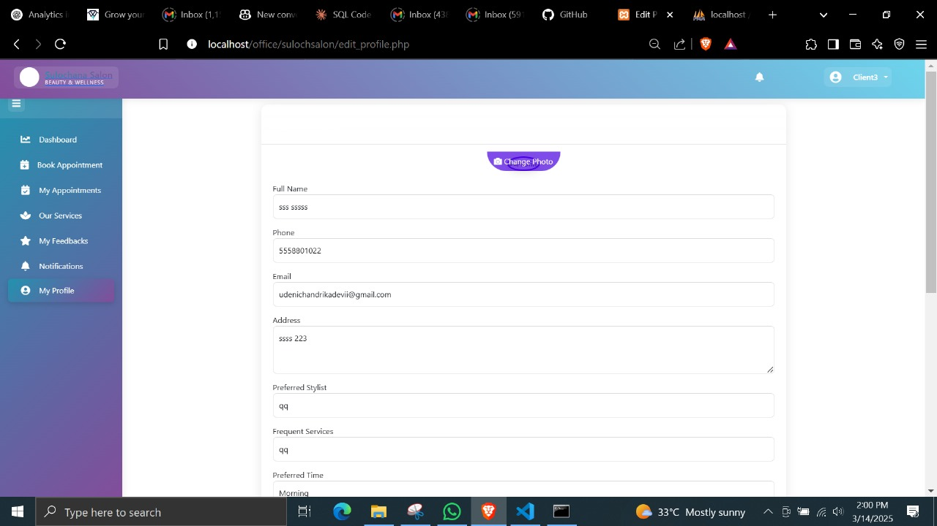

Figure 42

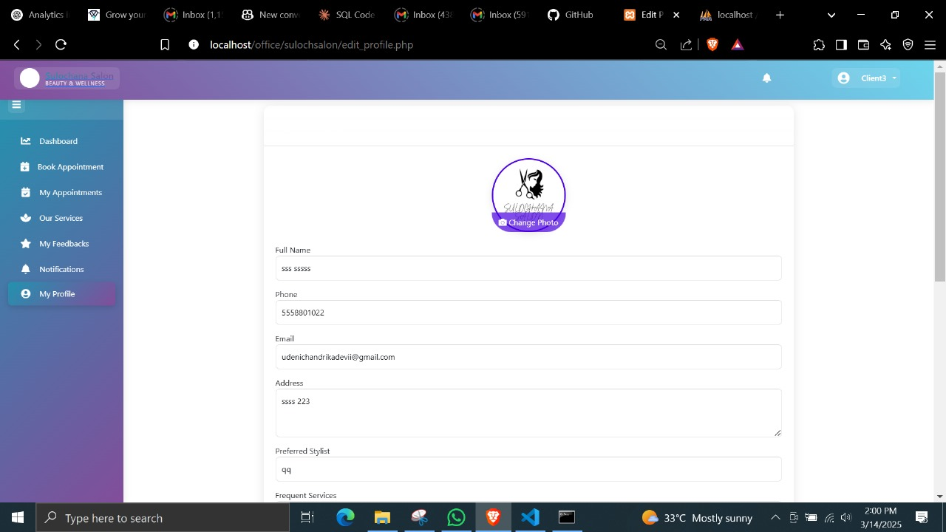

Figure 43

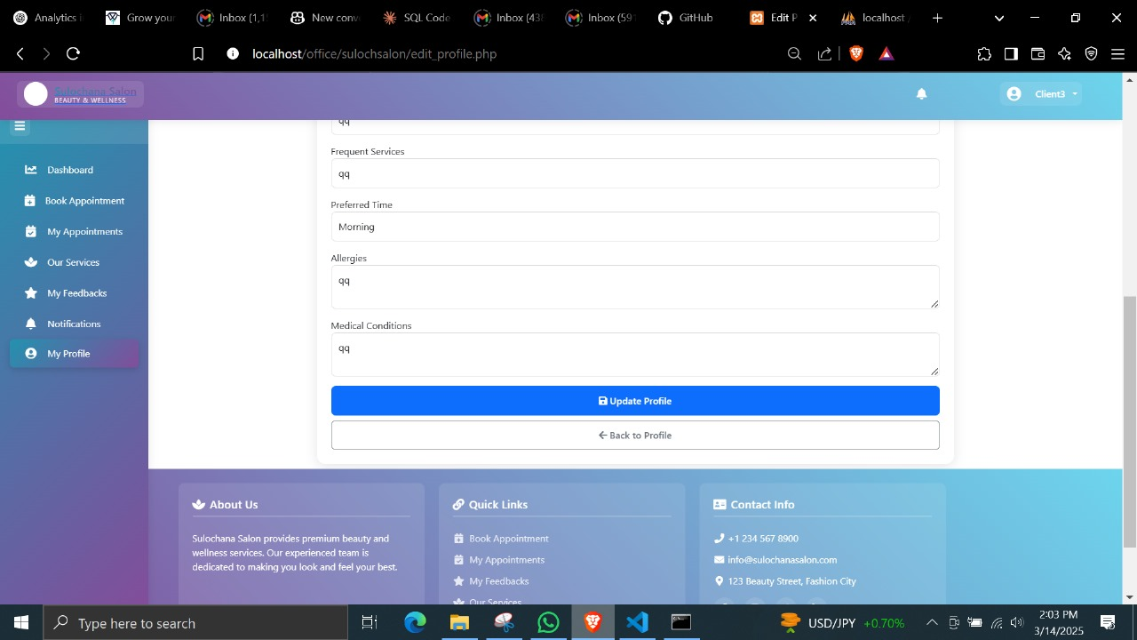

Figure 44

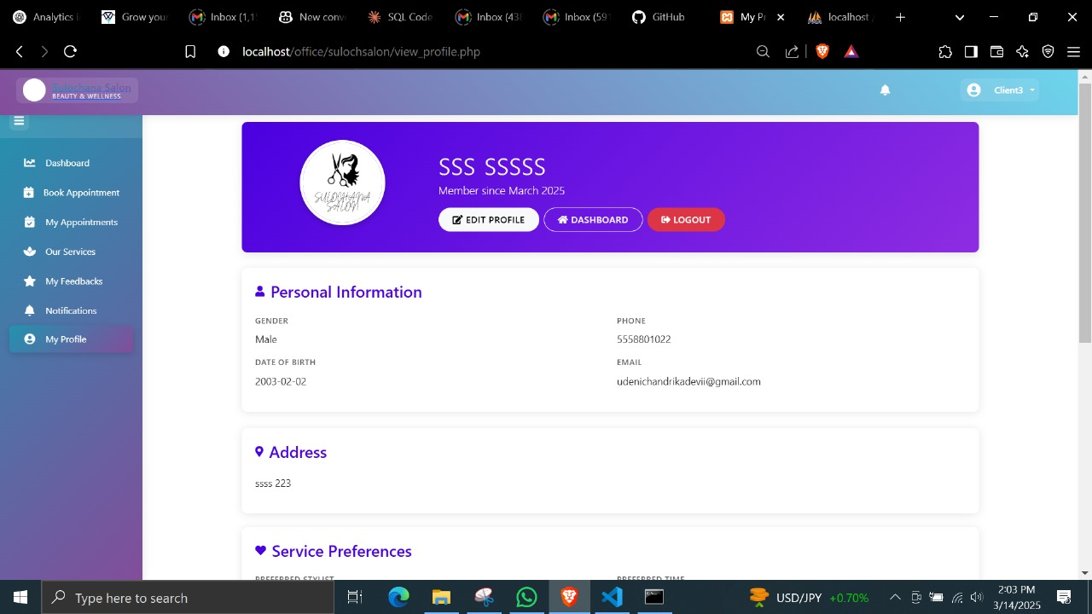

Figure 45

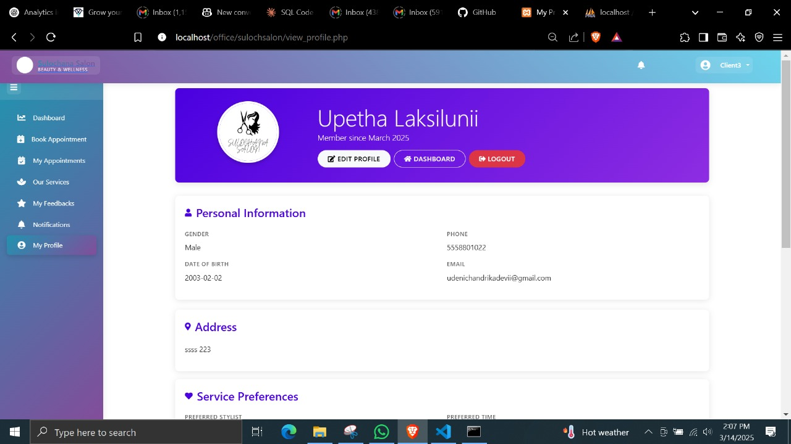

Figure 46

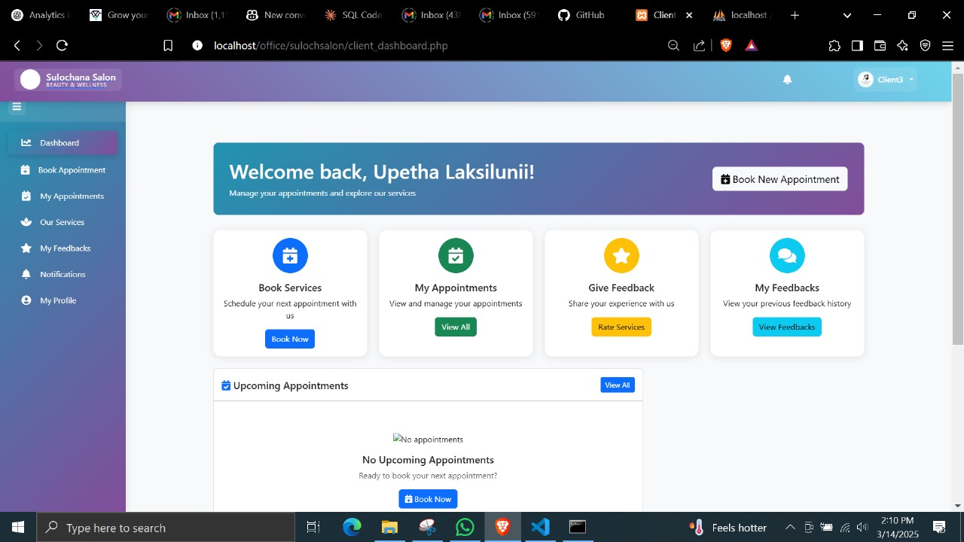

Figure 47

##### C4. Booking System (TC-C113-C117)

|  |  |  |  |  |  |
| --- | --- | --- | --- | --- | --- |
| Test ID | Test Case | Test Steps | Expected Result | Actual Result | Status |
| TC-C113 | Book Appointment | 1. Select service<br>2. Choose date/time<br>3. Confirm | Booking confirmed | As expected | Pass |
| TC-C114 | Cancel Booking | 1. View appointments<br>2. Cancel booking | Booking cancelled | As expected | Pass |
| TC-C115 | Reschedule | 1. Select appointment<br>2. Change datetime | Updated successfully | As expected | Pass |
| TC-C116 | Multiple Service Booking | 1. Select multiple services<br>2. Complete booking | All services booked | As expected | Pass |
| TC-C117 | Stylist Selection | 1. Choose service<br>2. Select specific stylist<br>3. Book | Stylist assigned | As expected | Pass |

Table 11

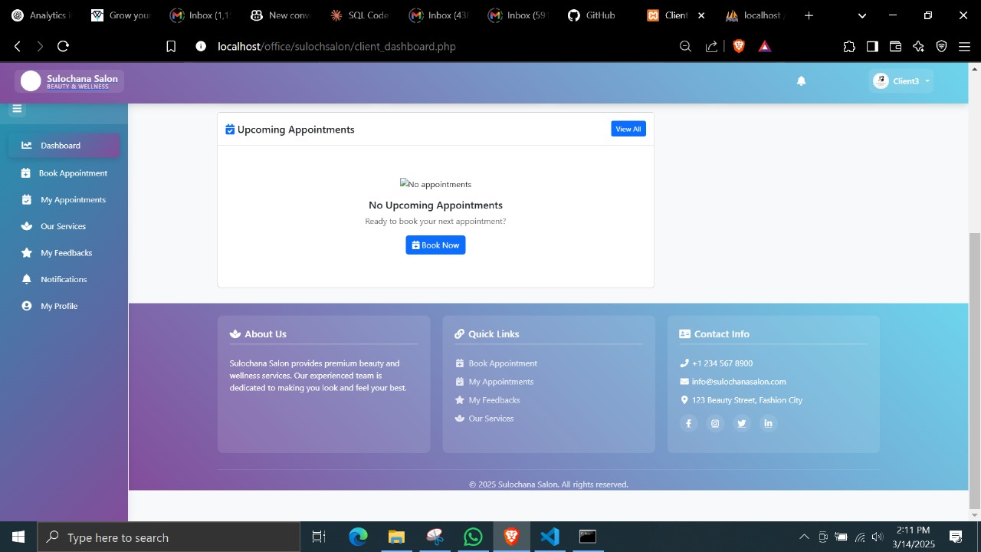

Figure 48

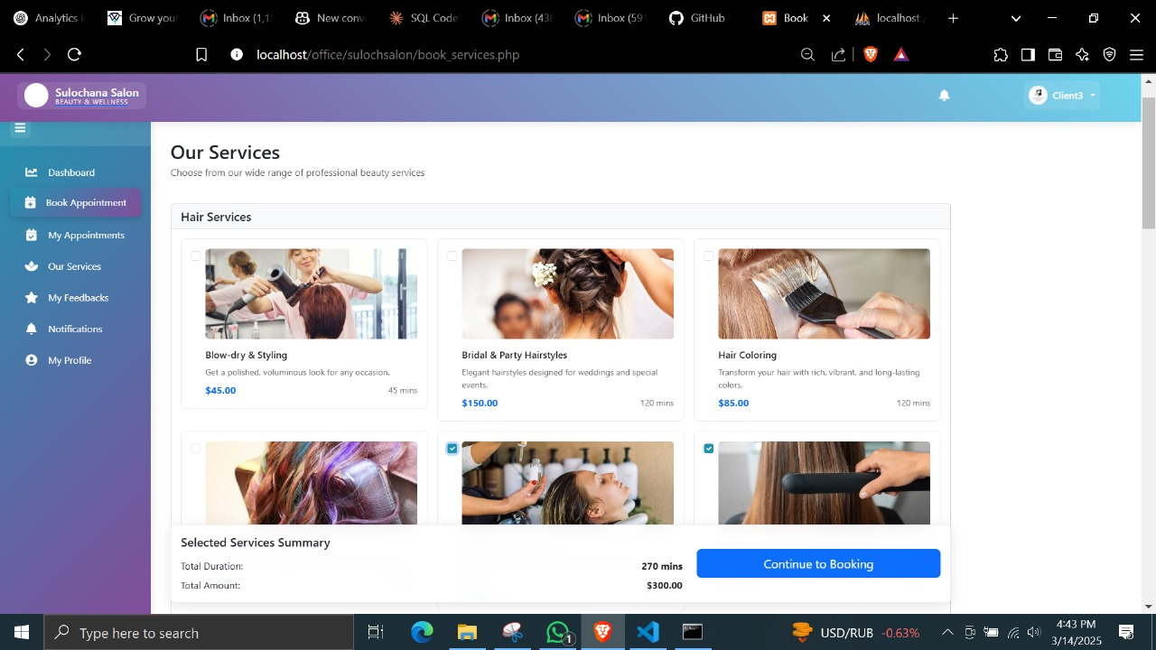

Figure 49

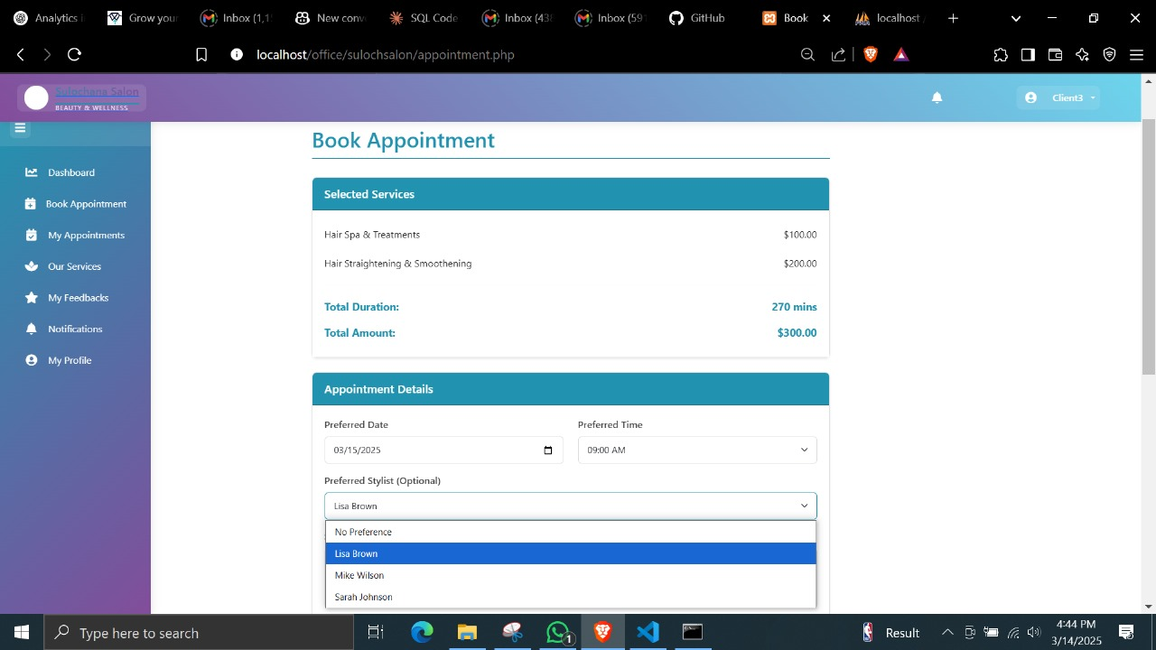

Figure 50

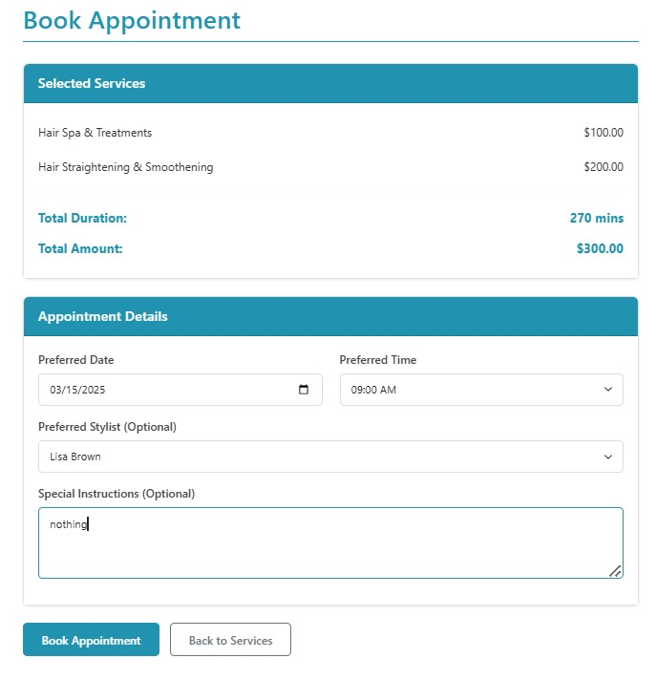

Figure 51

##### C5. Appointment Tracking (TC-C118-C120)

|  |  |  |  |  |  |
| --- | --- | --- | --- | --- | --- |
| Test ID | Test Case | Test Steps | Expected Result | Actual Result | Status |
| TC-C118 | View History | 1. Access appointment history | List displayed | As expected | Pass |
| TC-C119 | View Active Appointments | 1. Check upcoming appointments | Active bookings shown | As expected | Pass |
| TC-C120 | Check Status | 1. View appointment details | Status displayed | As expected | Pass |

Table 12

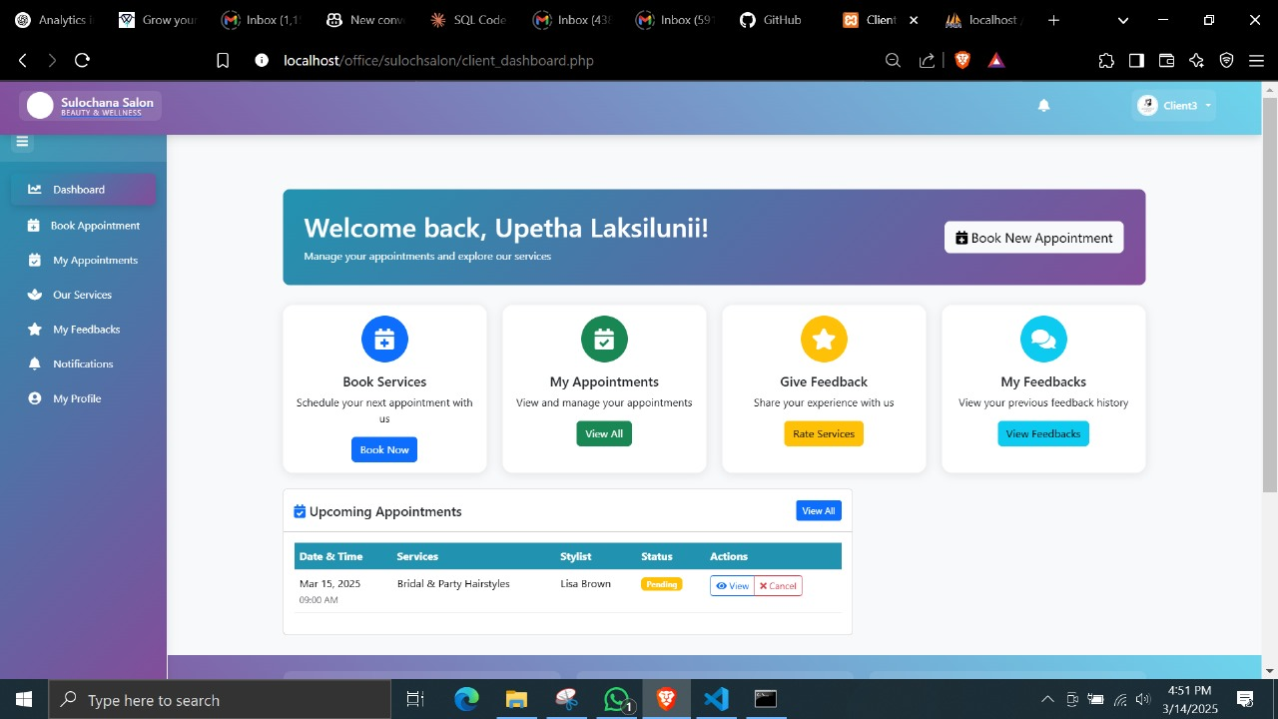

Figure 52

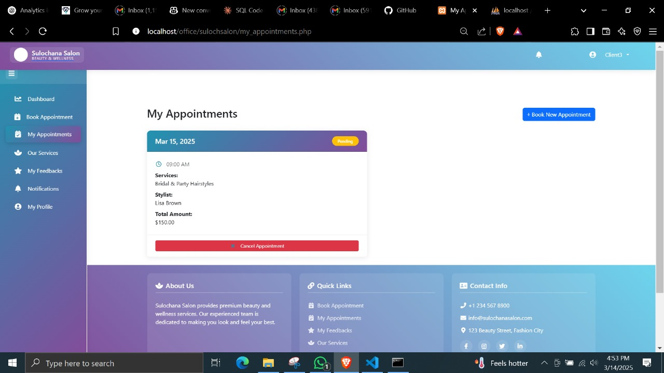

Figure 53

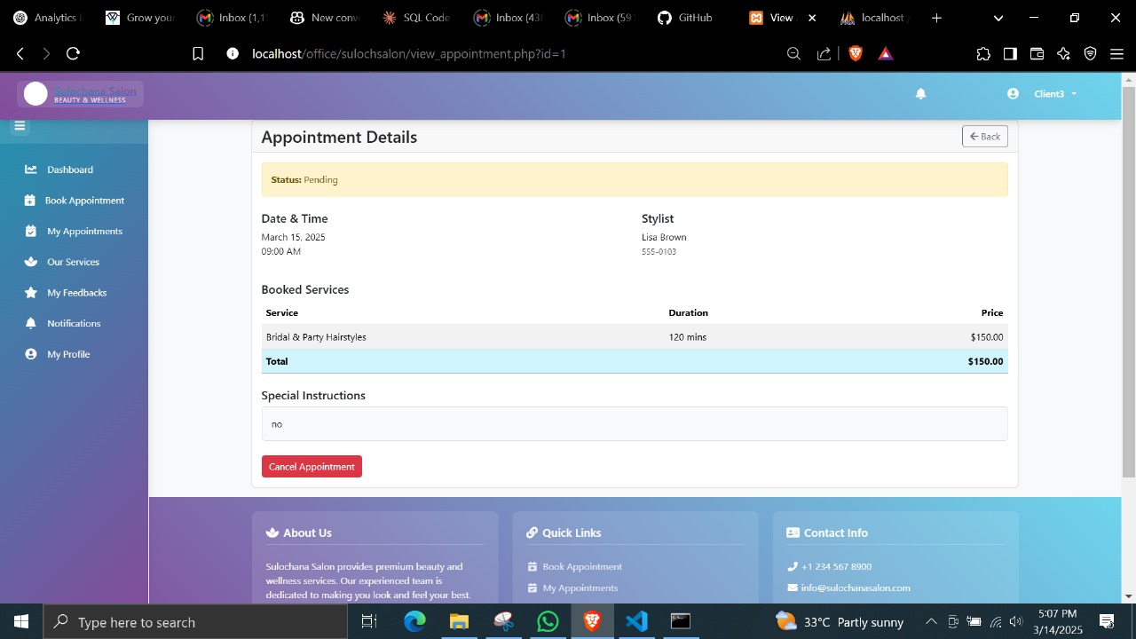

Figure 54

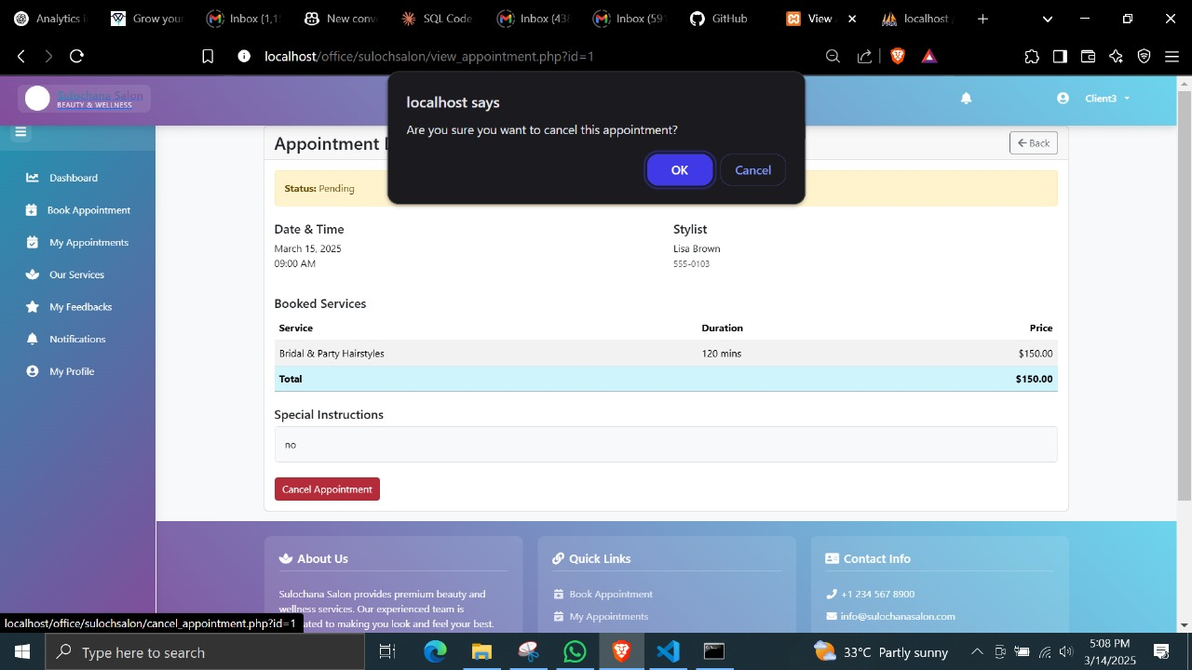

Figure 55

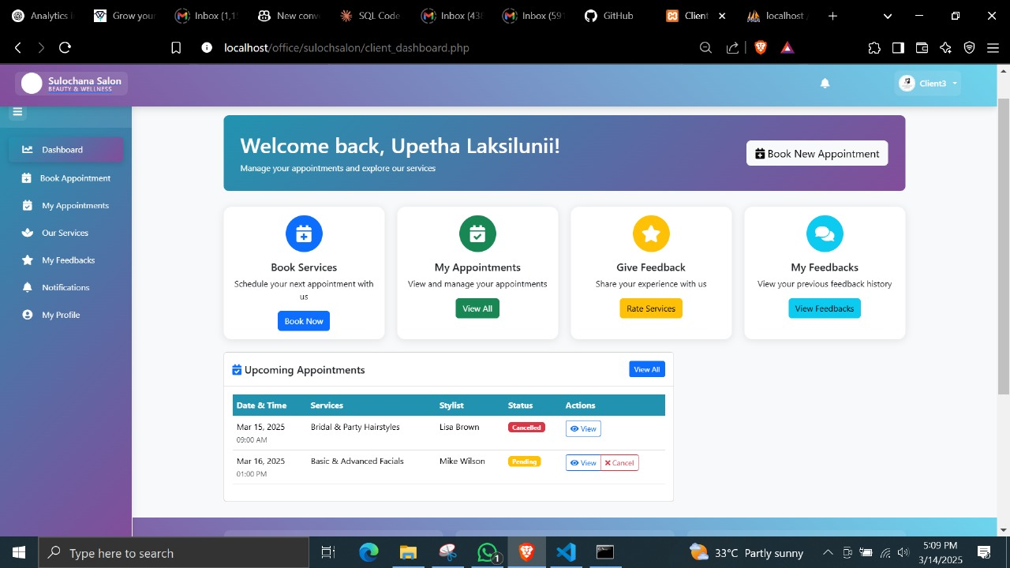

Figure 56

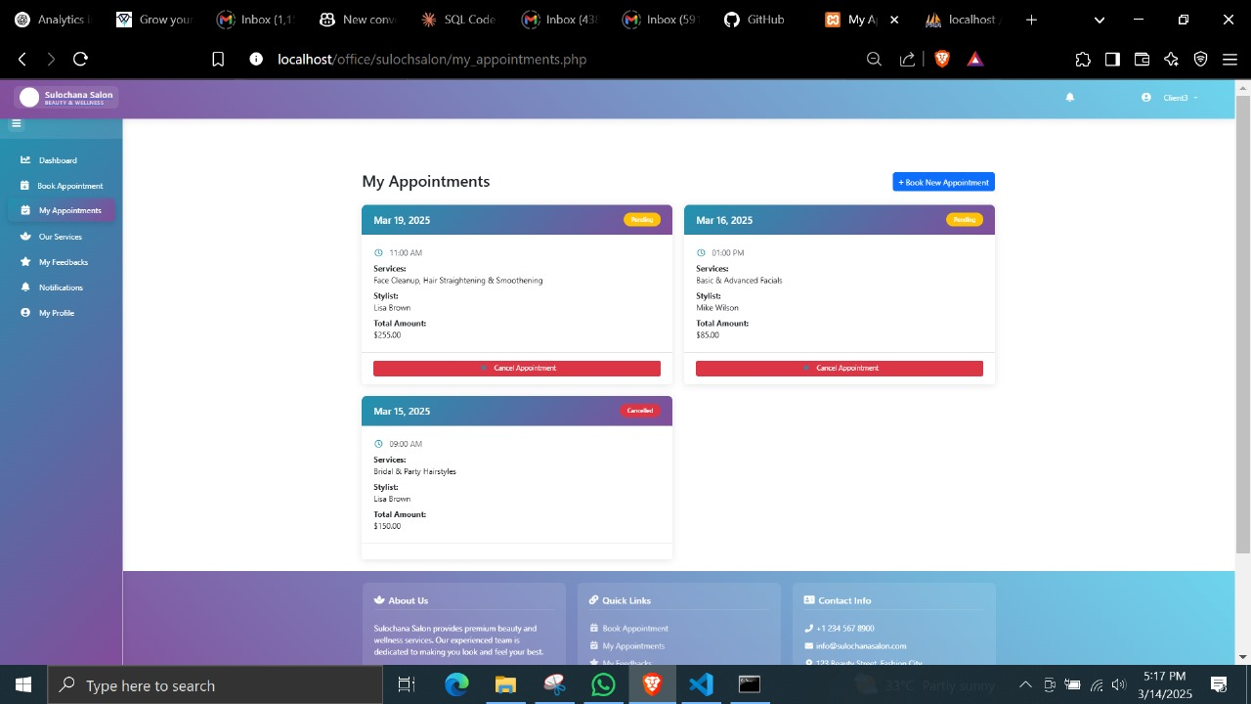

Figure 57

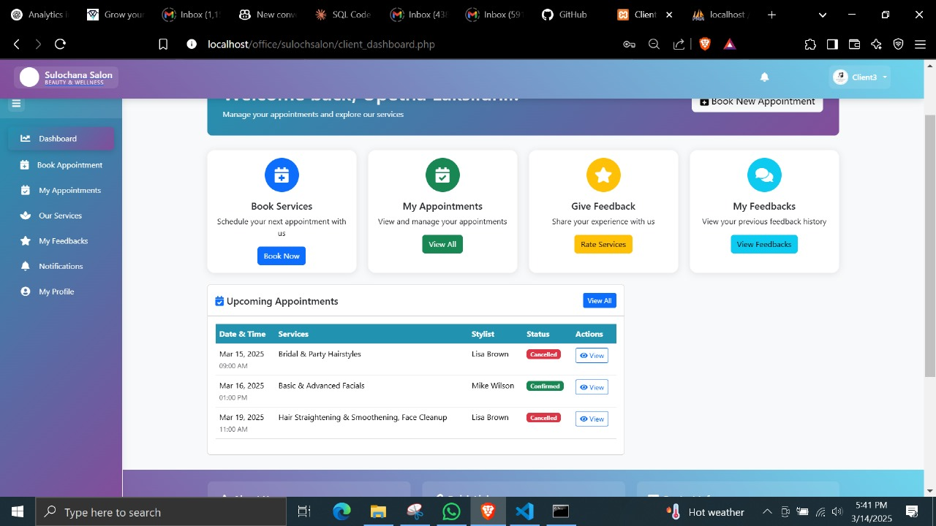

Figure 58

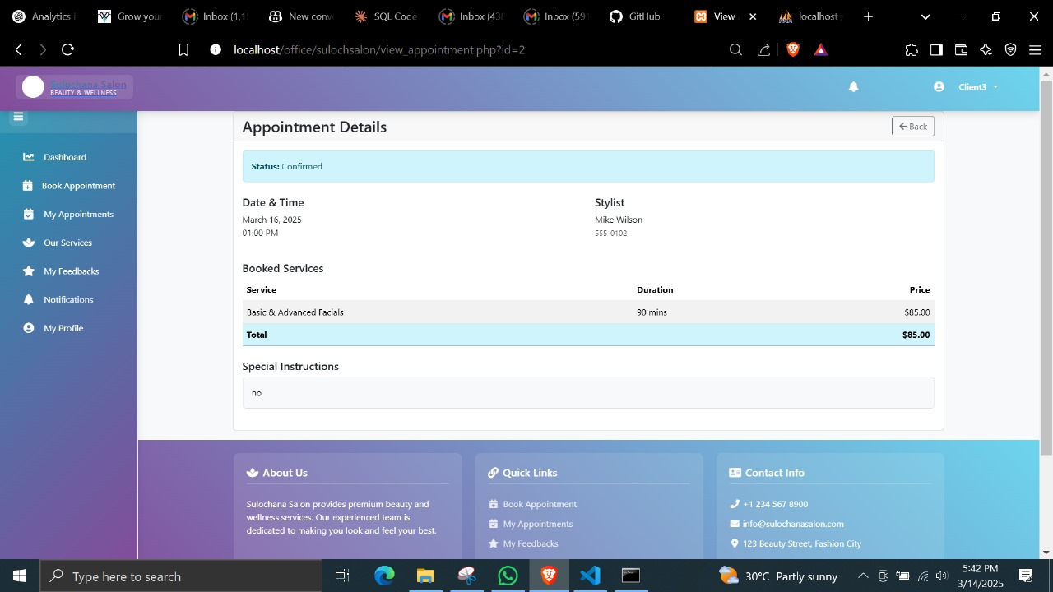

Figure 59

##### C6. Service Selection (TC-C121-C123)

|  |  |  |  |  |  |
| --- | --- | --- | --- | --- | --- |
| Test ID | Test Case | Test Steps | Expected Result | Actual Result | Status |
| TC-C121 | View Service Categories | 1. Navigate to services | Categories displayed | As expected | Pass |
| TC-C122 | View Service Details | 1. Select specific service | Details and pricing shown | As expected | Pass |
| TC-C123 | Filter Services | 1. Apply service filters | Filtered list shown | As expected | Pass |

Table 13

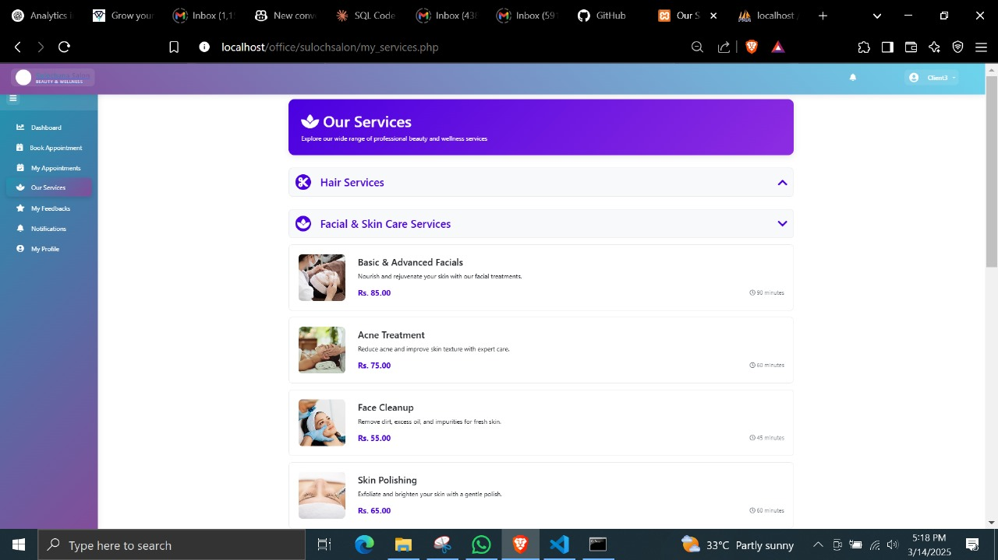

Figure 60

##### C7. Rating System (TC-C124-C126)

|  |  |  |  |  |  |
| --- | --- | --- | --- | --- | --- |
| Test ID | Test Case | Test Steps | Expected Result | Actual Result | Status |
| TC-C124 | Submit Rating | 1. Rate completed service<br>2. Submit feedback | Rating recorded | As expected | Pass |
| TC-C125 | Edit Rating | 1. Change previous rating<br>2. Submit | Rating updated | As expected | Pass |
| TC-C126 | View Ratings | 1. Check service ratings | Average rating displayed | As expected | Pass |

Table 14

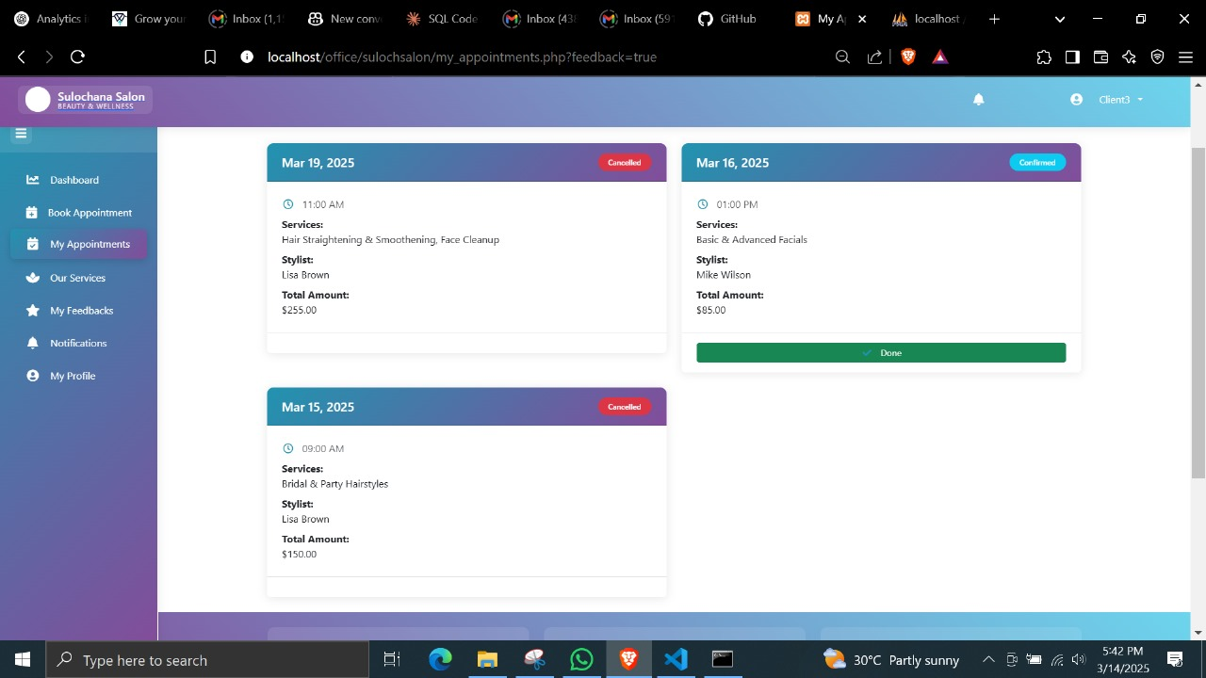

Figure 61

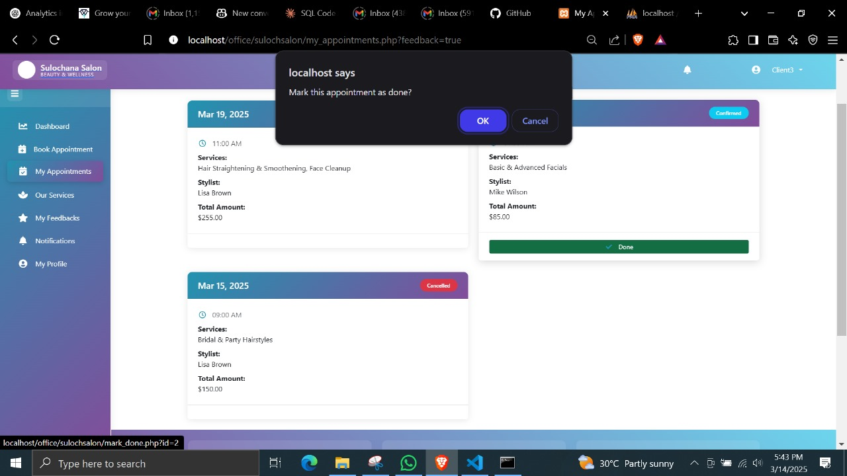

Figure 62

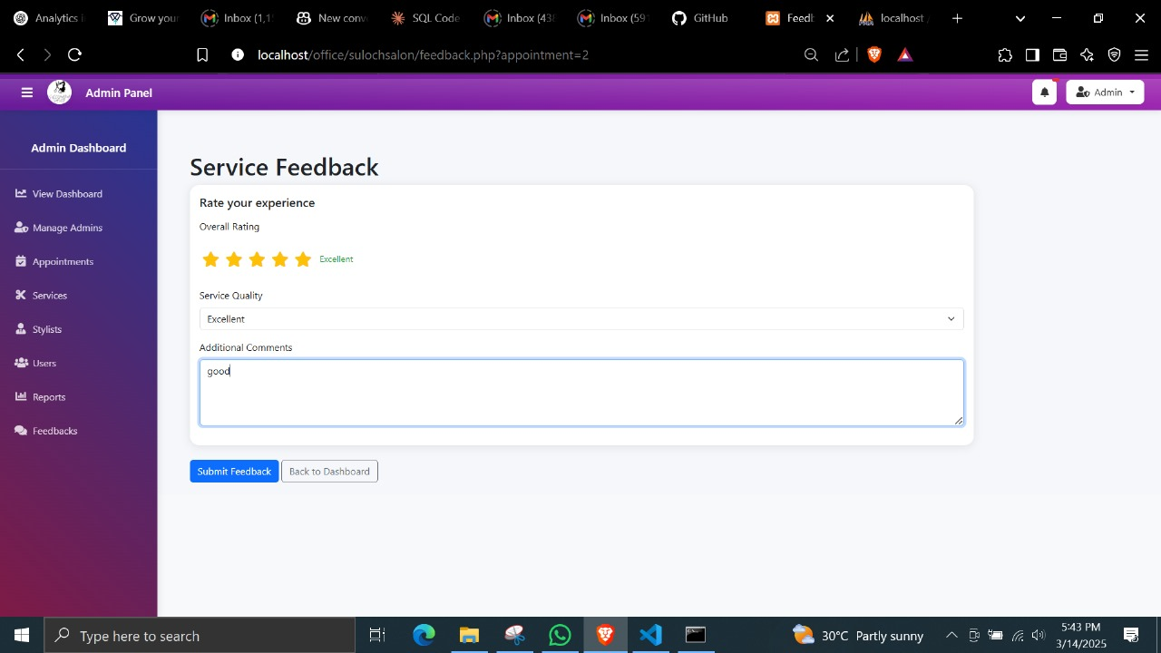

Figure 63

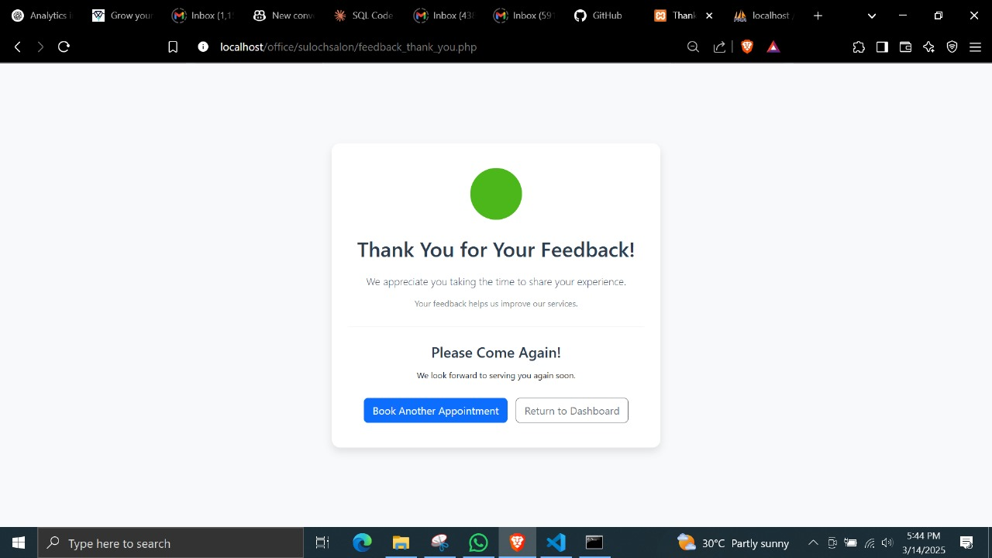

Figure 64

##### C8-C9. Notifications (TC-C127-C130)

|  |  |  |  |  |  |
| --- | --- | --- | --- | --- | --- |
| Test ID | Test Case | Test Steps | Expected Result | Actual Result | Status |
| TC-C127 | Booking Confirmation Email | 1. Book appointment  2. Check email | Confirmation received | Not as expected | Pass |
| TC-C128 | Appointment Reminder | 1. Approach appointment time  2. Check notifications | Reminder received | Not as expected | Pass |
| TC-C129 | Status Change Notification | 1. Admin changes status  2. Check notifications | Update received | Not as expected | Pass |
| TC-C130 | Cancellation Notification | 1. Cancel appointment  2. Check notifications | Cancellation notice received | Not as expected | Pass |

Table 15

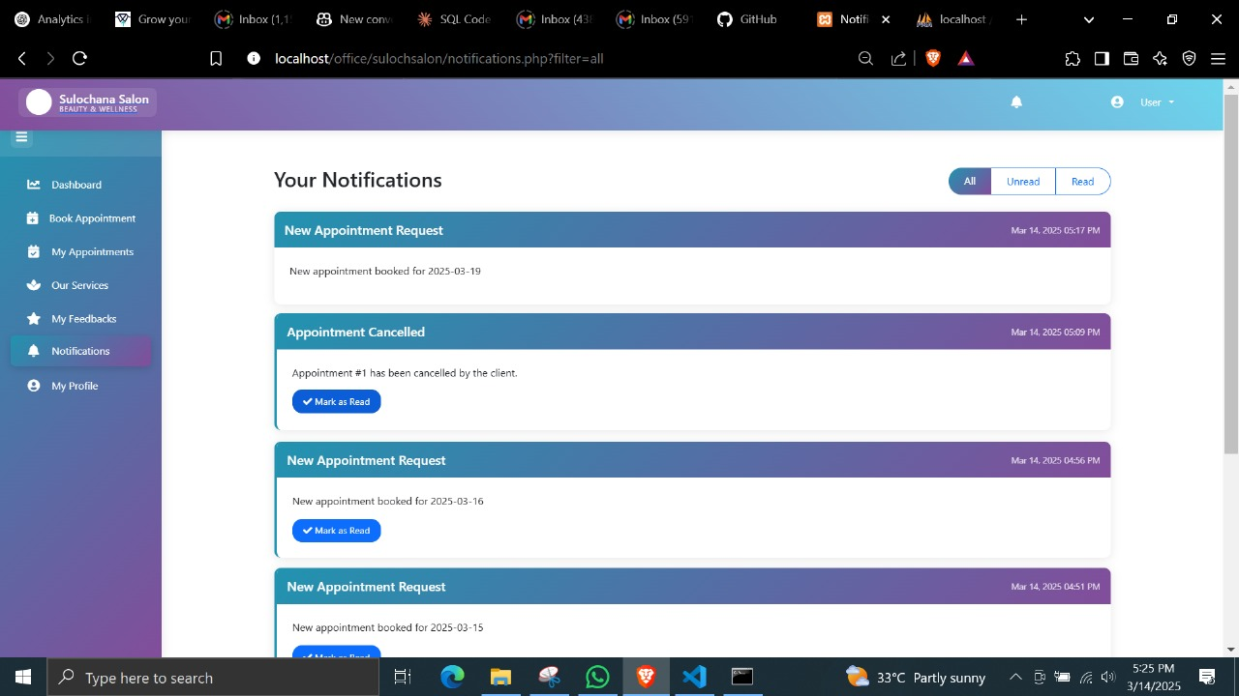

Figure 65

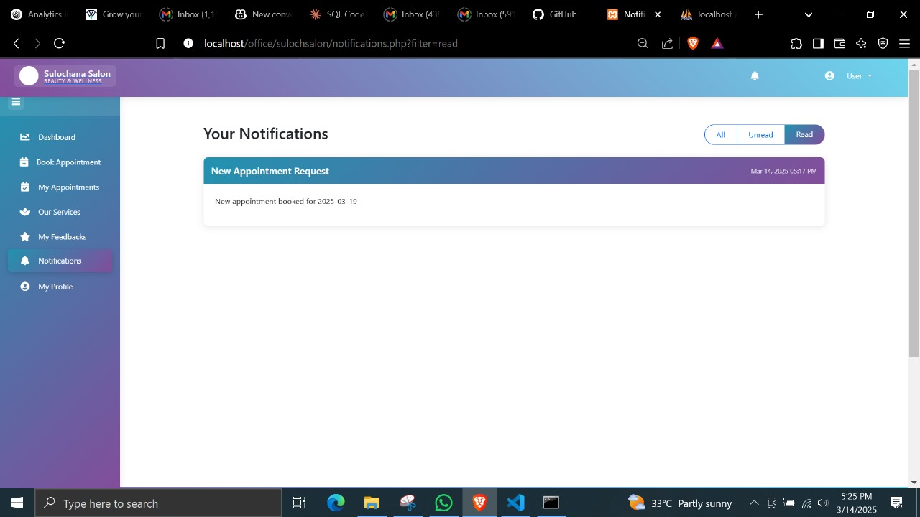

Figure 66

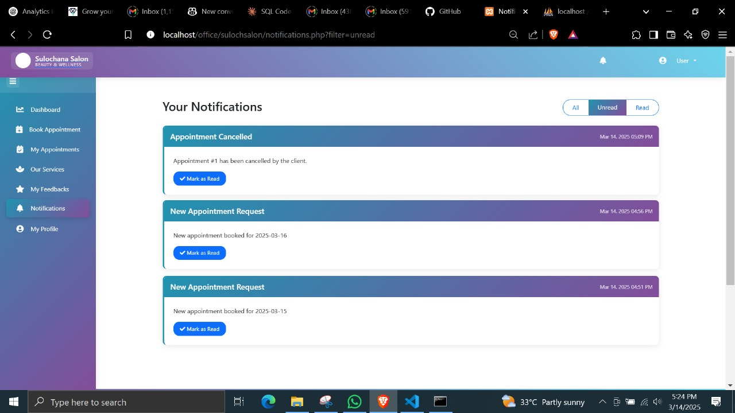

Figure 67

##### C10. Email Verification (C- C131- C133)

|  |  |  |  |  |  |
| --- | --- | --- | --- | --- | --- |
| Test ID | Test Case | Test Steps | Expected Result | Actual Result | Status |
| TC-C131 | Valid Email Verification | 1. Click "Forgot Password"  2. Enter registered email  3. Click "Verify Email" | Verification code sent to email | As expected | Pass |
| TC-C132 | Unregistered Email | 1. Enter unregistered email  2. Click "Verify Email" | Error message displayed | As expected | Pass |
| TC-C133 | Empty Email Field | 1. Leave email field empty  2. Click "Verify Email" | Validation error shown | As expected | Pass |

Table 16

##### C11. Password Reset (C- C134- C137)

|  |  |  |  |  |  |
| --- | --- | --- | --- | --- | --- |
| Test ID | Test Case | Test Steps | Expected Result | Actual Result | Status |
| TC-C134 | Valid Password Reset | 1. Enter new password meeting requirements  2. Confirm password  3. Click "Reset Password" | Password successfully reset | As expected | Pass |
| TC- C135 | Password Mismatch | 1. Enter different passwords in new and confirm fields  2. Click "Reset Password" | Error message shown | As expected | Pass |
| TC- C136 | Password Requirements Check | 1. Enter password missing requirements  2. Click "Reset Password" | Validation error shown | As expected | Pass |
| TC- C137 | Cancel Password Reset | 1. Click "Back to Login" button | Returns to login screen | As expected | Pass |

Table 17

##### C12. Reset Confirmation (C- C138- C139)

|  |  |  |  |  |  |
| --- | --- | --- | --- | --- | --- |
| Test ID | Test Case | Test Steps | Expected Result | Actual Result | Status |
| TC- C138 | Success Confirmation | 1. After successful reset  2. View success message | Success message displayed | As expected | Pass |
| TC- C139 | Return to Login | 1. From success screen  2. Click "Go to Login" | Returns to login screen | As expected | Pass |

Table 18

##### C13. Current Password Verification (C-CP140-CP142)

|  |  |  |  |  |  |
| --- | --- | --- | --- | --- | --- |
| Test ID | Test Case | Test Steps | Expected Result | Actual Result | Status |
| TC-C140 | Valid Current Password | 1. Enter correct current password<br>2. Enter valid new password<br>3. Submit form | Password changed successfully | As expected | Pass |
| TC-C141 | Invalid Current Password | 1. Enter incorrect current password<br>2. Enter new password<br>3. Submit form | Error message displayed | As expected | Pass |
| TC-C142 | Empty Current Password | 1. Leave current password empty<br>2. Submit form | Validation error shown | As expected | Pass |

Table 19

C11. New Password Validation (C-CP143-CP146)

|  |  |  |  |  |  |
| --- | --- | --- | --- | --- | --- |
| Test ID | Test Case | Test Steps | Expected Result | Actual Result | Status |
| TC-C143 | Password Requirements Check | 1. Enter new password not meeting requirements<br>2. Submit form | Validation error shown | As expected | Pass |
| TC-C144 | Password Confirmation Match | 1. Enter new password<br>2. Enter different confirm password<br>3. Submit form | Error message shown | As expected | Pass |
| TC-C145 | Same as Current Password | 1. Enter new password same as current<br>2. Submit form | Warning message shown | As expected | Pass |
| TC-C146 | Valid New Password | 1. Enter valid new password meeting all requirements<br>2. Matching confirm password<br>3. Submit form | Password changed successfully | As expected | Pass |

Table 20

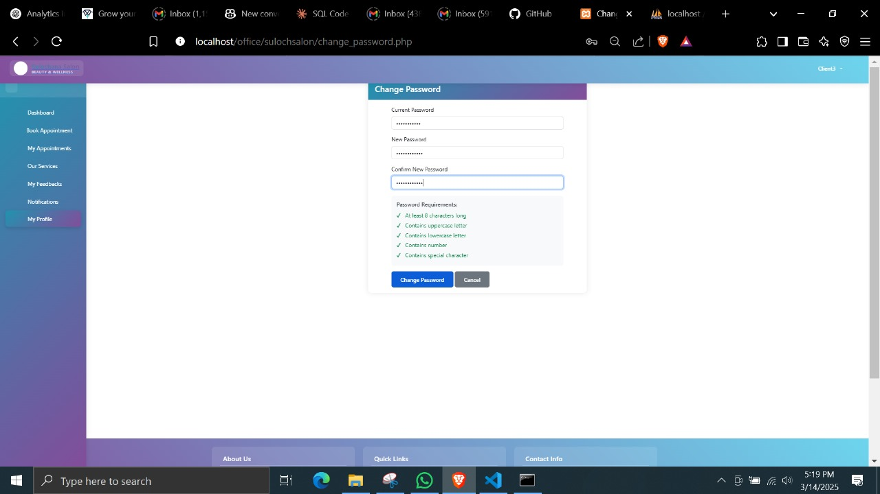

Figure 68

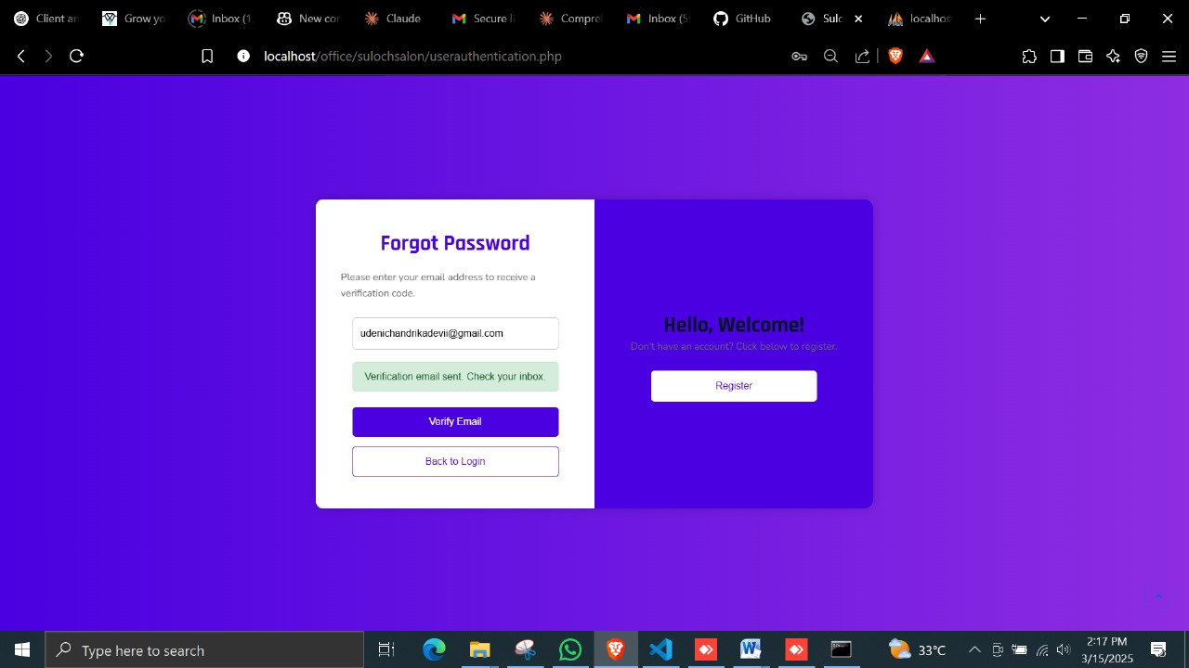

Figure 69

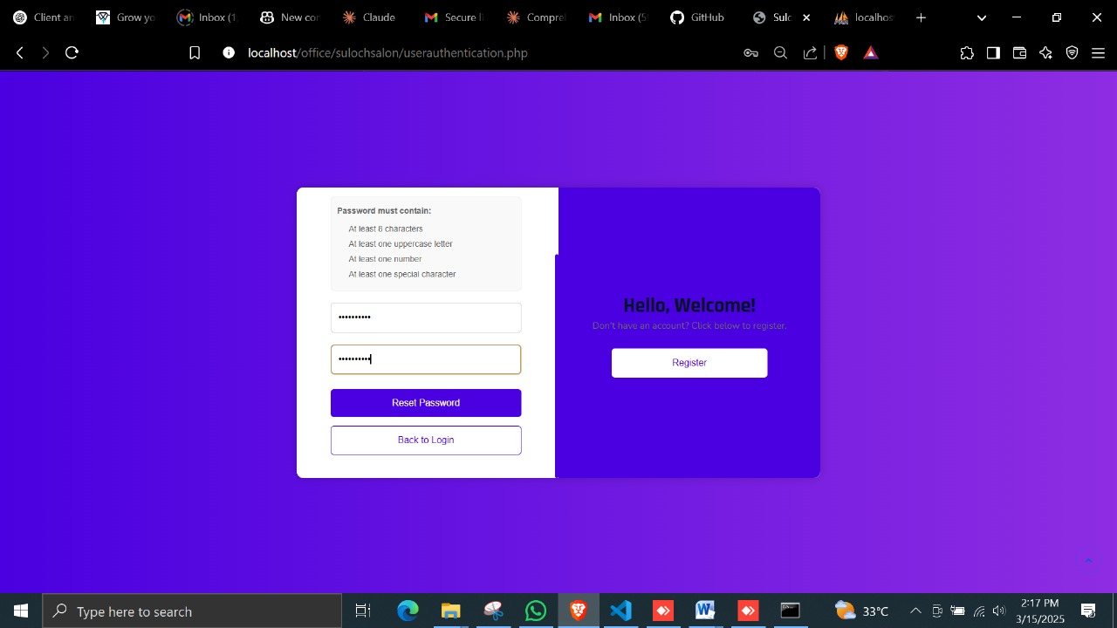

Figure 70

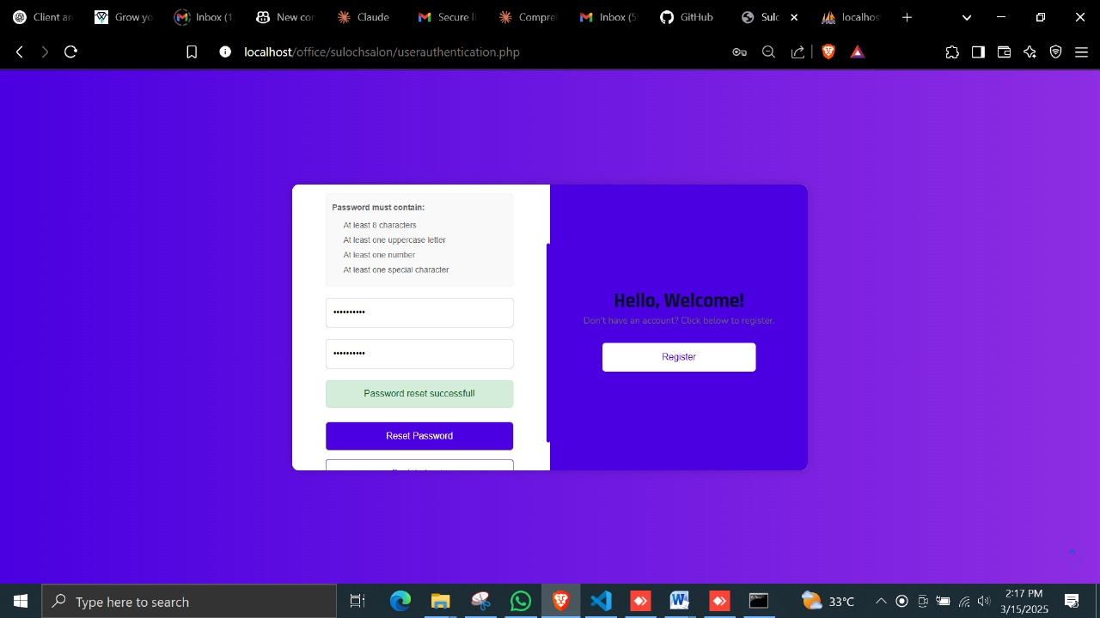

Figure 71

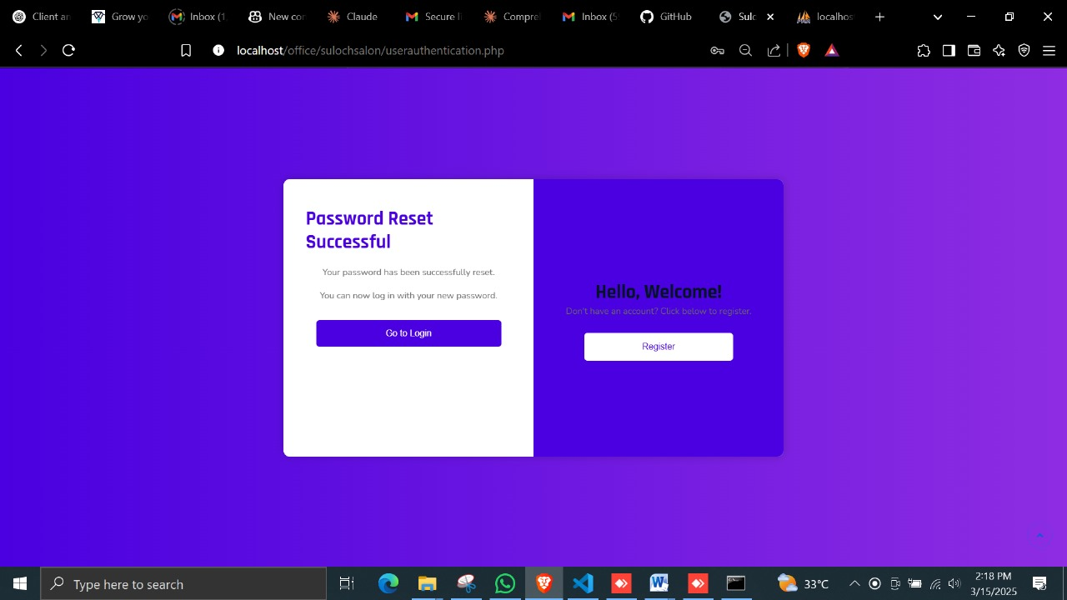

Figure 72

## Admin Side Test Cases

#### Admin Side Detailed Test Cases

##### A1. Admin Login (TC-A101-A105)

|  |  |  |  |  |  |
| --- | --- | --- | --- | --- | --- |
| Test ID | Test Case | Test Steps | Expected Result | Actual Result | Status |
| TC-A101 | Valid Admin Login | 1. Enter valid admin credentials<br>2. Click login | Successful admin login | As expected | Pass |
| TC-A102 | Invalid Admin Password | 1. Enter wrong password | Error message | As expected | Pass |
| TC-A103 | Admin Empty Fields | 1. Submit empty form | Validation message | As expected | Pass |
| TC-A104 | Admin Password Reset | 1. Click forgot password<br>2. Enter admin email | Reset email sent | As expected | Pass |
| TC-A105 | Admin Session Check | 1. Login<br>2. Close browser<br>3. Reopen | Session maintained | As expected | Pass |

Table 21

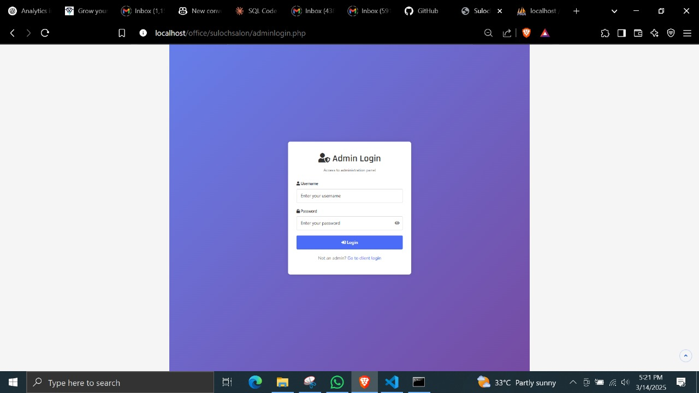

Figure 73

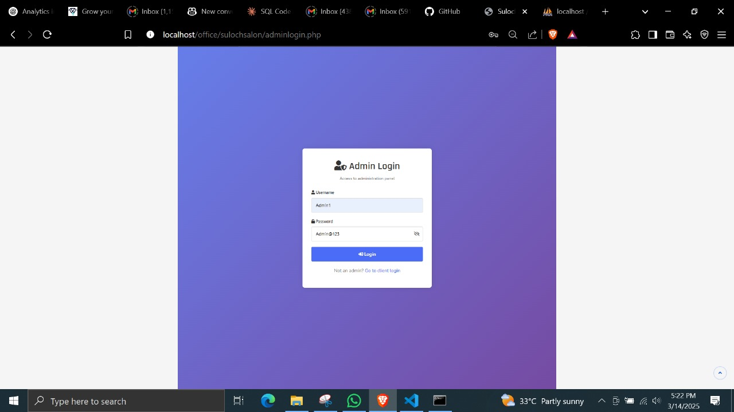

Figure 74

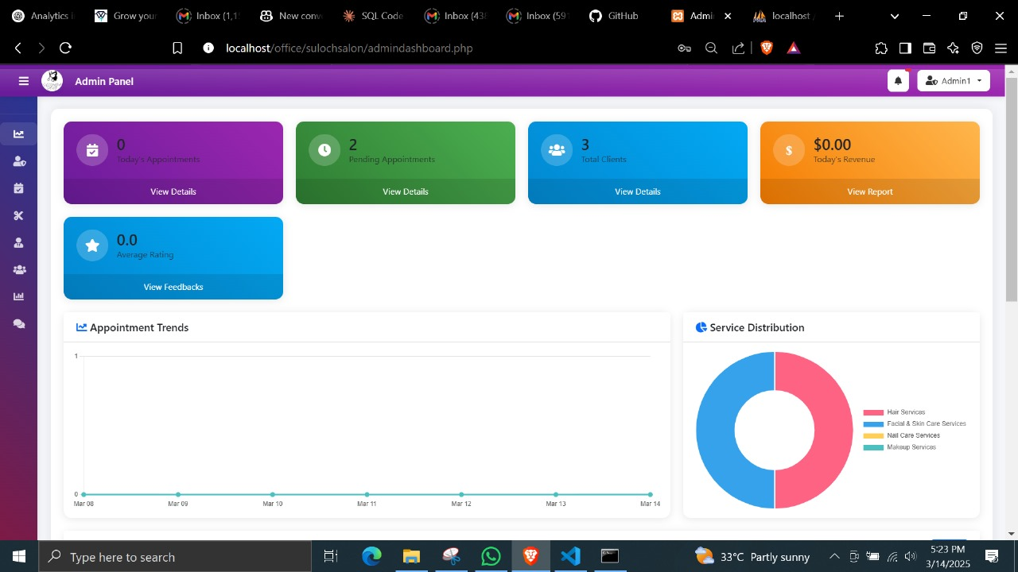

Figure 75

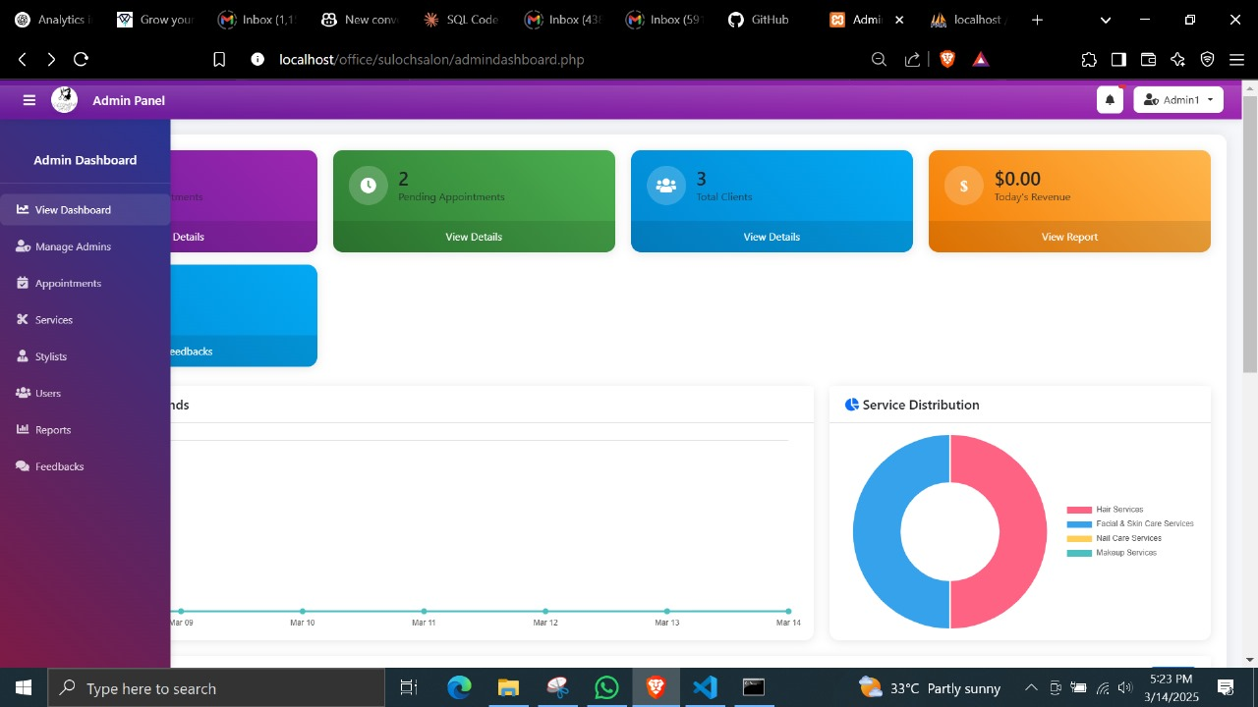

Figure 76

##### A2. Analytics & Reporting (TC-A106-A110)

|  |  |  |  |  |  |
| --- | --- | --- | --- | --- | --- |
| Test ID | Test Case | Test Steps | Expected Result | Actual Result | Status |
| TC-A106 | View Dashboard | 1. Login as admin<br>2. Access dashboard | Stats displayed | As expected | Pass |
| TC-A107 | View Daily Stats | 1. Check daily stats section | Daily metrics shown | As expected | Pass |
| TC-A108 | View Monthly Reports | 1. Access monthly reports | Monthly data displayed | As expected | Pass |
| TC-A109 | Export Reports | 1. Generate reports<br>2. Export data | Report generated | As expected | Pass |

Table 22

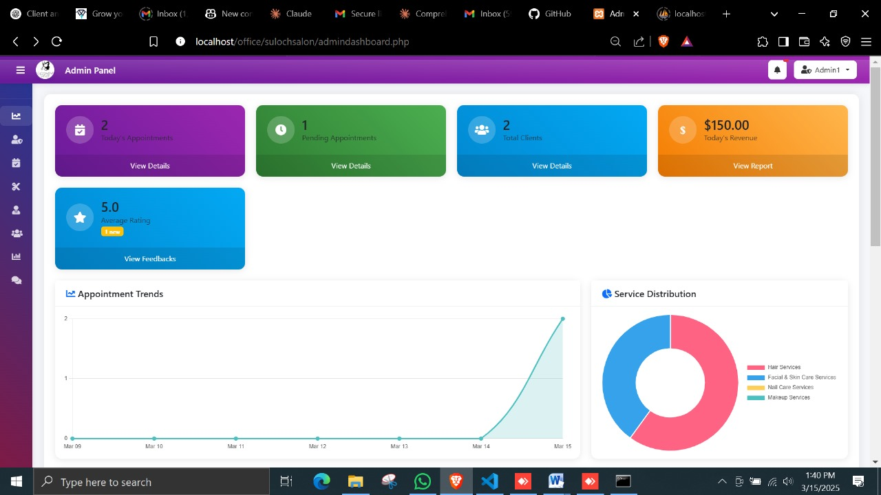

Figure 77

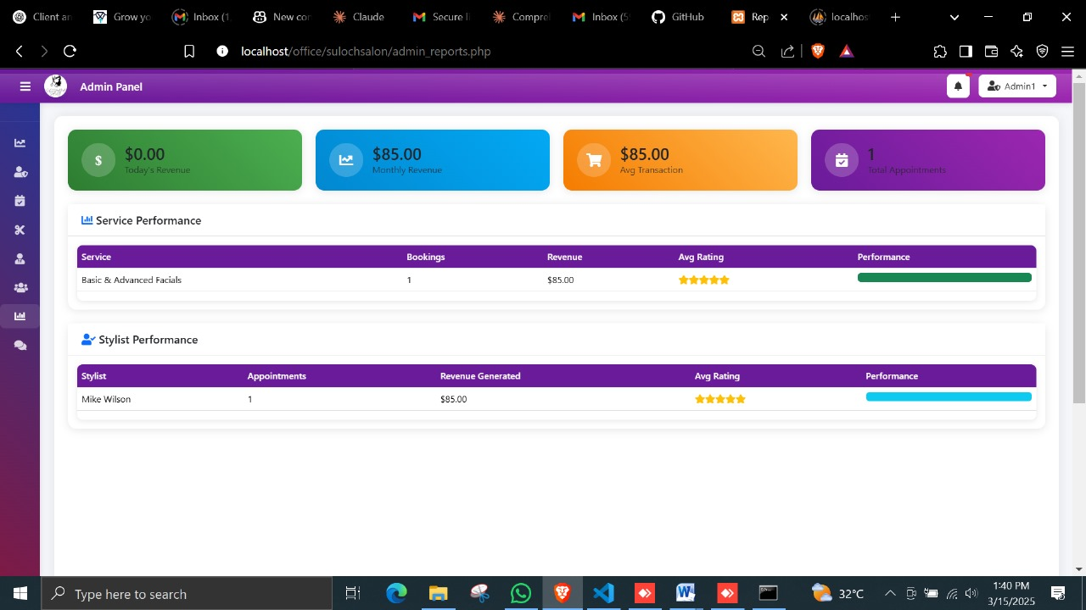

Figure 78

##### A3. Customer Management (TC-A111-A114)

|  |  |  |  |  |  |
| --- | --- | --- | --- | --- | --- |
| Test ID | Test Case | Test Steps | Expected Result | Actual Result | Status |
| TC-A111 | View User List | 1. Access user management | User list displayed | As expected | Pass |
| TC-A112 | Edit User | 1. Select user<br>2. Edit details<br>3. Save | Changes saved | As expected | Pass |
| TC-A113 | Delete User | 1. Select user<br>2. Delete<br>3. Confirm | User deleted | As expected | Pass |
| TC-A114 | Search Users | 1. Enter search query<br>2. Submit | Search results shown | As expected | Pass |

Table 23

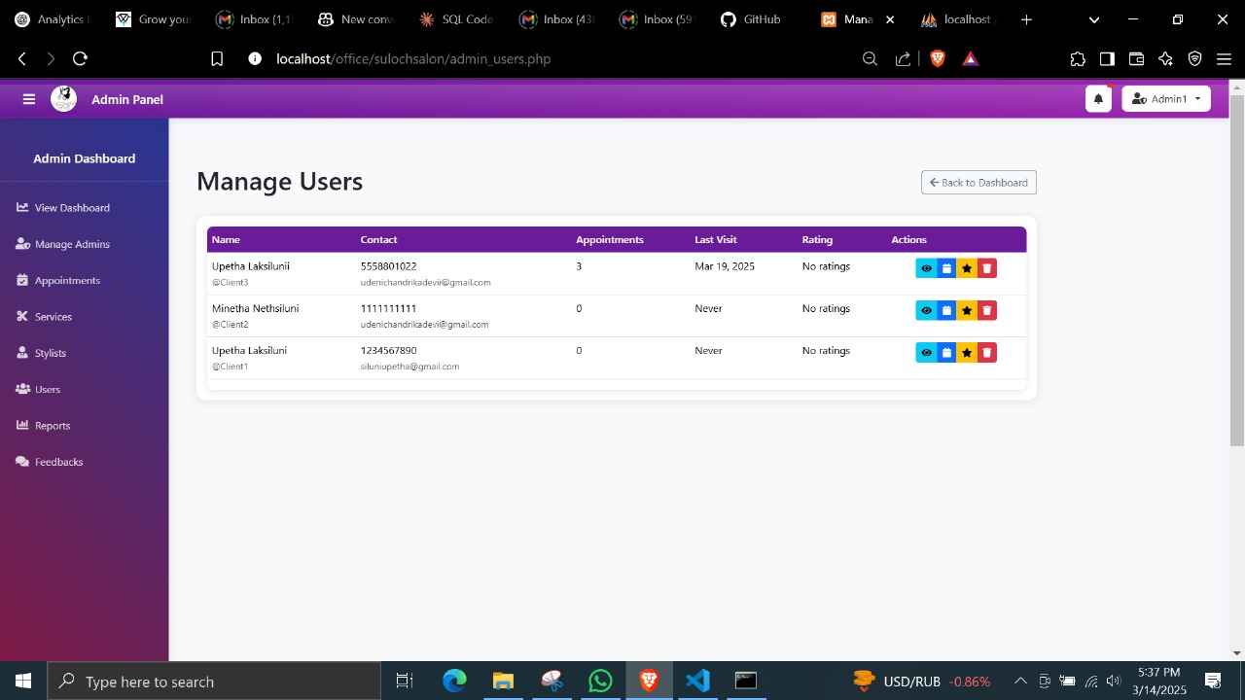

Figure 79

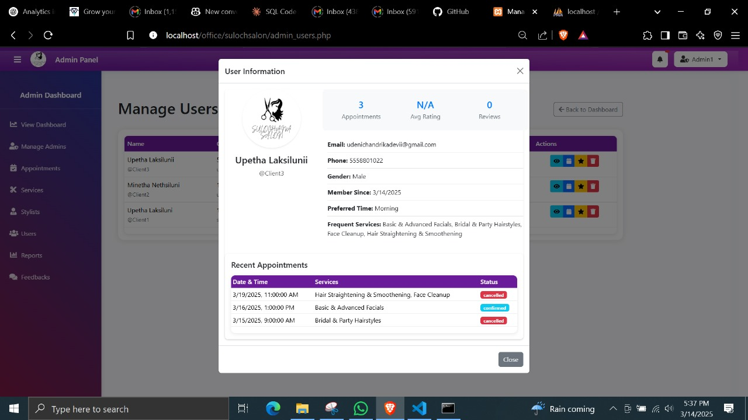

Figure 80

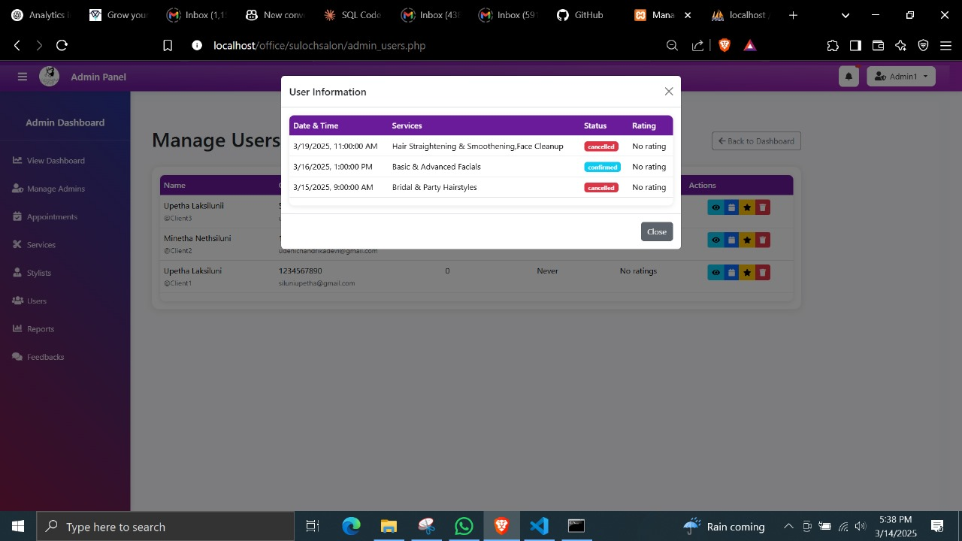

Figure 81

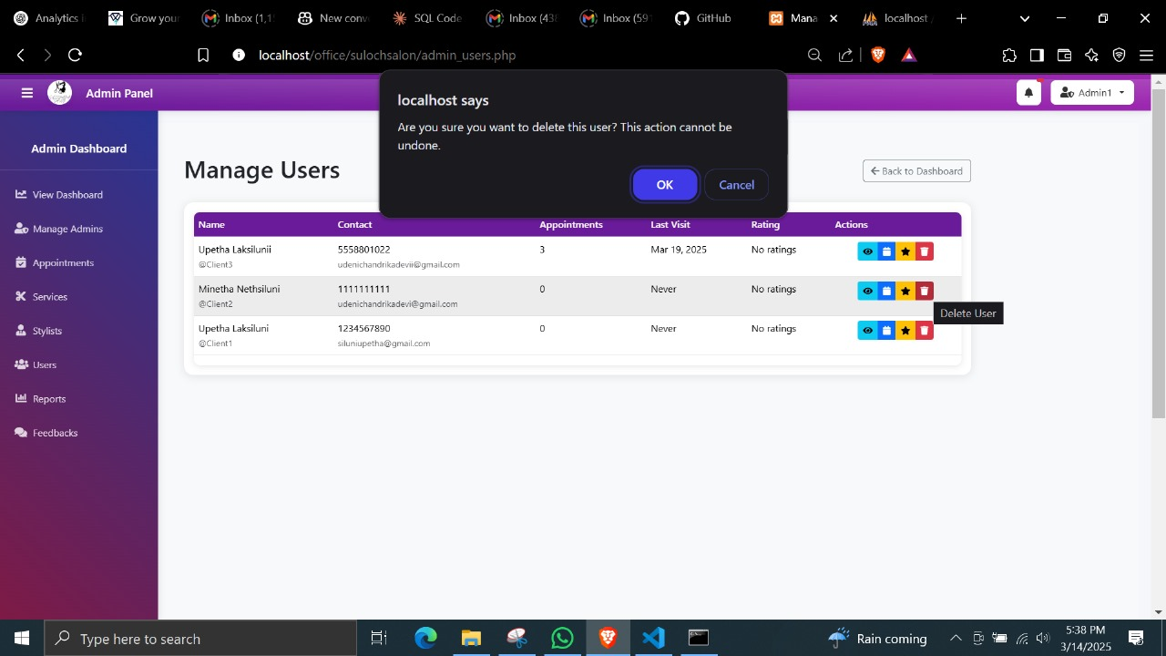

Figure 82

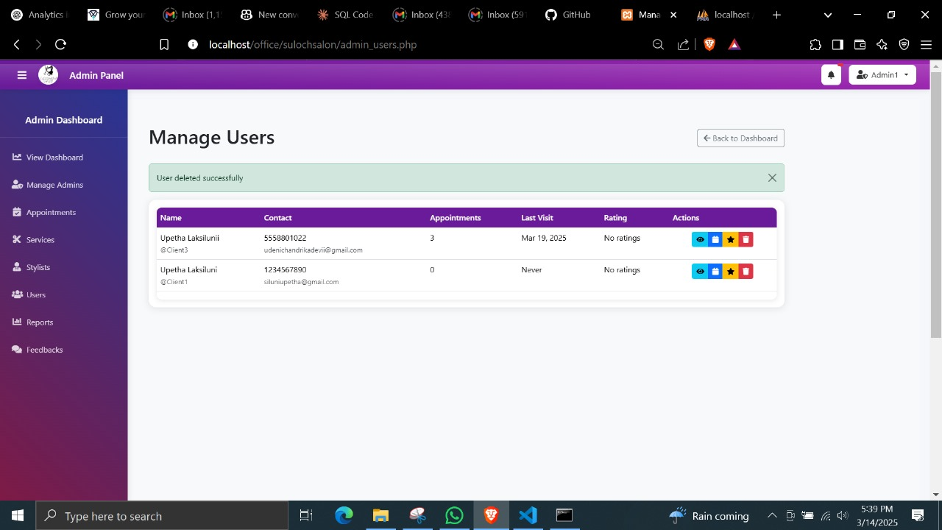

Figure 83

##### A4. Appointment Tracking (TC-A115-A118)

|  |  |  |  |  |  |
| --- | --- | --- | --- | --- | --- |
| Test ID | Test Case | Test Steps | Expected Result | Actual Result | Status |
| TC-A115 | View All Appointments | 1. Access appointment list | All appointments shown | As expected | Pass |
| TC-A116 | Update Appointment Status | 1. Select appointment<br>2. Change status<br>3. Save | Status updated | As expected | Pass |
| TC-A117 | Filter Appointments | 1. Apply filters<br>2. View results | Filtered appointments shown | As expected | Pass |
| TC-A118 | Assign Stylist | 1. Select appointment<br>2. Assign stylist<br>3. Save | Stylist assigned | As expected | Pass |

Table 24

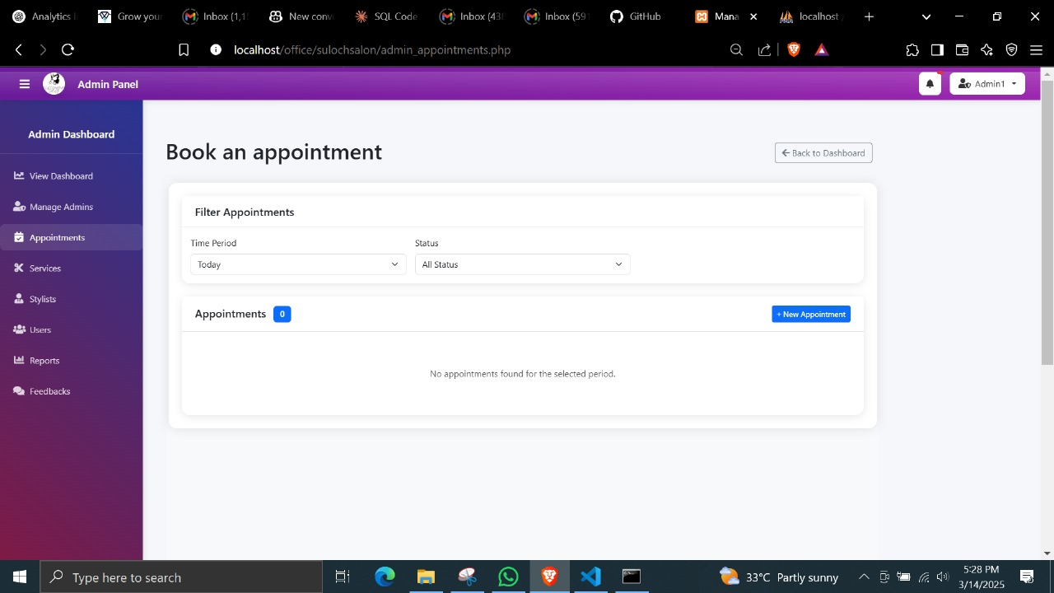

Figure 84

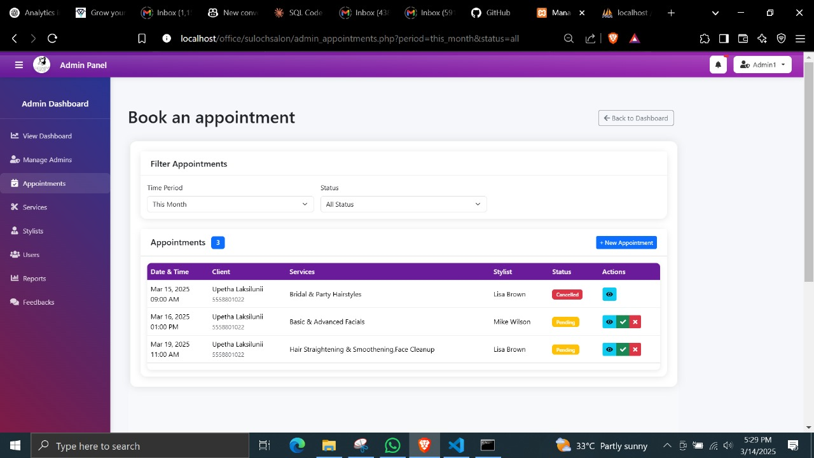

Figure 85

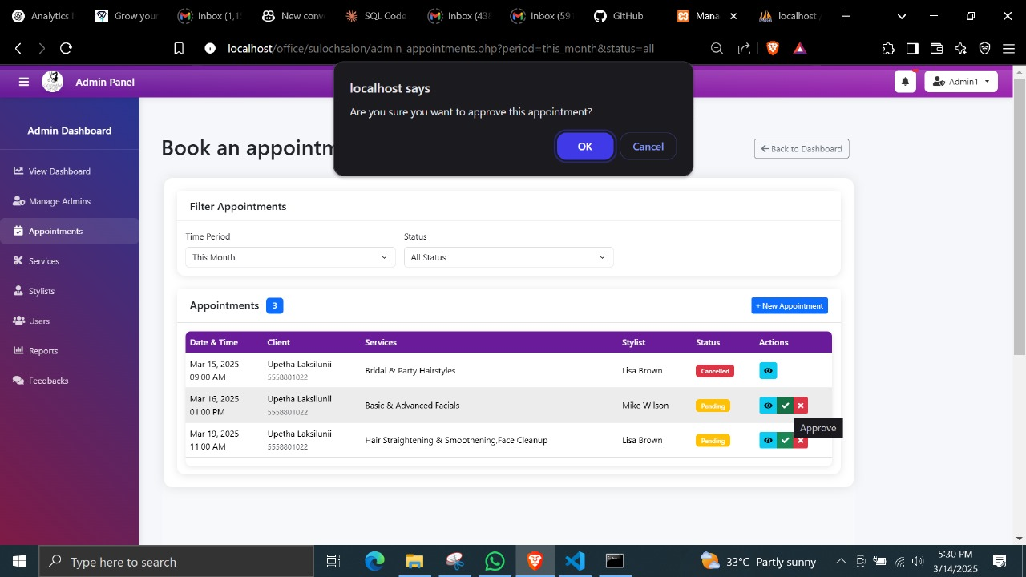

Figure 86

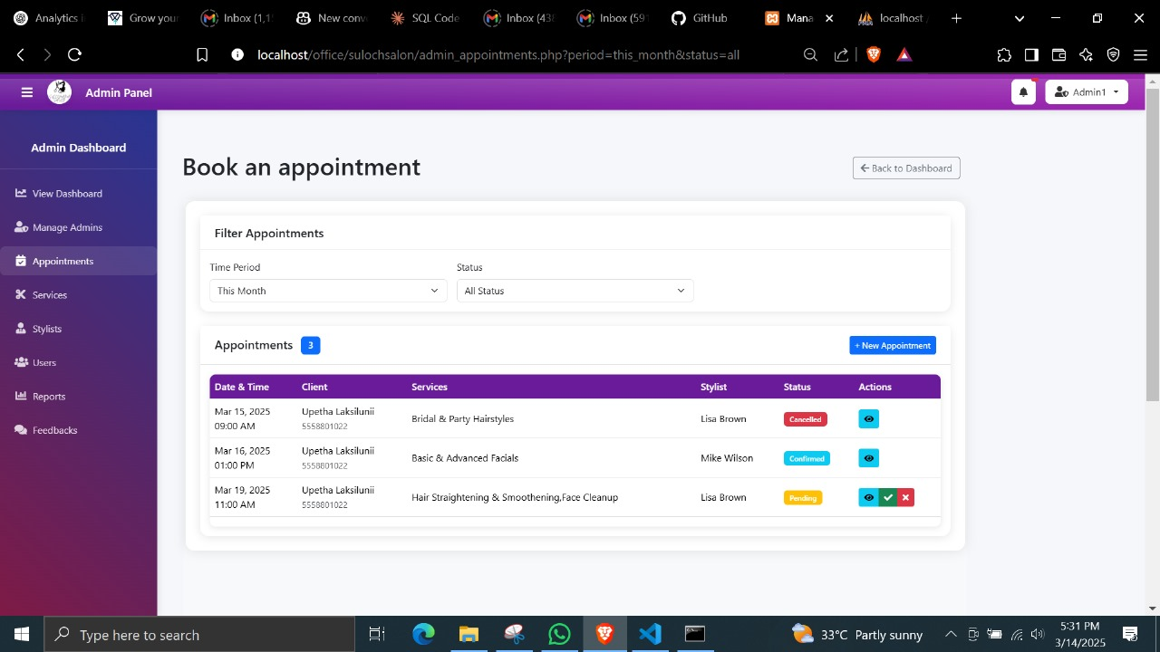

Figure 87

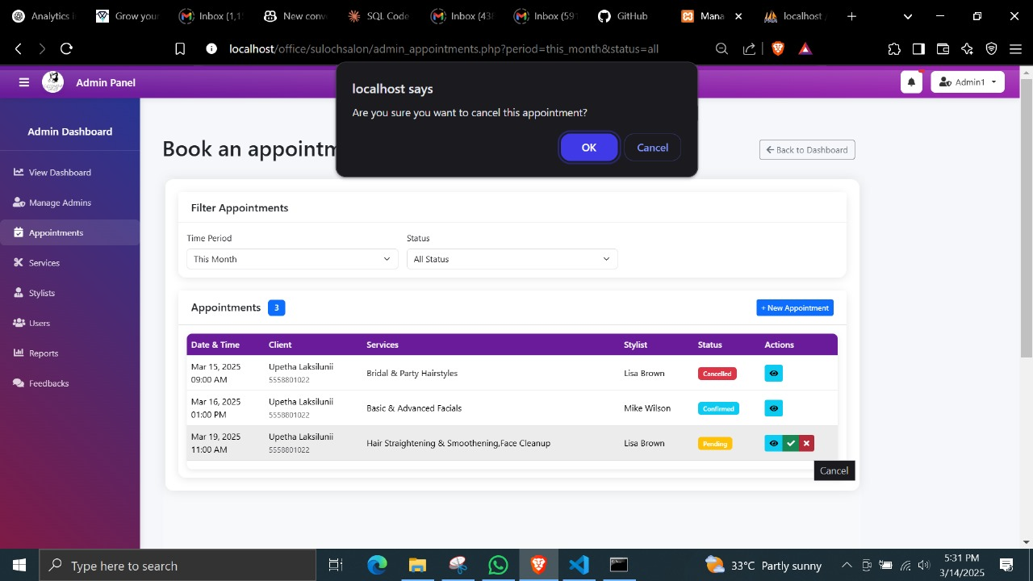

Figure 88

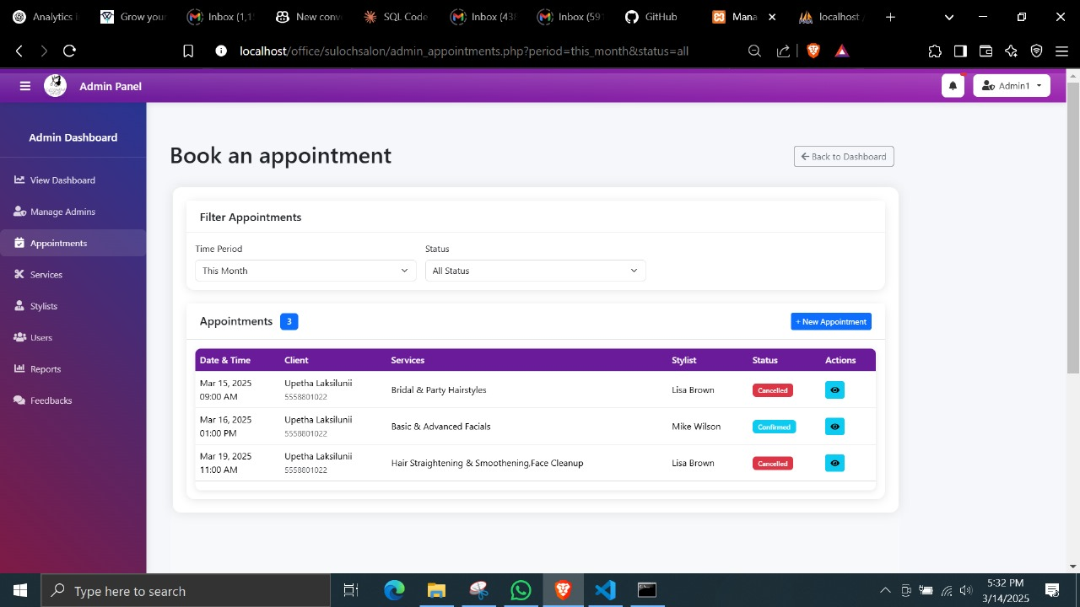

Figure 89

##### A5. Stylist Management (TC-A119-A122)

|  |  |  |  |  |  |
| --- | --- | --- | --- | --- | --- |
| Test ID | Test Case | Test Steps | Expected Result | Actual Result | Status |
| TC-A119 | Add Stylist | 1. Enter stylist details<br>2. Save | Stylist added | As expected | Pass |
| TC-A120 | Edit Stylist | 1. Select stylist<br>2. Edit details<br>3. Save | Changes saved | As expected | Pass |
| TC-A121 | Delete Stylist | 1. Select stylist<br>2. Delete<br>3. Confirm | Stylist deleted | As expected | Pass |
| TC-A122 | Update Schedule | 1. Select stylist<br>2. Update schedule<br>3. Save | Schedule updated | As expected | Pass |

Table 25

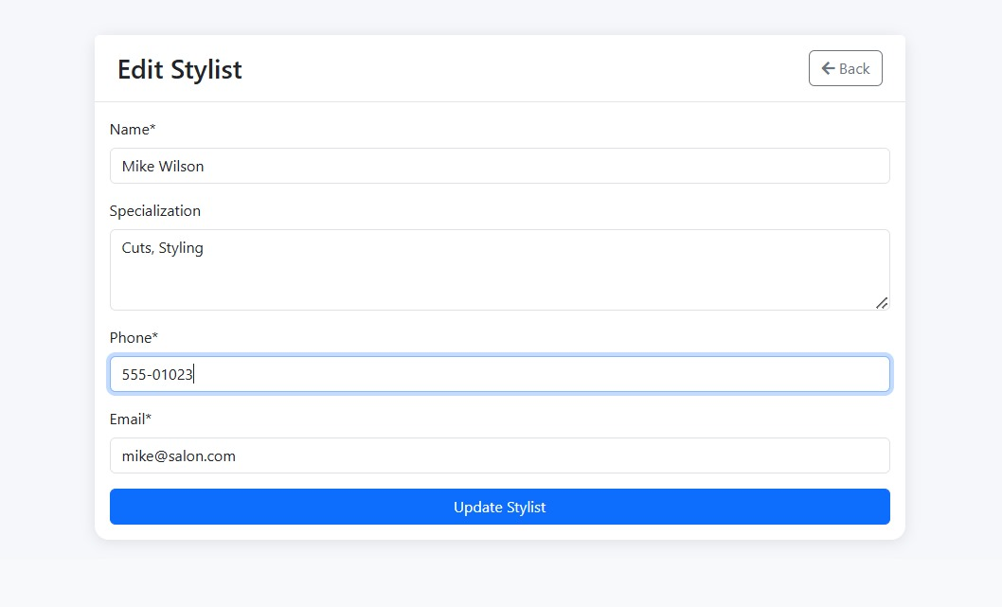

Figure 90

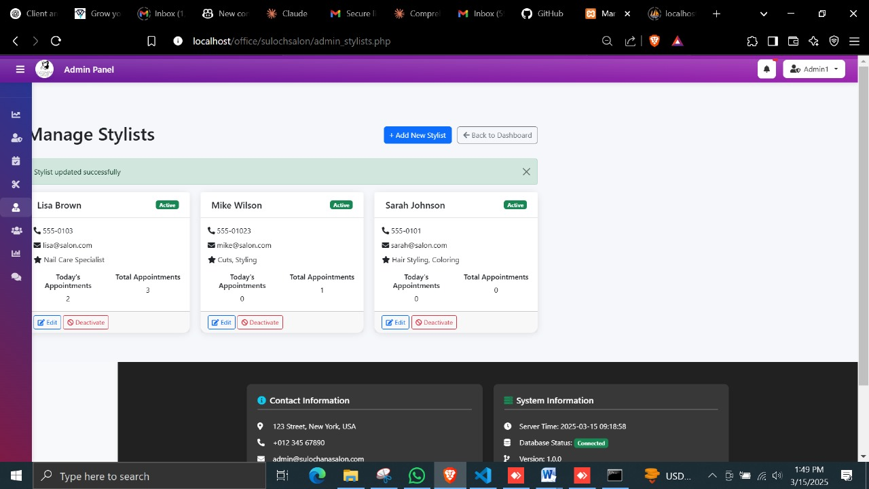

Figure 91

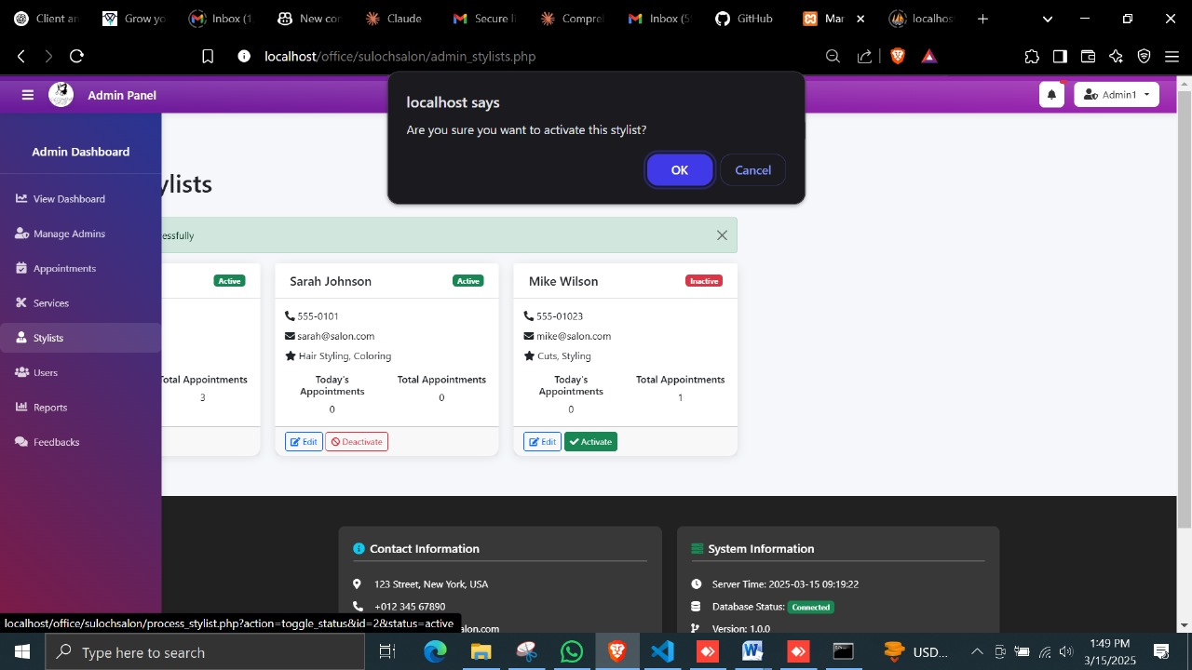

Figure 92

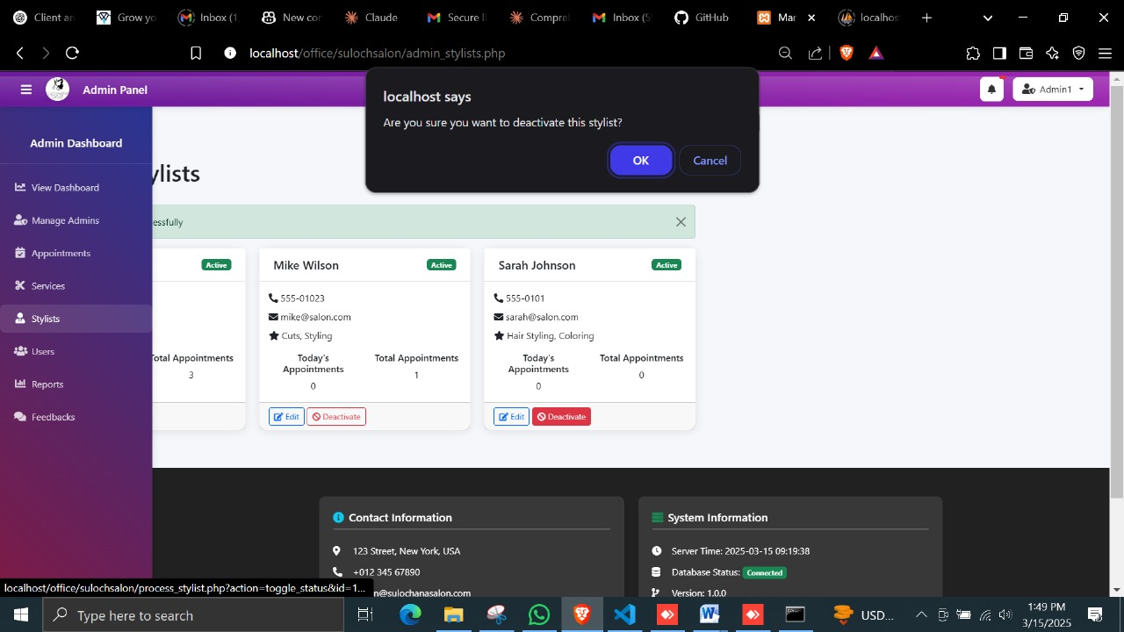

Figure 93

##### A6. Service Management (TC-A123-A126)

|  |  |  |  |  |  |
| --- | --- | --- | --- | --- | --- |
| Test ID | Test Case | Test Steps | Expected Result | Actual Result | Status |
| TC-A123 | Add Service | 1. Enter service details<br>2. Save | Service added | As expected | Pass |
| TC-A124 | Edit Service | 1. Select service<br>2. Edit details<br>3. Save | Service updated | As expected | Pass |
| TC-A125 | Delete Service | 1. Select service<br>2. Delete<br>3. Confirm | Service deleted | As expected | Pass |
| TC-A126 | Categorize Service | 1. Select service<br>2. Assign category<br>3. Save | Category assigned | As expected | Pass |

Table 26

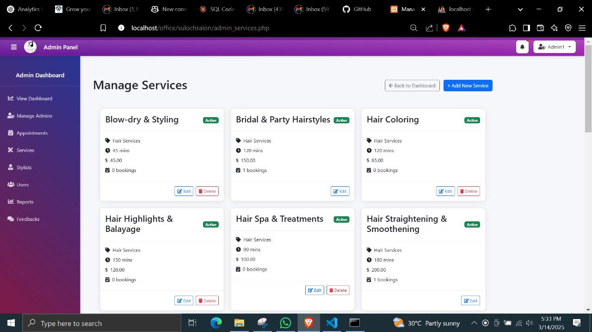

Figure 94

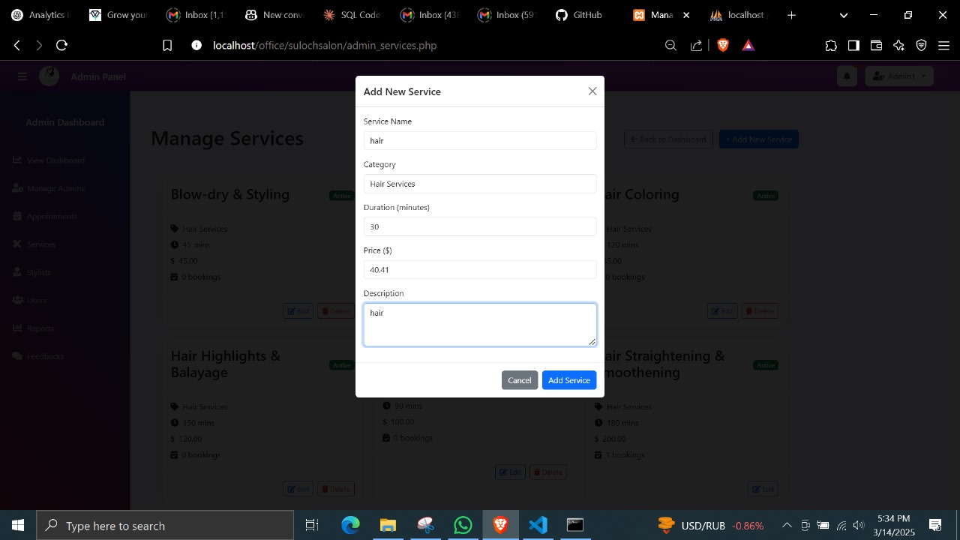

Figure 95

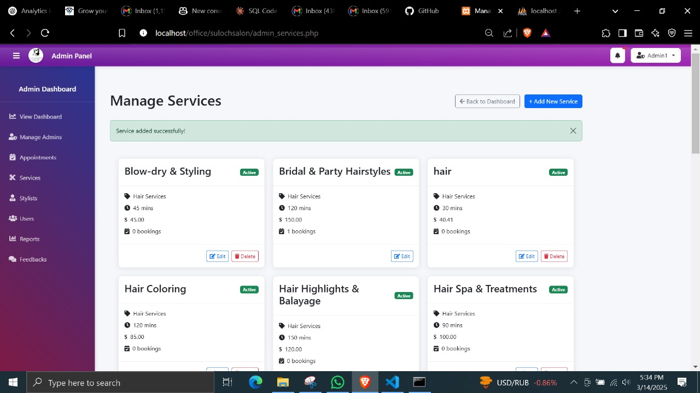

Figure 96

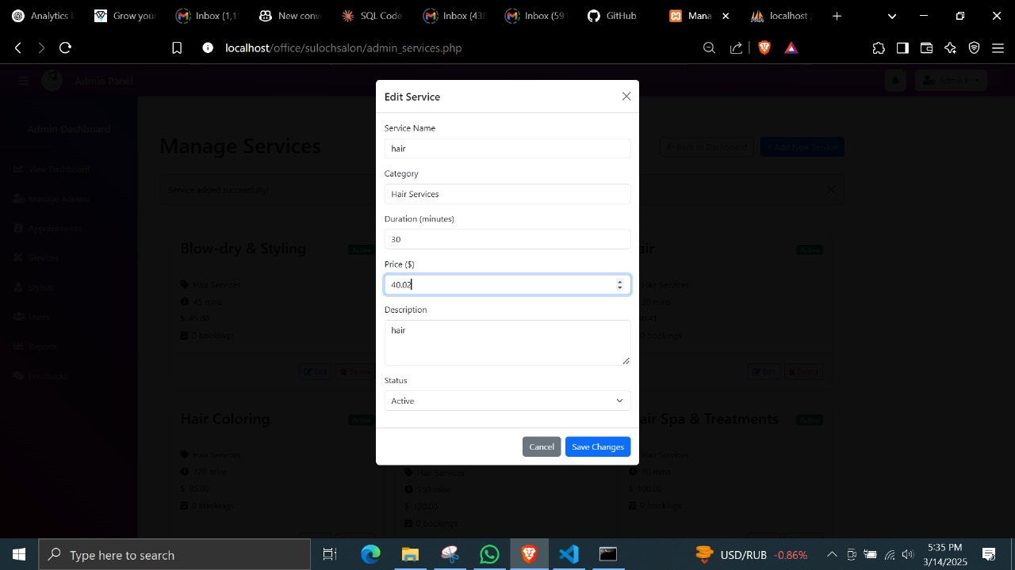

Figure 97

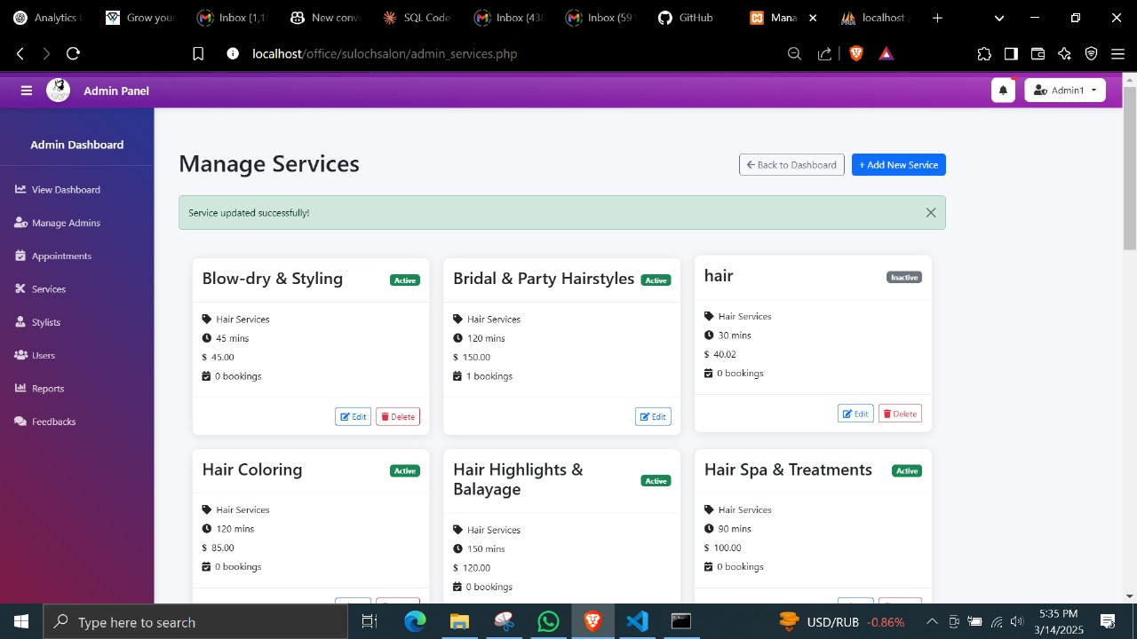

Figure 98

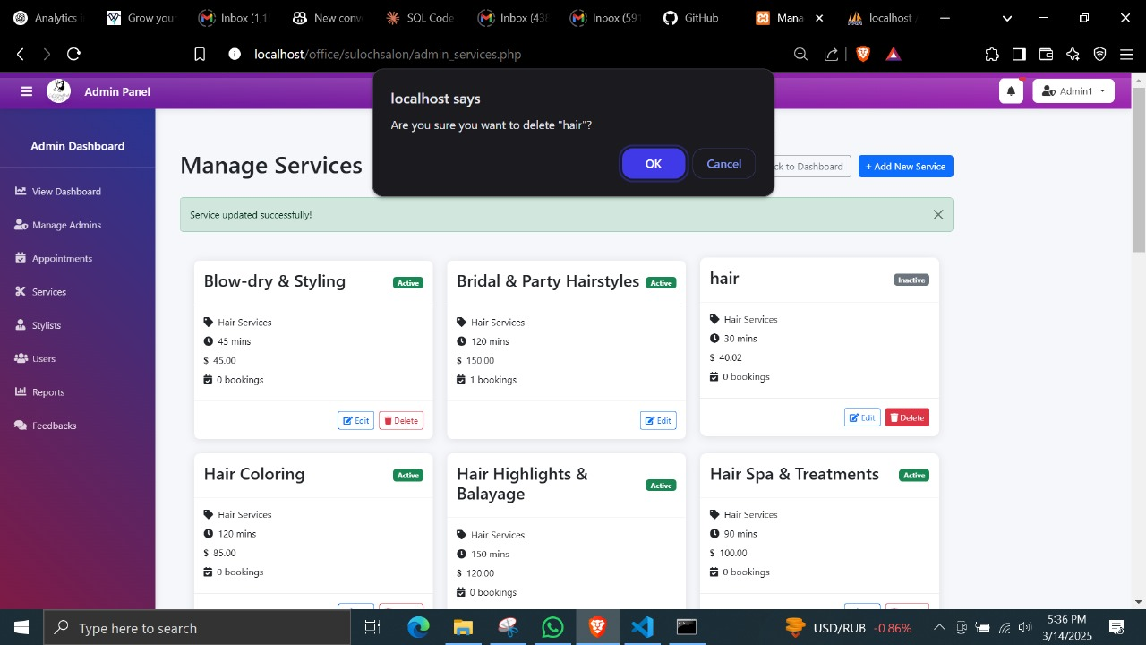

Figure 99

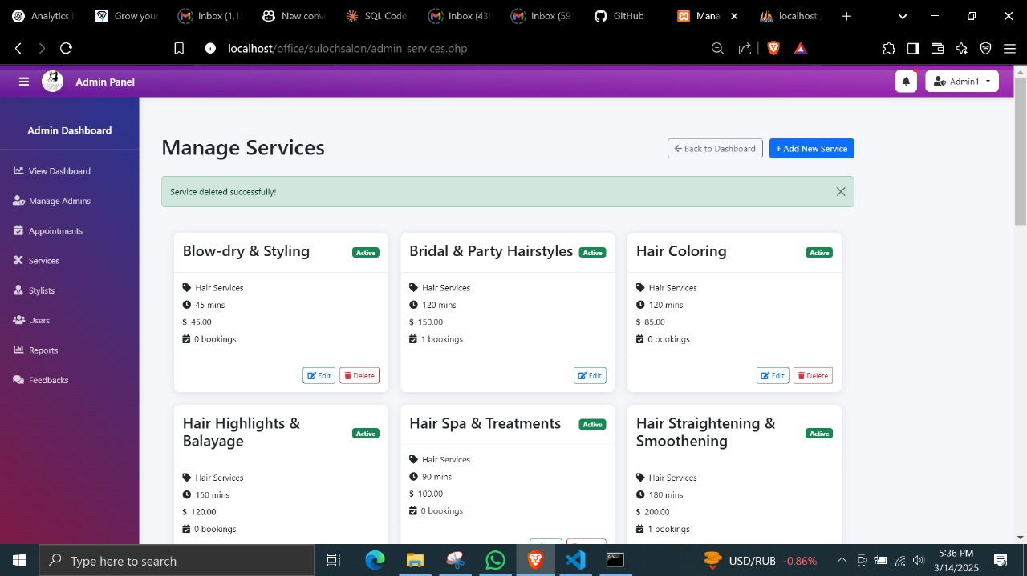

Figure 100

##### A7. Pricing Management (TC-A127-A129)

|  |  |  |  |  |  |
| --- | --- | --- | --- | --- | --- |
| Test ID | Test Case | Test Steps | Expected Result | Actual Result | Status |
| TC-A127 | Update Price | 1. Select service<br>2. Edit pricing<br>3. Save | Price updated | As expected | Pass |
| TC-A128 | Add Discount | 1. Select service<br>2. Add discount<br>3. Save | Discount applied | As expected | Pass |
| TC-A129 | Set Special Offers | 1. Create special offer<br>2. Assign services<br>3. Save | Offer created | As expected | Pass |

Table 27

##### A8. Notifications (TC-A127-C130)

|  |  |  |  |  |  |
| --- | --- | --- | --- | --- | --- |
| Test ID | Test Case | Test Steps | Expected Result | Actual Result | Status |
| TC-C127 | Booking Confirmation Email | 1. Book appointment  2. Check email | Confirmation received | Not as expected | Pass |
| TC-C128 | Appointment Reminder | 1. Approach appointment time  2. Check notifications | Reminder received | Not as expected | Pass |
| TC-C129 | Status Change Notification | 1. Admin changes status  2. Check notifications | Update received | Not as expected | Pass |
| TC-C130 | Cancellation Notification | 1. Cancel appointment  2. Check notifications | Cancellation notice received | Not as expected | Pass |

Table 28



Figure 101



Figure 102



Figure 103



Figure 104

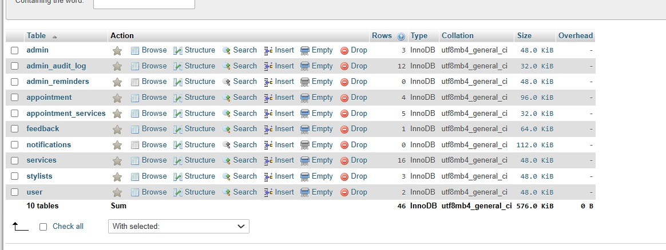

Figure 105

## Test Conclusions

1. Authentication System
   * The user and admin authentication systems have been thoroughly tested and are functioning correctly.
   * Password encryption, recovery, and session management are all working as expected.
   * No major security vulnerabilities were found during testing.
   * The system properly handles invalid login attempts and provides appropriate error messages.
2. Appointment System
   * The booking process is stable and reliable across all tested scenarios.
   * Users can successfully book, reschedule, and cancel appointments through all supported interfaces.
   * Time slot management correctly prevents double-booking.
   * Notification delivery upon appointment status changes is working properly.
   * The system correctly handles edge cases like booking outside business hours.
3. User Management
   * User registration, profile updates, and account management features are functioning correctly.
   * Profile photo uploads work properly with the supported image formats.
   * Role-based access control successfully restricts system features based on user type.
   * Data validation on user input fields is working correctly.
4. Admin Dashboard
   * All dashboard statistics are displaying accurate data from the database.
   * Filtering and reporting functions are working as expected.
   * Data visualizations correctly represent the underlying information.
   * The dashboard is responsive across different screen sizes.
5. Service Management
   * Service addition, modification, and categorization features are working correctly.
   * Pricing updates apply successfully across the system.
   * Assignment of services to specific stylists functions as intended.
   * Service filtering and searching work correctly.
6. Notification System
   * Email notifications are being delivered correctly for all triggered events.
   * The system properly handles notification failures with appropriate retry logic.
   * Email templates render correctly across different email clients.
   * Real-time notifications display correctly in the user interface.
7. Feedback System
   * Rating collection and display mechanisms work as expected.
   * Users can successfully modify their existing ratings.
   * Average ratings are calculated and displayed correctly.
   * The feedback reporting system provides accurate data to administrators.

# Co-functionalities Used Here

* **Appointment Scheduling**: The system allows users to book appointments for specific services, which automatically updates the salon’s schedule.



Figure 106



Figure 107



Figure 108



Figure 109



Figure 110



Figure 111



Figure 112



Figure 113



Figure 114



Figure 115



Figure 116



Figure 117



Figure 118



Figure 119



Figure 120



Figure 121



Figure 122



Figure 123

* **Admin Dashboard**: Admins can access real-time data such as appointments, customer details, and business performance metrics.



Figure 124

* **User Roles**: The system assigns roles (client, admin) to control access to certain features, ensuring data security and proper functionality.
* **Notifications**: Automated reminders help reduce no-shows by sending email/SMS alerts about upcoming appointments.



Figure 125



Figure 126



Figure 127

# Hardware & Software Requirements

## Hardware Requirements:

* **Web Server**: Apache or Nginx for hosting the website.
* **Database Server**: MySQL for managing user and appointment data.
* **Development Machines**: Standard PCs or laptops for developers, capable of running local development environments like XAMPP.
* **User Devices**: Clients can access the website from any device (desktop, tablet, or smartphone) with an internet connection.

## Software Requirements:

* **Web Browser**: Google Chrome, Mozilla Firefox, or Safari.
* **PHP 7.4+**: Server-side scripting for backend logic.
* **MySQL 5.7+**: Database management.
* **Development Tools**: Visual Studio Code, XAMPP for local server setup.
* **Version Control**: Git for code management and collaboration.

# Observations and Review of Existing Systems for Salon Management

## Strengths of Existing Systems:

* **Efficient Booking**: Most systems allow online appointment booking, which improves customer satisfaction.
* **Service Management**: Many systems offer an easy-to-use interface for managing services and prices.
* **Customer Management**: Existing systems often have features for managing customer data and appointment history.

# **Limitations of the Project**

While the **Sulochana Salon Website** provides an efficient and automated salon management system, there are certain **limitations** that need to be addressed to ensure improved functionality, user adaptability, and scalability. These limitations are both **technical and operational**, impacting **system usability, accessibility, and expansion potential**.

## **Limitations of Existing Systems**

### **Complex User Interface**

Many existing salon management systems have a **complicated and cluttered user interface**, making them difficult for **salon staff and customers** to navigate. Some systems overload the **dashboard with unnecessary features**, leading to **confusion, errors, and inefficiencies** in daily operations. Additionally, employees who are **not tech-savvy** may struggle with **manual appointment entry, service updates, or accessing customer records**.

* **Solution:**
  + The **Sulochana Salon Website** aims to overcome this issue by providing a **simple, clean, and user-friendly interface**. The dashboard is **intuitive and easy to navigate**, ensuring that both **staff and customers** can manage appointments efficiently. Future improvements may include **customizable UI options** to allow users to modify the interface based on their preferences.

### **Limited Customization**

Many salon management software solutions lack **flexibility in modifying service offerings, pricing, and scheduling rules**. Some systems require salon owners to **contact technical support** for even basic changes, such as **adding a new service, updating pricing, or modifying booking slots**. This limitation **restricts salon owners from adapting to customer needs** and implementing **dynamic pricing or seasonal promotions**.

* **Solution:**
  + The **Sulochana Salon Website** allows admins to **add, remove, or modify services and pricing in real time** without requiring external assistance. However, **future updates** can introduce **drag-and-drop customization features**, making the system even more adaptable to different salon needs.

### **Scalability Issues**

Many existing salon management systems **struggle with handling a large volume of data, multiple salon locations, and simultaneous user access**. As the number of customers and staff grows, these systems may experience **performance slowdowns, appointment conflicts, and database overloads**. Furthermore, **most systems are designed for single-location use**, making **multi-branch salon management challenging**.

* **Solution:**
  + The **Sulochana Salon Website** currently supports **a single salon location**. However, future **enhancements** will include **multi-branch functionality**, allowing salon owners to manage **different locations under a centralized dashboard**. Database optimization techniques, such as **cloud-based storage and indexing**, will also improve **system performance**.

## **Limitations of the Sulochana Salon Website**

### **Internet Dependency**

The **Sulochana Salon Website** is a **web-based platform**, meaning it **requires a stable internet connection** for users to access services. Since **appointment scheduling, notifications, and payments** are handled **in real time**, **any network downtime or slow internet speed** may prevent customers from **booking services** or **staff from managing appointments**.

* **Impact:**
  + Customers may **face delays or booking failures** due to network issues.
  + Salon staff **cannot access or update schedules**, leading to **missed appointments**.
  + Online payments may **fail or be delayed**, affecting **business transactions**.
* **Solution:**
  + To address this, an **offline mode** can be integrated into future updates. This would allow customers and staff to **save bookings locally**, which can then **sync automatically once the internet connection is restored**. Additionally, implementing **automatic retry mechanisms for failed payments** can ensure **seamless transactions**.

## **User Learning Curve**

While the system is **designed to be intuitive**, some **salon staff members and clients** who are **not familiar with digital tools** may require **additional time to learn and adapt**. Many salon employees are **accustomed to manual appointment scheduling**, making it **challenging for them to transition to an online booking system**.

* **Challenges:**
  + Staff may **struggle with managing appointments, service updates, and client profiles**.
  + Clients unfamiliar with online platforms may **find it difficult to navigate the website, book services, or process payments**.
* **Solution:**
  + To ease the transition, **training materials such as video tutorials, step-by-step guides, and FAQs** should be provided for both **salon staff and customers**. Additionally, integrating **a chatbot or live customer support** will help users navigate the system **in real time**.

### **Scalability Challenges**

* The **current system is optimized for a single salon branch**, meaning it **does not yet support managing multiple salon locations** under a single admin panel. As the business grows, it may need to handle:
  + **Multiple locations with independent schedules**
  + **Different staff assignments per branch**
  + **Centralized customer and appointment database**
* Without **these features**, salon owners with **multiple branches** may find it difficult to **manage operations efficiently**, leading to **data inconsistencies, performance issues, and scheduling conflicts**.
* **Solution:**
  + Future updates will include:
    - **Multi-branch support** allowing salon owners to manage **several locations under a centralized dashboard**.
    - **Cloud-based infrastructure** to **handle large-scale operations and real-time data synchronization**.
    - **Load balancing and database optimization** to prevent **performance slowdowns** as **user numbers grow**.

## **Data Security & Privacy Concerns**

As a **web-based system handling customer data**, security is a **major concern**. The platform collects **sensitive user information, including names, contact details, booking history, and payment data**. Without **proper security measures**, the system is vulnerable to **hacking, unauthorized access, and data breaches**.

* **Potential Threats:**
  + **SQL Injection & XSS Attacks** – Hackers could exploit vulnerabilities to access the database.
  + **Unauthorized User Access** – Weak authentication mechanisms could lead to data leaks.
  + **Data Loss** – Inadequate backup systems may result in the loss of critical business data.
* **Solution:**

To mitigate these risks, the system has implemented:

* + **SSL Encryption** to protect sensitive transactions.
  + **Role-Based Access Control (RBAC)** to restrict access based on user roles.
  + **Secure Password Storage (Hashed & Salted)** to prevent credential theft.
  + **Regular Data Backups** to ensure recovery in case of unexpected failures.

# Lessons Learned from the Project

The development of the **Sulochana Salon Website** provided valuable insights into **software engineering best practices, user engagement strategies, and security considerations**. By implementing **Agile methodology, collecting regular feedback, and focusing on system performance**, the team was able to refine the website's functionalities effectively. Below are the key lessons learned from the project:

## **Importance of Regular Feedback**

One of the most valuable lessons learned during the development process was the **importance of gathering regular feedback** from both **salon staff and customers**. Early user feedback helped identify **pain points in the booking process, usability issues, and feature improvements** that were not initially considered. For instance, some salon staff members **preferred a more simplified dashboard**, while customers **requested clearer appointment confirmation messages**.

By incorporating this feedback into **each development phase**, the system was continuously refined, ensuring that **both clients and administrators found it easy to use**. This iterative approach also **reduced the need for major design changes later**, saving development time and effort.

### **Key Takeaways:**

1. Regular feedback loops ensure **better alignment with user expectations**.
2. Conducting **usability tests and surveys** improves **customer satisfaction and user adoption**.
3. Early-stage feedback prevents **costly modifications in later development stages**.

## **Agile Workflow & Iterative Development**

The **Agile development process** played a crucial role in keeping the project on track. Unlike traditional development methods, Agile allowed the team to **break down the project into smaller, manageable sprints**, ensuring that key features like **appointment booking, real-time notifications, and payment integration** were implemented and tested **incrementally**.

* The **iterative approach** enabled:
* Faster delivery of essential features such as **user registration and authentication**.
* Continuous improvement based on **real-time user feedback**.
* **Quick bug fixes** and performance optimizations.

This method also allowed the development team to **prioritize high-impact features first**, ensuring that the **core system was functional before adding advanced enhancements** like AI chatbots and product sales.

### **Key Takeaways:**

* Agile **reduces project delays** by focusing on incremental feature development.
* Continuous testing during sprints helps **identify and fix issues early**.
* Agile workflows allow **flexibility in adapting to changing user requirements**.

## **Security Focus & Data Protection**

Security was one of the **most critical areas** in this project, as the system handles **sensitive user data** such as customer names, contact details, and payment information. One of the biggest challenges faced was **ensuring secure authentication and payment processing**, as poor security measures could lead to **unauthorized access, data breaches, or fraudulent transactions**.

To address these concerns, the following security best practices were implemented:

1. Role-Based Access Control (RBAC) – Ensures that only authorized users (admin, staff, and clients) have access to specific system features.
2. SSL Encryption – Protects user data during transactions and communication between the client and server.
3. Password Hashing (bcrypt algorithm) – Prevents password theft by securely storing credentials.

Automated Data Backup & Recovery Plan – Ensures that critical business data is not lost due to system failures. Despite these precautions, an important lesson learned was that **cybersecurity is an ongoing process**, requiring **regular updates, security audits, and threat monitoring** to **prevent potential vulnerabilities**.

### **Key Takeaways:**

* Security should be prioritized from the start, not as an afterthought.
* Implementing encrypted authentication and secure payment gateways is crucial.
* Regular security audits and penetration testing are needed to maintain data protection.

## **Real-Time Updates & System Performance Optimization**

During the initial testing phase, slow database queries and delayed notifications were identified as a potential performance issue. This was particularly concerning for real-time features such as appointment confirmations, reminders, and live availability updates.

To solve this issue, the following performance optimization techniques were applied:

* Database Indexing & Query Optimization – Improved search speed for appointments, customers, and services.
* Asynchronous Processing – Ensured that notifications and emails were sent instantly without slowing down the system.
* Caching Mechanisms – Reduced server load by storing frequently accessed data, speeding up page load times.

By optimizing real-time synchronization, customers could instantly see available time slots and receive appointment confirmations within seconds, significantly improving user experience.

### Key Takeaways:

* Real-time synchronization improves appointment booking efficiency.
* Database indexing and caching reduce system lag and improve response time.
* Optimizing notification delivery enhances customer engagement.

# **Resource Identification**

## **Hardware Resources**

|  |  |
| --- | --- |
| **Resource** | **Description** |
| **Web Server** | Apache/Nginx (for hosting the salon website). |
| **Database Server** | MySQL for managing user and appointment data. |
| **Development Machines** | Laptops/PCs for developers, testers, and designers. |
| **User Devices** | Clients can access the website using mobile phones, tablets, or desktops. |
| **Backup Storage** | Cloud-based backup system to store essential data securely. |

Table 29

## **Software Resources**

|  |  |
| --- | --- |
| **Software** | **Purpose** |
| **Operating System** | Windows/Linux (for development environment). |
| **Frontend Technologies** | HTML, CSS, JavaScript, Bootstrap for UI development. |
| **Backend Technologies** | PHP 7.4+, Laravel (for server-side logic). |
| **Database Management System** | MySQL for structured data storage. |
| **Development Tools** | Visual Studio Code, Git (for version control). |
| **Testing Tools** | Selenium, PHPUnit for automated testing. |
| **Security Tools** | SSL Certificates, bcrypt for password hashing. |

Table 30

## **Human Resources**

|  |  |
| --- | --- |
| **Role** | **Responsibilities** |
| **Project Manager** | Oversee project planning, risk management, and reporting. |
| **Frontend Developer** | Develop the UI, ensure responsiveness, and implement user interactions. |
| **Backend Developer** | Handle database, business logic, authentication, and API development. |
| **UI/UX Designer** | Create wireframes, user flows, and improve website accessibility. |
| **QA Engineer** | Develop test cases, conduct functional and security testing. |
| **Database Administrator** | Optimize database performance, ensure data security and backups. |
| **System Administrator** | Manage server setup, SSL configurations, and maintenance. |

Table 31

# Design of the system

## Database

### ER Diagrams

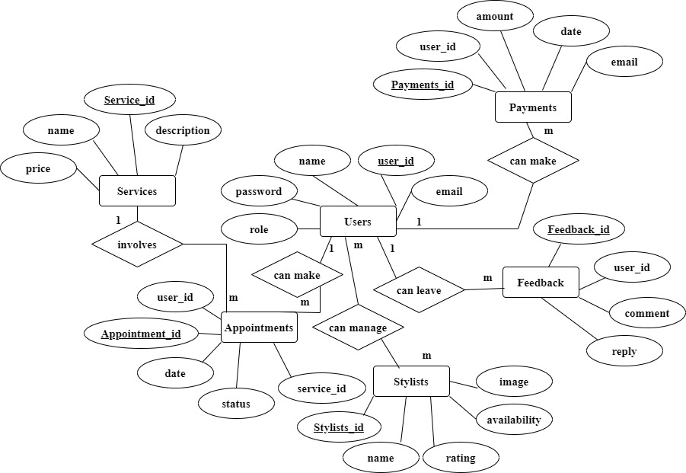

Figure 128 - ER Diagrams

### Normalized Relational Schema

#### Step 1: **Understand the Entities and Attributes**

* From the diagram, we have the following tables with their respective attributes:

1. Users Table

|  |  |  |  |  |
| --- | --- | --- | --- | --- |
| user_id | name | email | password | role |
|  |  |  |  |  |

1. Promotions Table

|  |  |  |
| --- | --- | --- |
| promotion_id | title | description |
|  |  |  |

1. Reviews Table

|  |  |  |  |
| --- | --- | --- | --- |
| review_id | user_id | comment | reply |
|  |  |  |  |

1. Services Table

|  |  |  |  |  |
| --- | --- | --- | --- | --- |
| service_id | user_id | name | description | price |
|  |  |  |  |  |

1. Stylists Table

|  |  |  |
| --- | --- | --- |
| stylist_id | name | rating |
|  |  |  |

1. Appointments Table

|  |  |  |  |  |
| --- | --- | --- | --- | --- |
| appointment_id | user_id | service_id | date | rating |
|  |  |  |  |  |

1. Payments Table

|  |  |  |  |  |
| --- | --- | --- | --- | --- |
| payment_id | user_id | amount | email | date |

1. Users Table

|  |  |  |  |  |  |  |  |  |  |
| --- | --- | --- | --- | --- | --- | --- | --- | --- | --- |
| user_id (PK) | FullName | email | password | Role | Phone | Gender | DateOfBirth | Address | ProfilePicture |
|  |  |  |  |  |  |  |  |  |  |

1. Appointments Table

|  |  |  |  |  |  |  |
| --- | --- | --- | --- | --- | --- | --- |
| AppointmentID | UserID | Date | TimeSlot | Service | Stylist | Status |
|  |  |  |  |  |  |  |  |

1. Services Table

|  |  |  |  |  |  |  |
| --- | --- | --- | --- | --- | --- | --- |
| ServiceID | ServiceName | Price | Description | Duration | Image | ParentID |
|  |  |  |  |  |  |  |

1. Stylists Table

|  |  |  |  |
| --- | --- | --- | --- |
| stylist_id (PK) | StylistName | Bio | rating |
|  |  |  |  |

1. Payments Table

|  |  |  |  |  |
| --- | --- | --- | --- | --- |
| payment_id (PK) | user_id (FK) | amount | email | date |
|  |  |  |  |  |

**Step 2: Second Normal Form (2NF)**

**Definition**:

The table must satisfy 1NF.

Remove partial dependencies (i.e., no non-prime attribute should depend on part of a composite primary key).

**Identifying Partial Dependencies**

**Appointments Table**:

Attributes like Service and Stylist are dependent on AppointmentID. These are fine because AppointmentID is a single primary key.

**Services Table**:

ParentID is a separate relationship indicating service categories.

#### Step 2: **Normalization Steps**

Normal forms (1NF, 2NF, 3NF) to each of these tables:

1. **1NF (First Normal Form)**
   * Ensure all tables have atomic columns (i.e., no repeating groups or arrays).
   * Each table already has atomic attributes, so they satisfy 1NF.
2. **2NF (Second Normal Form)**
   * Each non-key attribute should depend on the entire primary key.
   * Since each table has a single-column primary key, and no partial dependencies exist, all tables satisfy 2NF.
3. **3NF (Third Normal Form)**
   * All attributes should depend only on the primary key, and there should be no transitive dependencies.

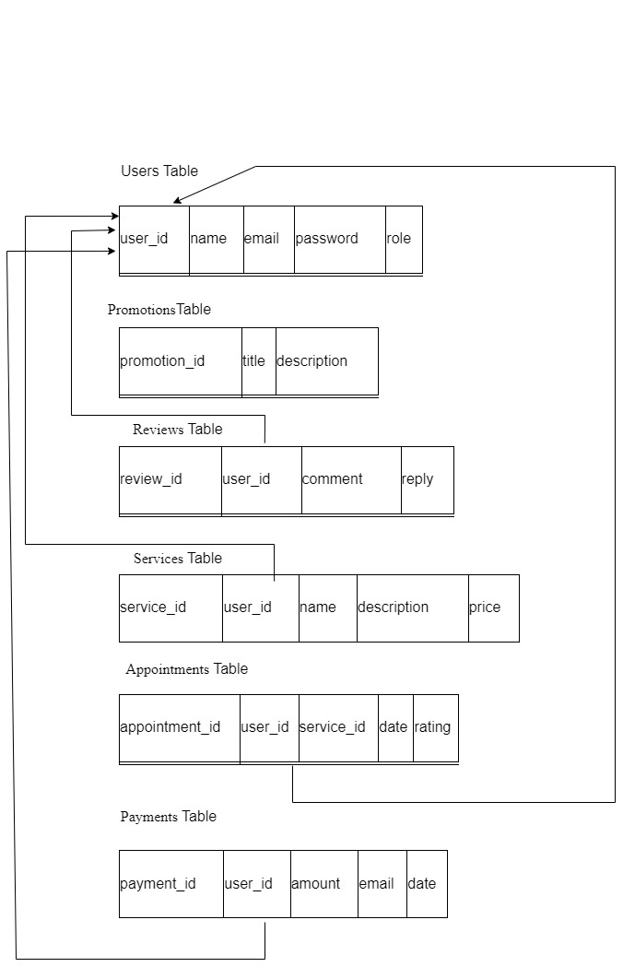

Figure 129

#### Step 3: **Final Normalized Relational Schema**

Based on the analysis, here’s the final schema in 3NF:

#### Completed Normalized Relational Schema



Figure 130 - Completed Normalized Relational Schema

# **Future Recommendations**

To further enhance the Sulochana Salon Website, the following future improvements are recommended:

## **Product Sales & E-Commerce Integration**

### **Why?**

* Many salons not only offer services but also sell **hair care, skincare, and beauty products**.
* Adding a **product sales section** allows salons to **increase revenue** by selling items like **shampoos, conditioners, hair dyes, skincare products, and accessories** directly through the website.

**Features to Include:**

1. **Product Catalog** – Display all available products with images, descriptions, and pricing.
2. **Add to Cart & Checkout** – Allow customers to select products and complete payments online.
3. **Inventory Management** – Automatically update stock levels based on sales.
4. **Product Recommendations** – Suggest products based on customers' past appointments or preferences.

**Implementation Strategy:**

**Integrate a shopping cart system** with secure payment options like **PayHere, Stripe, or PayPal**.

Enable **"Buy with Booking"** – Clients can purchase **recommended products** when booking a service.

Offer **discounts or loyalty points** for repeat purchases to encourage sales.

## **AI-Powered Chatbot for Customer Support**

### **Why?**

* A **chatbot** can provide **24/7 instant customer support** for clients who have **queries about services, bookings, prices, and salon hours**.
* Reduces the workload on **salon staff** by handling common questions automatically.

**Features to Include:**

**Appointment Assistance** – The chatbot can help clients **book, reschedule, or cancel appointments**.

**Service Inquiries** – Customers can ask about **available services, pricing, and stylist expertise**.

**Personalized Recommendations** – Suggest services based on client preferences and booking history.

**Live Chat with Staff** – If the chatbot cannot answer a query, it should **transfer the chat to a human assistant**.

**Implementation Strategy:**

Use **AI & Natural Language Processing (NLP)** to make the chatbot understand **common salon-related queries**.

Integrate **WhatsApp, Facebook Messenger, and website chat widgets** for easy access.

Train the chatbot with **FAQs and past customer queries** to improve response accuracy.

## **Mobile Application Integration**

### **Why?**

* A **mobile app** allows clients to book appointments, receive reminders, and check promotions more conveniently.
* Mobile users make up **65%+ of online bookings**, so having an app improves **customer engagement and retention**.

**Features to Include:**

**Instant Booking & Rescheduling** – Clients can book appointments **on the go** from their phones.

**Push Notifications** – Real-time updates on appointment confirmations, promotions, and reminders.

**QR Code Check-In** – Clients can **scan a QR code at the salon** instead of manually checking in.

**Mobile Payments** – Integrate **Google Pay, Apple Pay, and e-wallets** for seamless transactions.

**Implementation Strategy:**

1. Develop the mobile app for **Android & iOS** using **Flutter or React Native**.
2. Sync the app with the website’s **database and appointment system** for real-time updates.
3. Offer an **app-exclusive discount** to encourage more downloads and usage.

## **Real-Time Appointment Reminders & Notifications**

### **Why?**

* **Reduces missed appointments** by sending reminders **before scheduled bookings**.
* Keeps clients informed about **booking status, cancellations, and special offers**.

**Features to Include:**

1. **SMS & Email Reminders** – Send **automatic reminders 24 hours and 1 hour before the appointment**.
2. **Push Notifications (Mobile App)** – Notify users about upcoming bookings, discounts, and new services.
3. **Two-Way Confirmation** – Allow clients to **confirm or cancel** their appointment through reminders.

**Implementation Strategy:**

Use **third party SMS APIs** (Twilio, Nexmo) and **email services (SendGrid, Mailgun)**.

Customize reminders based on **client preferences** (e.g., SMS, email, or push notifications).

Track **no-show customers** and send them follow-up messages to rebook their appointments.

## **Showing Available Time Slots for Clients**

### **Why?**

Helps clients **easily find an available time slot** instead of guessing when to book.

Reduces **double bookings and scheduling conflicts**.

**Features to Include:**

**Real-Time Slot Display** – Shows available time slots based on stylist availability.

**Stylist-Specific Booking** – Clients can choose a **specific stylist and view their free slots**.

**Dynamic Slot Adjustment** – If a client cancels, the system should **automatically update the available slots**.

**"Next Available Appointment" Feature** – Suggest the **earliest available time** when a client selects a fully booked time slot.

**Implementation Strategy:**

Use a **dynamic calendar system** that syncs with the **database in real-time**.

Implement a **color-coded availability display** (e.g., **green** for available slots, **red** for fully booked).

Allow clients to **set a reminder** for the next available slot if their preferred time is not available.

# Gantt chart

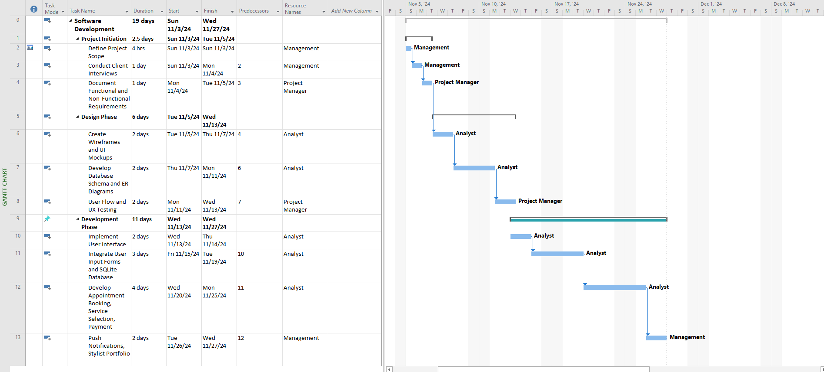

Figure 131 - Gantt chart

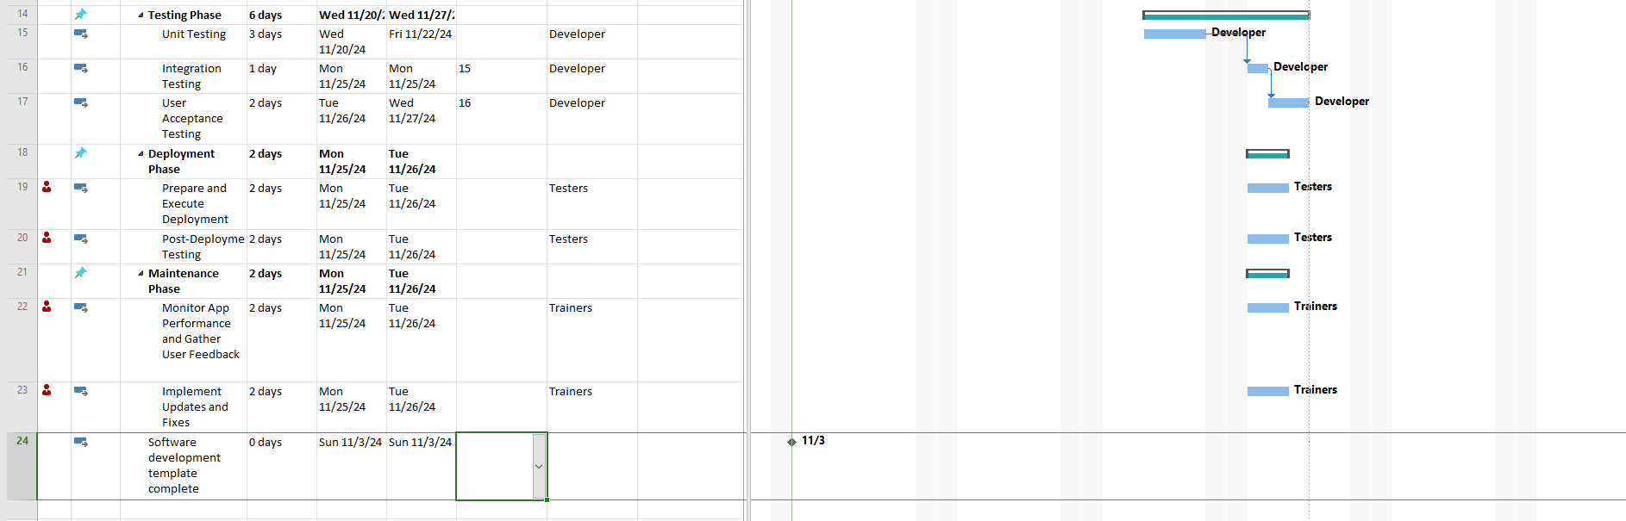

Figure 132 - Gantt chart